|  |  |
| --- | --- |
| C:\Users\Plasma-PC\Desktop\logo.jpg | **MINISTRY OF EDUCATION AND TRAINING** |

**FPT UNIVERSITY**

**Capstone Project Document**

**Olives**

|  |  |  |
| --- | --- | --- |
| **Olives Team** | | |
| **Group member** | Phạm Đức Thắng | SE03055 |
| Trần Ánh Dương | SE02797 |
| Phạm Minh Tuấn | SE02875 |
| Bùi Quốc Trọng | SE03418 |
| Nguyễn Văn Hưng | SE02582 |
| Nguyễn Duy Linh | SE03150 |
| **Supervisor** | Lecturer: Phan Trường Lâm | |
| **Capstone Project code** | Olives | |

**Hoa Lac, 12th August 2016**

**CONTENT**

**Acknowledgements** 4

**Definitions and Acronyms** 5

**CHAPTER 1: INTRODUCTION** 6

**1.1 Purpose** 6

**1.2 Project information** 6

**1.3 The people** 7

1.3.1 Supervisors 7

1.3.2 Team members 7

**1.4 Background** 7

**1.5 Literature review of existing system** 8

1.5.1 UDoctor 8

1.5.2 Jio Healths 9

**1.6 Ideas** 11

**1.7 Proposal of system** 11

1.7.1 Our proposal system 11

**1.8 Reference** 13

**CHAPTER 2: PROJECT MANAGEMENT** 14

**2.1 Purpose** 14

**2.2 Problem Definition** 14

2.2.1 Name of this Capstone Project 14

2.2.2 Problem Abstract 14

2.2.3 Project Overview 14

2.2.4 The Proposed System 14

2.2.5 Boundaries of the System 14

2.2.6 Development Environment 15

**2.3 Project organization** 15

2.3.1 Software Process Model 15

2.3.2 Roles and Responsibilities 16

**2.4 Project Management Plan** 17

2.4.1 Task 17

2.4.2 Project Schedule 18

2.4.3 Meeting Minutes 18

2.4.4 Resource 19

**2.5 Risk Management** 20

**2.6 Communication Management** 20

2.6.1 Communication between Team Members 20

2.6.2 Communication with Supervisor 21

**2.7 Configuration Management Process** 2.7.1 CI Identification and Naming Convention 21

**2.8 Project Milestones** 22

**2.9 Project Infrastructure** 22

**2.10 Coding convention** 23

**2.11 Version Numbering Rule** 23

**2.12 Directory Structure** 24

**2.13 Other Olives Rules** 24

**CHAPTER 3: SOFTWARE REQUIREMENT SPECIFICATION** 25

**3.1 Introduction of SRS** 25

3.1.1 Purpose 25

3.1.2 Scope 25

3.1.3 Definitions, acronyms and abbreviations 25

3.1.4 References 25

3.1.5 Overview 25

**3.2 Overall description** 26

3.2.1 Product perspective 26

3.2.2 Product functions 26

**3.3 Specification requirements** 28

3.3.1 Admin Website Application 28

3.3.2 Olives Website Application 29

3.3.3 Patient Application 79

3.3.4 Doctor Application 110

**3.4 Non-functional Requirement** 129

3.4.1 Usability 129

3.4.2. Security 129

3.4.3. Maintainability & Extensibility 131

3.4.4. Performance 131

**3.5 Entity Relationship Diagram** 132

**CHAPTER 4: SOFTWARE DESIGN** 133

**CHAPTER 5: SOFTWARE TESTING DOCUMENTATION** 134

**5.1 Introduction** 134

5.1.1 Purpose 134

5.1.2 Scope 134

**5.2 Test Plan** 135

5.2.1 Tool and Environment 135

5.2.2 Resources and responsibilities 136

5.2.3 Test strategy 136

**5.3 Test Approach** 139

5.3.1 Unit Test 139

5.3.2 Integration and System Test 139

5.3.3 Acceptance Test 139

5.3.4 Defect Log 139

**CHAPTER 6: INSTALLATION GUIDE & USER MANUAL** 141

**6.1 Purpose** 141

**6.2** 141

**6.3 User Guidelines** 141

6.3.1 Admin website application 141

6.3.2 Olives website application 143

6.3.3 Doctor application 160

6.3.4 Patient application 171

**Acknowledgements**

*The success and final outcome of this project required a lot of guidance and assistance from many people and wish to express our deepest gratitude to them. Without them, this project would have been done with much more obstacles than it was.*

*First, we want to say thanks to Mr. Phan Truong Lam for his continuously sharing and motivating throughout the project. Mr. Phan Truong Lam has always been very responsive in providing necessary information, and without his generous support project would lack in accurate information on current developments. Under the instructions of Mr. Phan Truong Lam, the project team has always felt comfortable and confident. Apart from all the technologies and methodologies, Mr. Phan Truong Lam shared with us the philosophy of keeping the right attitude towards problems.*

*Second, we would like to say thanks to the instructors at FPT University for all the classes. Without the knowledge that university teaches us through each class, semester, we cannot finish this project.*

*Third, we truly appreciate the random fellows on the internet who has discussed with us. Every our tiny problem was answered clearly.*

*Finally, we want to thank our family for their help, inspiring during this project.*

**Definitions and Acronyms**

|  |  |  |
| --- | --- | --- |
| **Acronym** | **Definition** | **Note** |
| SRS | Software Requirement Specification |  |
| API | Application Programming Interface |  |
| HTML | Hypertext Markup Language |  |
| CSS | Cascading Style Sheets |  |
| IDE | Integrated Development Environment |  |
| DBMS | Database Management System |  |
| UML | Unified Modeling Language |  |
| PM | Project Manager |  |
| UC | Use Case |  |
| N/A | Not Available |  |
| ORM | Object Relational Mapping |  |
| GUI | Graphical User Interface |  |
| HTTP | Hypertext Transfer Protocol |  |
| PHP | Hypertext Preprocessor |  |
| REST | Representational State Transfer |  |
| RAM | Random Access Memory |  |
| URL | Uniform Resource Locator |  |

# **CHAPTER 1: INTRODUCTION**

## **1.1 Purpose**

This chapter provides an overview of project include the initial idea and background information of the group’s Capstone project, overview of similar existing solutions, literature review of existing system and raising a proposal for ideas of improvement.

## **1.2 Project information**

* Project name: **Olives**
* Project code: **Olives**
* Product type: **Web and iOS Application**
* Timeline: **From 9th May to 27th August**

## **1.3 The people**

### 1.3.1 Supervisors

|  |  |  |  |  |
| --- | --- | --- | --- | --- |
|  | **Full name** | **Phone** | **Email** | **Title** |
| Supervisors | Phan Trường Lâm | 0913507828 | LamPT@fpt.edu.vn | Lecturer |

*Table 1.3.1: Supervisor’s information*

### 1.3.2 Team members

|  |  |  |  |  |  |
| --- | --- | --- | --- | --- | --- |
| **No** | **Full name** | **Student code** | **Phone** | **Email** | **Role in group** |
| 1 | Phạm Đức Thắng | SE03055 | 01649584307 | [thangpdse03055@fpt.edu.vn](mailto:thangpdse03055@fpt.edu.vn) | Leader |
| 2 | Trần Ánh Dương | SE02797 | 01656000145 | [duongtase02797@fpt.edu.vn](mailto:duongtase02797@fpt.edu.vn) | Member |
| 3 | Phạm Minh Tuấn | SE02875 | 01684036595 | [tuanpmse02875@fpt.edu.vn](mailto:tuanpmse02875@fpt.edu.vn) | Member |
| 4 | Bùi Quốc Trọng | SE03418 | 01653708468 | [trongbqse03418@fpt.edu.vn](mailto:trongbqse03418@fpt.edu.vn) | Member |
| 5 | Nguyễn Văn Hưng | SE02582 | 0984794286 | [hungnvse02582@fpt.edu.vn](mailto:hungnvse02582@fpt.edu.vn) | Member |
| 6 | Nguyễn Duy Linh | SE03150 | 0964133048 | [linhndse03150@fpt.edu.vn](mailto:linhndse03150@fpt.edu.vn) | Member |

*Table 1-2: Team member’s information*

## **1.4 Background**

Health care is becoming one of the most concerning problem nowadays, especially when there are a lot of arising problem about our polluted environment, poisoned foods and drinks,.. People are taking really serious about their health so the need to have a personal doctor for everyone is getting bigger and bigger. But for the last decades the way we use to communicate with a doctor and the process to take a treatment are normally costing time as well as ineffective in managing the data of medical records. Here are some specific information about what is going on in our traditional treatment.

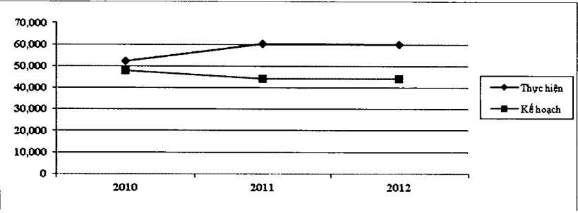

*Figure 1.4.1: The number of patients increases*

* About the difficulties
* Service attitude of doctors
* The price of medicine and services
* Infrastructure
* The difficulties in the procedures of the hospital
* Don’t have connection between doctors and patients
* Reality example and statistics

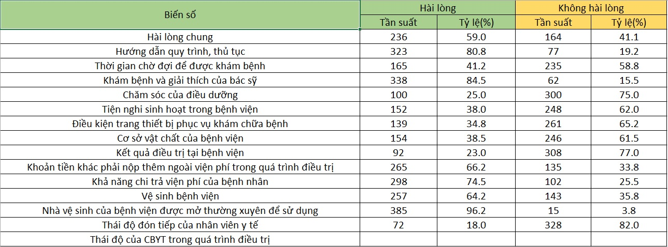

*Figure 1-2: Satisfaction with hospital services*

Nothing can getting better without the help of information technology. As one research done by ITOnline, two third of American wanted to use digital health management method rather than physical ones. That research also showed that there are at least 79% of American said they were always ready to use devices such as hand-worn devices for managing their health status, 45% of them would use those devices for monitoring decease symtoms while the 43% wanted them to manage health problems. The recent research of PricewaterhouseCoopers (PWC) showed health care is one of three mobile trends in 2016. This was based on a fact that while American adults used wireless devices always installed at least 1 health care or fitness application, increased 16% than 2 years ago. It also pointed out that health care applications are one of the top download application types.

As we can see, the needs are real and we still have a lot of customers to serve. So we decided to create **Olives – Healthcare Application**.

## **1.5 Literature review of existing system**

### 1.5.1 UDoctor

* The app is a free Q & A channel with hundreds of doctors available to answer you with the big data warehouse has been censored and classified.
* The app directly to ask questions and get feedback from leading clinicians without go to doctor working places.
* The application read the news initiative, enabling users to access the health issues that you care about quickly and directly.
* Recordkeeping health benefits permanently store your health records on the system, finding a prescription and quickly and conveniently

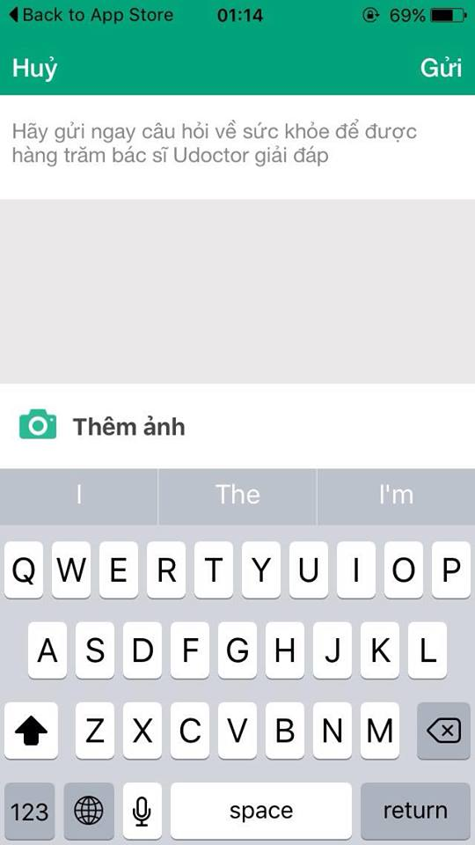 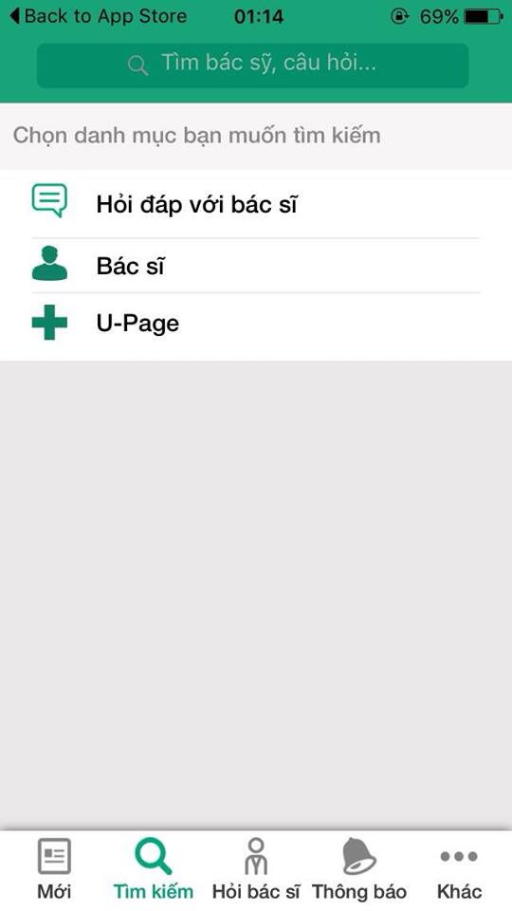 

*Figure 1-3: Main content of “Udoctor”*

Udoctor has a problem that it’s just for counseling, a doctor isn’t able to make precise answers unless he (she) meet his (her) patients directly. Health isn’t not a thing that allows for mistakes, and without meeting face to face, a doctor can’t see any potential diseases that weren’t revealed through any symptoms.

### 1.5.2 Jio Healths

* This Application track your vitals, log your food and nutrition, manage your medications, and securely connect with your providers and caregivers.
* Application creates a medication list that works for you. Simply search our extensive, verified database of medications and select your medication times.
* Application empowers you to securely connect with your doctors, care providers, and loved ones and seamlessly share your health data
* Your insurance card, conditions, allergies, and documents - all seamlessly organized into your personal health profile. Health History at your fingertips a complete record of your conditions, notes, and allergies.
* Connect with your doctor. Search for the best local doctors and find instant telemedicine consultations. Instantly book appointments, get directions for your visits and share data with physicians. Stay in touch with your doctors through secure audio/video calls and message threads. Access your clinical notes and medication prescriptions and receive real-time
* And integrated with some other Application to control your weight, diet and fitness exercises.

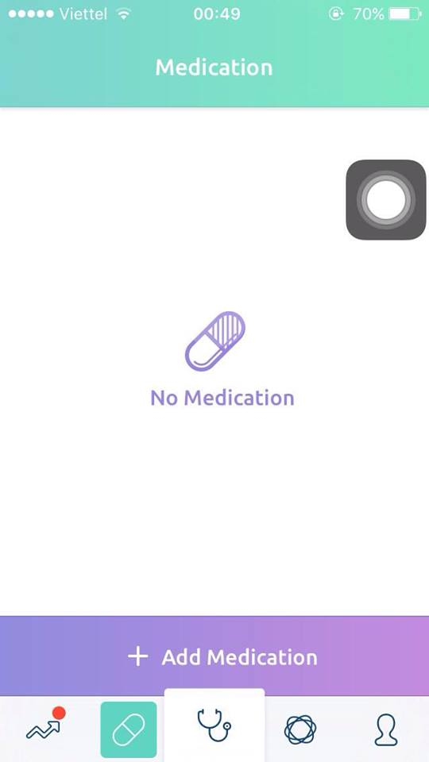 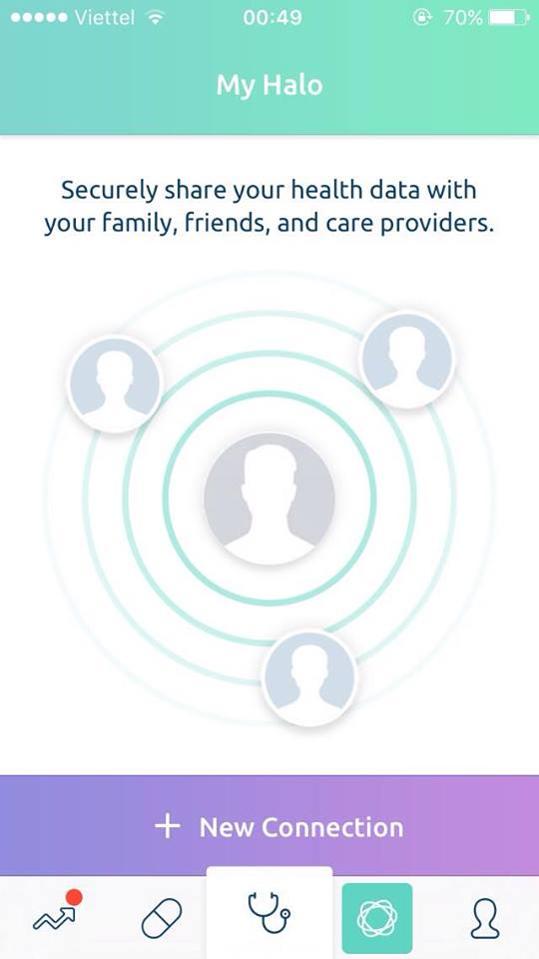 

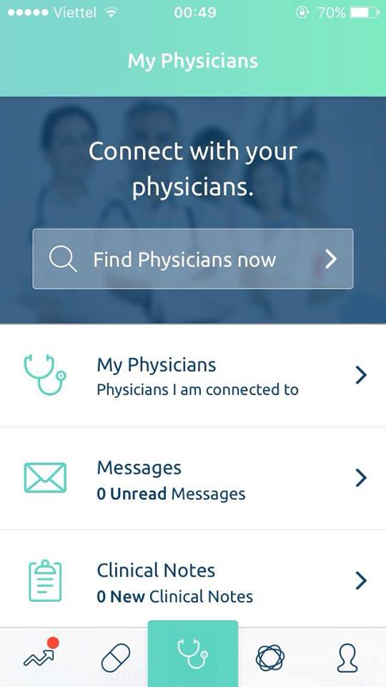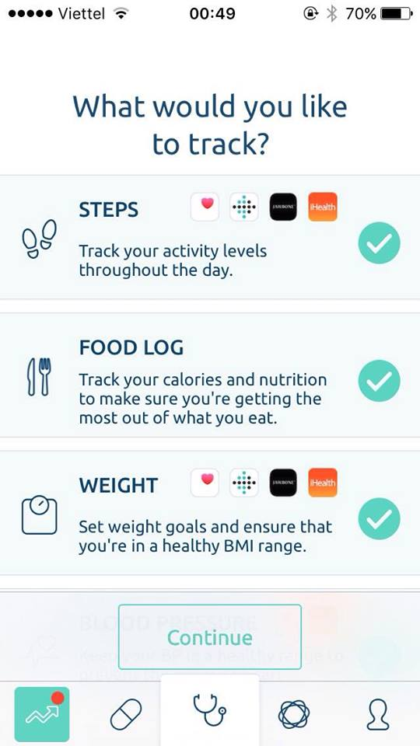

*Figure 1-4: Main content of “Jio Healths”*

**Business:** App helps connect between doctors with patients via video or chat. Advice through video or chat and it will be charged depending on the requirements of doctors. Consulting fees will be listed on the application.

There are some things about Jio Health that makes it less perfect. If you want to record your daily health information or view your medication when you’re offline, you cannot do that in Jio Health application, because it requires Internet to be able to start working. One of other problems with Jio Health is about only allow store medical records in photos. So no one is able to read them if these photos is too blurry or handwriting is not so good. Jio Health can only be used on smart phone, but using phone with small screen is inconvenient in the way when you want to record about health status precisely or chatting frequently... etc.

Here is the comparison table among our system, Olives, Jio Healths, Udoctor:

|  |  |  |  |
| --- | --- | --- | --- |
| **Features** | **Olives** | **Jio Health** | **Udoctor** |
| Find doctors | ✓ | ✓ | ✓ |
| Contact with doctors | ✓ | ✓ | ✗ |
| Rating doctor’s expertise | ✓ | ✓ | ✗ |
| Make an appointment | ✓ | ✓ | ✗ |
| Telemedicine | ✗ | ✓ | ✗ |
| Store medical records | ✓ | ✗ | ✗ |
| Health counseling | ✓ | ✓ | ✓ |
| Review health status | ✓ | ✓ | ✗ |
| Medication schedule | ✓ | ✓ | ✗ |
| Track heart rate, weight… | ✓ | ✓ | ✗ |
| Access service in website UI | ✓ | ✗ | ✗ |
| Can use application without Internet | ✓ | ✗ | ✗ |

## **1.6 Ideas**

We came up with the idea, to develop a system that help patients to find and contact with a doctor to get a treatment the way easier, all the costing time works would be cut and provide a professional way to check and manage information about the personal medical record’s data. And for the doctors we want to create a new trend of working style, with our system doctors can work independency with the hospital and help them to increase their income effectively. Moreover, in business perspective we see that 2016 and could be next few years health care services will become a new trend in IT development.

## **1.7 Proposal of system**

After review and analyzing advantage and disadvantage of those applications, we came to an agreement about which functions our application should support to inherit their strong points and reduce their limitations:

### 1.7.1 Our proposal system

**BASIC FUNCTION:**

Objects using the system: Guest, Admin, Doctor, Patient

**Guest:**

* Allow user to login to the system.
* Allow user to register to the system.
* Allow user to search doctors.
* Allow user to view doctor’s profile.

**Admin:**

* Allow user to add a new doctor and accept doctor’s information
* Allow user to view all information of doctors and patients (personal information, history,…)
* Allow user to manage doctor’s request (change status: Active or De-active)
* Allow user to change status of account (Active or De-active)
* Allow user to search doctor or patient
* Allow user to add new places
* Allow user to edit places
* Allow user to add new categories of medical record
* Allow user to edit category of medical record

**Doctor:**

* Allow user to accept patient’s request
* Allow user to view personal information of your patients
* Allow user to view medical record of your patients
* Allow user to edit medical record of your patients
* Allow user to view Daily Record of patients (Heartbeat, Blood pressure, Blood sugar)
* Allow user to add Appointment
* Allow user to edit appointment
* Allow user to change status of appointment (Active/Cancel)
* Allow user to view medical record of your patients
* Allow user to add medical record of your patients
* Allow user to edit medical record of your patients
* Allow user to view Prescription and medicines
* Allow user to add Prescription and medicines
* Allow user to edit prescription and medicines
* Allow user to view diary
* Allow user to add diary
* Allow user to edit or delete diary
* Allow user to chat with your patient
* Allow user to view notification
* Allow user to view rate and comment
* Allow user to edit general information

**Patient:**

* Allow user to find doctors
* Allow user to view information of doctor
* Allow user to rate and comment doctors (Based on satisfaction of patients)
* Allow user to edit profile
* Allow user to add Daily Record (Heartbeat, Blood pressure, Blood sugar)
* Allow user to view Daily Record
* Allow user to edit or delete Daily Record
* Allow user to add new appointment
* Allow user to edit appointment
* Allow user to change status of appointment (Active or Cancel)
* Allow user to add new medical record
* Allow user to view medical record
* Allow user to edit or delete medical record
* Allow user to add prescription and medicines
* Allow user to view prescription and medicines
* Allow user to edit or delete prescription and medicines
* Allow user to chat with your doctors
* Allow user view all notifications

However, due to the limitation of team’s effort, we will not implement these following functions, although we are aware that they are also important to a system

**OUT OF SCOPE FUNCTIONS:**

* Payment
* Video Call
* Around Here
* Native mobile apps

## **1.8 Reference**

<http://www.nhandan.com.vn/chinhtri/item/28428402-nam-2016-se-la-nam-cua-xu-huong-cham-soc-suc-khoe-so.html>

<http://www.tienphong.vn/Khoe-Dep-Suc-Khoe/20-benh-vien-co-co-so-ha-tang-chua-dap-ung-nhu-cau-73961.tpo>

<http://iccchr-hue.org.vn/Images/Upload/files/WSM9F7A.pdf>

# **CHAPTER 2: PROJECT MANAGEMENT**

## **2.1 Purpose**

The purpose of this chapter is to describe the organization and plan of the project. All team members must use this chapter as a guideline for tracking assigned tasks and deadlines. This chapter also included an overview of this project and team member. This is a document for daily meeting and meeting minute.

## **2.2 Problem Definition**

* + 1. Name of this Capstone Project
  + Project name: **Olives**
  + Project code: **Olives**
  + Product type: **Web and iOS Application**
  + Timeline: **From 9th May to 27th August**
    1. Problem Abstract

Nowadays, the human health issues always are interested. But hospitals services can’t meet the needs of patients. Many doctors have good specialize but they can’t approach to patients. Patients having difficulty looking for good doctors. Between them don’t have connections, the only solution is go to the hospital. Patients take long time with hospital procedures and doctors can’t take care them. Olives is a software for doctors. It’s a connection between doctors and patients. Olives helps doctors take care their patients.

* + 1. Project Overview

2.2.3.1 The Current System

* + - The system has not been developed previously.
    - The system is growing up as begin at the moment.
    1. The Proposed System

Objects using the system: Guest, Admin, Doctor, Patient

Function:

* Guest: Login to the system, Register to the system, search doctors, View information.
* Admin: View information, manage doctor’s request (change status), change status of doctor’s account and patient’s account, search doctor or patient, manage places, manage categories of medical record.
* Doctors: View information, Manage medical record (view/add/edit), manage appointment (view/add/change status), manage prescription (view/ add/edit), manage diary (view/add/edit/delete), view information of patients, chat with your patients.
* Patients: View information, Manage medical record (view/add/edit/delete), manage appointment (view/add/change status), manage prescription (view/ add/ edit/ delete), manage daily record (view/add/edit/delete), Find doctors, Rate and comment doctors, chat with your doctors.
  + 1. Boundaries of the System

This document is for all members engage to <Olives>

It is used in: Software requirement, evaluation and acceptance standards are developed

* + 1. Development Environment
* Programming languages:
* C#, HTML5, Objective C
* Framework:
* AngularJS v1.2.22 (JavaScript)
* ASP.NET Framework 4.6
* ASP.NET 5
* Software Architecture:
* Web Service
* Process Model:
* Iterative and Incremental Software Process Model.
* Version Control:
* Github.
* IDEs: VisualStudio 2015, Xcode, Resharper 10.0.2 ultimate.
* DBMS:
* MySQL v5.5, Redis v3.0, MySQL Workbench v6.2.
* UML tools:
* Enterprise Architect v12, Astah Professional v6.9.0
* Hosting:
* Heroku
* AppHarbor
* Manage tools:
* Jira
* Web server:
* Apache2.0.

Other: Microsoft Office 2013, Microsoft Visio 2013, Microsoft Project 2013

## **2.3 Project organization**

2.3.1 Software Process Model

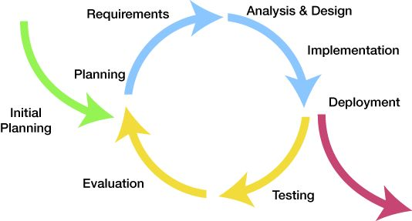  
*Figure 2.3.1.1: Iterative and Incremental Software Process Model*

This figure above describes the information and products flow lifecycle process model. Olives project uses the Iterative and Incremental Software Process Model.

The Iterative and Incremental Software Process Model is most use when the scope of the project is big, the major requirements were defined clearly, some more detail will be added in time, and for the newbie group in software development. By using this software process model, we break down the developing system task into series of smaller tasks which be completed separately, evaluated, and subsequently re-worked until the system’s performance adequately. In addition, the iterative model is easier than other models when the issues are discovered. They are fed back to the team, and solutions found while the project is still in development.

2.3.2 Roles and Responsibilities

2.3.2.1 Organizational Structure

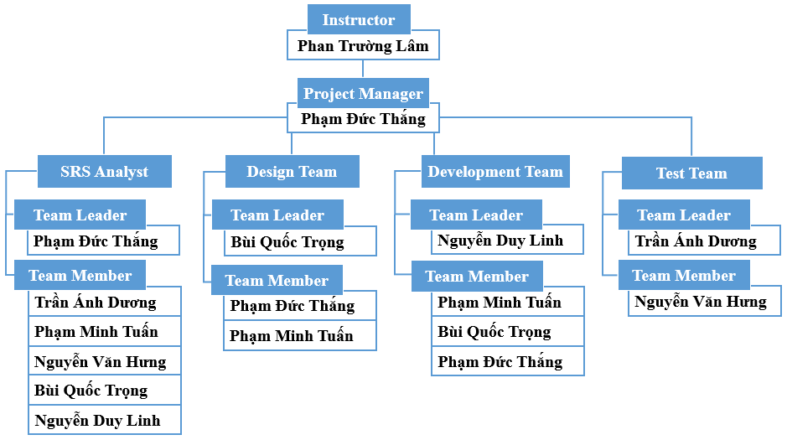

*Figure 2.3.2.1.1: Organization Structure Chart*

2.3.2.2 Project Role

|  |  |  |
| --- | --- | --- |
| Name | Role | Quality Responsibility |
| ThangPD | Project Management | - Planning and defining scope, developing schedules, allocating resources, coordinating communication, generally responsible for keeping the team’s focus on main goal, and tries to keep the project team focused on the right goal at a time. |
| TrongBQ | Developer, Designer | - Involve to code product.  - Involve to design product. (Build system architecture, coding. Review codes. Fix bug) |
| LinhND | Developer | - Involve to code product.  (Building common framework, Investigate solution. Build system architecture, coding. Review codes. Fix bug) |
| TuanPM | Developer | -Involve to code product. (Colecting database. To be in charge of data issues. Review code. Fix bug) |
| DuongTA | QA and Tester | - Responsible for test execution, including test set-up and test run, evaluation of test run and error recovery, defect logging and test results recording.  - Create test cases, Execute test cases  - Manage the Quality Assurance function |
| HungNV | QA and Tester | - Audits and approve project deliverables from QA perspective. Review plans and deliverables for compliance with applicable standards. Provides guidance and assistance on process matters  - Create test cases, Execute test cases |

## **2.4 Project Management Plan**

2.4.1 Task

**Planning**

* Generate Project Ideas and review
* Assign project manager (PM)
* Register capstone project
* Confirm capstone project registration
* Kick off meeting
* Prepare scope management
* Prepare Work Breakdown Structure (WBS)
* Prepare project schedule

**SRS: Create Software Requirement Specification (SRS)**

* Create user requirements specification
* Create interface requirements
* Create functional requirements
* Create non-functional requirements
* Review and finalize SRS

**Design**

* Analysis SRS
* Create detailed design of component
* Create user interface design
* Review and finalize SDD

**Code**

* Coding main function
* Create unit test
* Release final product

**Test**

* Create and review test case.
* Execute Test (GUI and Functional)

2.4.2 Project Schedule

Below are the image of task list used to assign and tracking tanks.

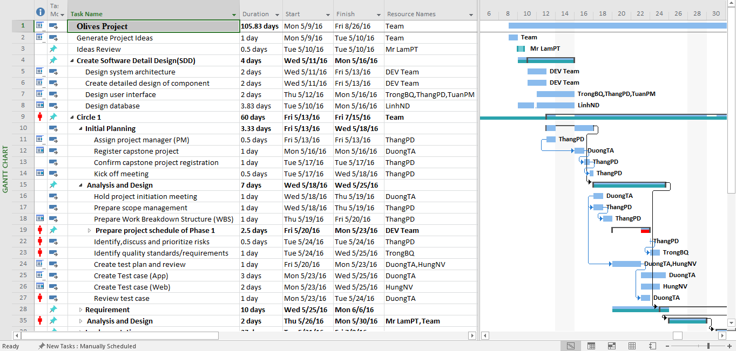

*Figure 2.4.3.1: Project Schedule*

***Refer to OL_ProjectPlan_v1.0.mpp to see more detail.***

2.4.3 Meeting Minutes

All meeting minutes will be written follow this template:

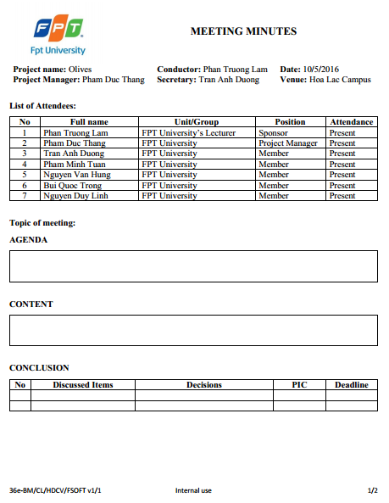

*Figure 2.4.3.1: Meeting minutes*

2.4.4 Resource

* Human resource: Team member
* Non-human resource

Equipment:

- 1 Dell Alienware Core i7

- 2 MacBook Pro (Retina, 13-inch, Early 2015)

- 1 Dell Inspiron 7548 Core i5

- 1 Dell Inspiron 15R 5537 core i5

- 1 iPhone 6 Plus 128 GB

- 1 iPhone 6 64GB

- 1 iPhone 5C 16GB

Building: Room 105R – Beta Building – FPT University

## **2.5 Risk Management**

|  |  |  |  |  |  |
| --- | --- | --- | --- | --- | --- |
| **No** | **Description** | **Root Cause** | **Avoidance Plan** | **Contingency plan** | **Status** |
| **R1** | The project is not on time. | -Underestimate time of project.  - The scope of project is too big for team.  - Spend too much time to research and study but don’t start coding. | Keep track with capstone’s deadline.  - Ask supervisor for advice to define suitable scope.  - Put high priority on main functions.  - Start coding as early as possible. | - Work together for tracking schedule | Close |
| **R2** | The domain name has been bought. | The domain name for the website has been bought | Check the available of the domain name before decide to use | Have some back up domain name so we can use it if need. | Close |
| **R3** | Change version of iOS | Release new version of iOS with a lot of changes. | Can’t be avoid | Always make code clean so we can change it easier | Close |
| **R4** | Difficult Problems | Project has technical issue which wastes time and cost to investigate | Learning technology clearly before starting project | Limit related function | Close |
| **R5** | Changes of team member | New member join or old member out. | Minimum the changes | Require the member who left hand over the work carefully | Close |
| **R6** | Total cost increase | The total amount of money increase and can’t be controlled. | Have good plan to control the cost and make prediction about the total cost carefully | QA check the report about the money used carefully | Close |

## **2.6 Communication Management**

2.6.1 Communication between Team Members

* **Weekly meeting schedule:** By using Iterative and Incremental Process Model, Olives project system will be divided into a series of small tasks, each task will be assigned to team members, and depend on difficulty, Project Manager will assign deadlines for each task. Olives team will have a meeting every Monday, and Friday from 19h00 to 21h30 to report the progress of the whole team’s tasks and review together all task and problem in project. Any member who doesn’t finish his/her task (without reasonable explanation) will be fined. The issues which we are having, we will discuss and find solution together. If it is too difficult and can’t be solved by ourselves, we will ask our supervisor for advises.
* **Unscheduled meeting:** If someone has an important problem want to be solved immediately, he proposes to Project Manager and we will have a meeting for discussion.
* **Communication channel:** Our main communication channels are face – to – face meeting, Email, Facebook and Skype. However, we sometimes can make a phone call or instant message if someone has problem.

2.6.2 Communication with Supervisor

* **Face-to-face meeting:** Weekly on every Tuesday to make sure that supervisor can keep tracking of the team’s progress
* **E-mail:** Gmail is the fastest way to get advice and document checking from supervisor
* **Mobile phone:** is used to get time and place arranged for the meeting every weeks

### **2.7 Configuration Management Process** 2.7.1 CI Identification and Naming Convention

|  |  |  |
| --- | --- | --- |
| **No** | **Configuration Items** | **Naming convention** |
| **Project Management** | | |
| 1 | Project Plan | OL_ProjectPlan_v[version number]  For example: Olives_ProjectPlan_v1.0 |
| **Requirement & Design** | | |
| 2 | SRS | OL_SRS_v[version number]  For example: OL _SRS_v1.0 |
| 3 | Architectural Design | OL_AD_v[version number]  For example: OL_ArchitecturalDesign_v1.0 |
| 4 | Screen Design | OL_SD_ v[version number]  For example: OL_ScreenDesign_v1.0 |
| 5 | Data Design | OL_DD _v[version number]  For example: OL_DataDesign_v1.0 |
| **Source Code** | | |
| 6 | Source Code | OL_SourceCode_ v[version number][Tested/Untested]  For example: OL_SourceCode_v1.0Tested |
| **Support Document** | | |
| 7 | User Manual | OL_UserManual_v[version number]  For example: OL_UserManual_v[version number] |
| **Test** | | |
| 8 | Unit Test Plan | OL_UnitTestPlan_v[version number]  For example: OL_UnitTestPlan_v1.0 |
| 9 | Integration Test Plan | OL_ITP_v[version number]  For example: OL_IntegrationTestPlan_v1.0 |
| 10 | System Test Plan | OL_STP_v[version number]  For example: OL_SystemTestPlan_v1.0 |
| 11 | Unit Test Case | OL_UTC_v[version number]  For example: OL_UnitTestCase_v1.0 |
| 12 | Integration Test Case | OL_ITC_v[version number]  For example: OL_IntegrationTestCase_v1.0 |
| 13 | System Test Case | OL_STC_v[version number]  For example: OL_SystemTestCase_v1.0 |
| 14 | Test Result | OL_TR_v[version number]  For example: OL_TestResult_v1.0 |
| 15 | Test Data | OL_TD_v[version number]  For example: OL_TestData_v1.0 |
| **Process** | | |
| 16 | Guideline | OL_[Name Of Guideline]Guideline_v[version number] For example: OL_UnitTestGuideline_v1.0 |
| 17 | Convention | OL_[Name Of Convention]Conventions_v[version number]  For example: OL_CodingConventions_v1.0 |
| 18 | Template | OL_Template-[Name Of Template]_v[version number]  For example: OL_Template-ChangeRequestForm_v1.0 |
| 19 | Checklist | OL_[Name Of Checklist]Checklist_v[version number]  For example: OL_Review Checklist_v1.0 |
| **File Type** | | |
| 20 | MS Word | *.doc |
| 21 | MS Excel | *.xls |
| 22 | MS PowerPoint | *.ppt |
| 23 | MS Project | *.mpp |

*Table 2.7.1.1: CI Identification and Naming Convention*

### **2.8 Project Milestones**

|  |  |  |  |
| --- | --- | --- | --- |
| **No** | **Milestones** | **Completion Date** | **Verification** |
| 1 | Project Start | 9th May 2016 | Instructor approval |
| 2 | Submit report 1 | 15th May 2016 | Instructor approval |
| 3 | Submit report 2 | 23rd May 2016 | Instructor approval |
| 4 | Submit report 3 | 2nd June 2016 | Instructor approval |
| 5 | Submit report 4 | 17th June 2016 | Instructor approval |
| 6 | Submit report 5 | 24th July 2016 | Instructor approval |
| 7 | Submit report 6 | 17th August 2016 | Instructor approval |
| 8 | Submit report 3 update | 27th July 2016 | Instructor approval |
| 9 | Submit report 4 update | 30th July 2016 | Instructor approval |
| 10 | Submit report 5 update | 10th August 2016 | Instructor approval |
| 11 | Submit Final Report | 24th August 2016 | Instructor approval |

*Table 2.8.1: Project Milestones*

### **2.9 Project Infrastructure**

2.9.1 Software and Techniques

|  |  |  |
| --- | --- | --- |
| **Category** | **Software name** | **Version** |
| Operating System | Microsoft Windows 8,10 | Professional |
| Mac OS |  |
| Office Tools | Microsoft Office | 2010, 2013 |
| Task tracking | Microsoft Project | 2013 |
| Atlassian Jira Software | 7.1.7 |
| Design Tool | Astah Community | 7.0 |
| Developments tools | Xcode | 7.3 |
| Visual Studio 2015 Enterprise | 2015 |
| Resharper Ultimate | 9.0 |
| Database tool | SQLite | 3.13.0 |
| Source version control | Xcode | 7.3 |
| Documentation | Microsoft Word | 2010, 2013 |
| Microsoft PowerPoint | 2010, 2013 |
| Microsoft Excel | 2010, 2013 |
| UI design tool | Adobe Photoshop | CS6 |
|  |  |

2.9.2 Hardware

Personal computer for developing and testing with the minimum configuration: 2GB Ram, 8 of hard disk, Intel Core I3.Internet network connection with the minimum speed 512kbit/s.

2.9.3 Other Infrastructure

Rooms for meeting and working. Internet and mobile phone services for communication.

### **2.10 Coding convention**

Follow Objective C coding convention. See the reference for detail: <https://developer.apple.com/library/mac/documentation/Cocoa/Conceptual/CodingGuidelines/CodingGuidelines.html>

Follow C# coding convention. See the reference for detail

[https://msdn.microsoft.com/en-us/library/ff926074.aspx](https://l.facebook.com/l.php?u=https%3A%2F%2Fmsdn.microsoft.com%2Fen-us%2Flibrary%2Fff926074.aspx&h=KAQFIHl7V)

### **2.11 Version Numbering Rule**

**For Document:**

* Each file has a version number as part of its identity. This version number is physically represented as a 2-part string with the following format: <version>.<revision> For example, version 1.0 indicates 1 as the version, and 0 as the revision number. The original version will be numbered 0.1. Subsequent revisions will be numbered 0.2, 0.3 and so on. The approved version will be 1.0.
* **Version number**: appears to the left of the decimal. It is changed only when the core content of the item is significance changed. For example: when an item is completely overhauled, with substantial internal changes, the version 1.0 would become version 2.0.
* **Revision number**: appears to the right of the decimal. It is changed when the existing content is changed, but the main (or core) content is remained. The normal sequence of revision is 1.1, 1.2, and so on.

**For Software source files:**

* Software executable and support files are generally identified by name and version number. The version number is physically represented as a 3-part string with the following format: <Version>.<revision><update> For example, version 1.1a indicates 1 as the version, 0 as the revision number, and a as the update level.
* **Version number:** appears to the left of the decimal. It is changed only when the core content of the item is significance changed, as when moving from one are of the development tool to another, when an application is completely overhauled, or the user interface changes fundamentally. In this case, version 1.1a would become version 2.0.
* **Revision number:** appears to the right of the decimal. It is changed when new features, functionality or other content are added or significantly changed. In normal case, the core architecture or user interface have been extended or limited in some manner. The most common reason for changing the revision number is adding a new module or other functionality to the software. The normal sequence of revision is 1.0, 1.1 and 1.2 and so on.
* **Update level:** is appended or incremented when the only change to the software item is to correct one or more defects, without the addition of any new function. Version 1.1 would become v1.1a, 1.1b and so on. This updating is overridden when a combination revision, involving bug fixes and new feature additions, is performed. In such a case, the software revision number is incremented and any update indicator is dropped, as in v1.1b to 1.2.

### **2.12 Directory Structure**

|  |  |  |
| --- | --- | --- |
| **Main folder** | **Sub-folder** | **Purpose** |
| Documents | Meeting minutes | Store project meeting minutes |
| Q&A | Store QA Management Sheet |
| Final deliverable | Report 1 | Store final deliverables of report 1 |
| Report 1 | Store final deliverables of report 1 |
| Report 2 | Store final deliverables of report 2 |
| Report 3 | Store final deliverables of report 3 |
| Report 4 | Store final deliverables of report 4 |
| Report 5 | Store final deliverables of report 5 |
| Report 6 | Store final deliverables of report 6 |
| Report 3 Update | Store final deliverables of report 3 Update |
| Report 4 Update | Store final deliverables of report 4 Update |
| Report 5 Update | Store final deliverables of report 5 Update |
| Report 6 Update | Store final deliverables of report 6 Update |
| Final Report | Store final deliverables of Final Report |
| Plan |  | Store project plan, Task list |
| Resource | Template | Store template needed in project |
| Tool | Store tool needed in project |
| Working Space | Each team members has a folder | Team member’s working area |
| Reference |  | Store reference needed in project |

*Table 2.12.1 Directory Structure*

### **2.13 Other Olives Rules**

* **Email subject naming convention:** All email related to the Olives project must have prefix [Olives]. For example: [Olives] Progress Report 1.
* **Document changing rule:** When a member wants to modify a document, he/she must update version of that document with appropriate description for the modification.

# **CHAPTER 3: SOFTWARE REQUIREMENT SPECIFICATION**

## **3.1 Introduction of SRS**

### 3.1.1 Purpose

Software requirement specification outlines function and non-function requirements of the project called Olives, which is an application that helps people take care their health. It also provides some format constraints in common requirements and project success criteria. All members will work (design, code, test) based on the information provided in this document

### 3.1.2 Scope

Olives is an application that built on IOS platform and website application, in which people can track vitals & activity by connecting your favorite devices. Securely share your data with a Physician and receive better care.

### 3.1.3 Definitions, acronyms and abbreviations

|  |  |
| --- | --- |
| **Term** | **Definition** |
| **OL** | Olives |
| **Olives** | Name of the application, so does the project |
| **Admin** | Manage system |
| **Doctors** | People interact with the system |
| **Patients** | People interact with the system |
| **Guest** | People interact with the system |

### 3.1.4 References

|  |  |  |
| --- | --- | --- |
| **No** | **Document** | **Source/Web Address** |
| 1 | System Requirements Specification Template | FPT Software Cop. |

### 3.1.5 Overview

The rest of the SRS contain 3 sections:

* **Introduction**: provides an overview of this document. It includes the purpose, scope, definitions, acronyms, abbreviations, references, and overview.
* **Overall Description**: describes the general factors that affect to the product and their requirements.
* **Specific Requirement**: Contains all requirements to a level of detail sufficient to help designers and testers satisfy those requirements.

## **3.2 Overall description**

### 3.2.1 Product perspective

Nowadays, the human health issues always are interested. But hospitals services can’t meet the needs of patients. Olives application is developed to help people take care their health with good doctors. Doctors reach larger populations without the traditional limitations. Grow your practice with more engaged care.

### 3.2.2 Product functions

3.2.2.1 Patient website application

* **View appointments**: Allow patients to view all appointments with doctors
* **Add appointments**: Allow patients to create appointments
* **Accept appointments**: Allow patients to accept appointments
* **Cancel appointments**: Allow patients to cancel appointments
* **View prescriptions**: Allow patients to view all current prescriptions and history prescriptions
* **Add prescriptions**: Allow patients to create prescriptions
* **Delete prescriptions**: Allow patients to delete prescriptions
* **Edit prescriptions:** Allow patients can edit prescriptions
* **View medical records:** Allow patients to view medical records
* **Add medical records:** Allow patients to add medical records
* **Edit medical records:** Allow patients to edit medical records
* **Delete medical records:** Allow patients to delete medical records
* **View blood pressure stats:** Allow patients to view blood pressure stats
* **Add blood pressure stats:** Allow patients to add blood pressure stats
* **Edit blood pressure stats:** Allow patients to edit blood pressure stats
* **Delete blood pressure stats:** Allow patients to delete blood pressure stats
* **View blood sugar stats:** Allow patients to view blood sugar stats
* **Add blood sugar stats:** Allow patients to add blood sugar stats
* **Edit blood sugar stats:** Allow patients to edit blood sugar stats
* **Delete blood sugar stats:** Allow patients to delete blood sugar stats
* **View heartbeat stats:** Allow patients to view heartbeat stats
* **Add heartbeat stats:** Allow patients to add heartbeat stats
* **Edit heartbeat stats:** Allow patients to edit heartbeat stats
* **Delete heartbeat stats:** Allow patients to delete heartbeat stats
* **Find doctors:** Allow patients to find doctors by name, specialty, country, city
* **View information of doctors:** Allow patients to view information of doctors
* **Rate:** Allow patients to rate for their doctors
* **View profile:** All patients to view their profile
* **Edit profile:** All patients to edit their profile
* **Chat with doctors:** Allow patients to chat with doctors
* **Notification:** Allow to view all notifications

3.2.2.2 Doctors website application

* **View appointments**: Allow doctors to view all appointments with patients
* **Add appointments**: Allow doctors to create appointments
* **Accept appointments**: Allow doctors to accept appointments
* **Cancel appointments**: Allow doctors to cancel appointments
* **View prescriptions**: Allow doctors to view all current prescriptions and history prescriptions
* **Add prescriptions**: Allow doctors to create prescriptions
* **Edit prescriptions:** Allow doctors to edit prescriptions
* **View medical records:** Allow doctors to view medical records
* **Add medical records:** Allow doctors to add medical records
* **Edit medical records:** Allow doctors to edit medical records
* **View blood pressure stats:** Allow doctors to view blood pressure stats
* **View blood sugar stats:** Allow doctors to view blood sugar stats
* **View heartbeat stats:** Allow doctors to view heartbeat stats
* **View profile:** Allow doctors to view their profile
* **Edit profile:** Allow doctors to edit their profile
* **Create Diary:** Allow doctors to create dairy
* **Edit Diary:** Allow doctors to edit dairy
* **Delete Diary:** Allow doctors to delete dairy
* **Chat with patients:** Allow doctors to chat with patients
* **Notification:** Allow doctors to view all notifications

3.2.2.3 Patient Application

* **View appointments**: Allow patients to view all appointments with doctors
* **Add appointments**: Allow patients to create appointments
* **Accept appointments**: Allow patients to accept appointments
* **Cancel appointments**: Allow patients to cancel appointments
* **View prescriptions**: Allow patients to view all current prescriptions and history prescriptions
* **Add prescriptions**: Allow patients to create prescriptions
* **Delete prescriptions**: Allow patients to delete prescriptions
* **Edit prescriptions:** Allow patients to edit prescriptions
* **View medical records:** Allow patients to view medical records
* **Add medical records:** Allow patients to add medical records
* **Edit medical records:** Allow patients to edit medical records
* **Delete medical records:** Allow patients to delete medical records
* **View blood pressure stats:** Allow patients to view blood pressure stats
* **Add blood pressure stats:** Allow patients to add blood pressure stats
* **Edit blood pressure stats:** Allow patients to edit blood pressure stats
* **Delete blood pressure stats:** Allow patients to delete blood pressure stats
* **View blood sugar stats:** Allow patients to view blood sugar stats
* **Add blood sugar stats:** Allow patients to add blood sugar stats
* **Edit blood sugar stats:** Allow patients to edit blood sugar stats
* **Delete blood sugar stats:** Allow patients to delete blood sugar stats
* **View heartbeat stats:** Allow patients to view heartbeat stats
* **Add heartbeat stats:** Allow patients to add heartbeat stats
* **Edit heartbeat stats:** Allow patients to edit heartbeat stats
* **Delete heartbeat stats:** Allow patients to delete heartbeat stats
* **Find doctors:** Allow patients to find doctors by name, specialty, country, city
* **View information:** Allow patients to view all information of doctors
* **Rate:** Allow patients to rate for their doctors
* **Chat with doctors:** Allow patients to chat with doctors
* **View profile:** Allow patients to view their profile
* **Edit profile:** Allow patients to edit their profile
* **Notification:** Allow patients to view all notifications

3.2.2.4 Doctors application

* **View appointments**: Allow doctors to view all appointments with patients
* **Add appointments**: Allow doctors to create appointments
* **Accept appointments**: Allow doctors to accept appointments
* **Cancel appointments**: Allow doctors to cancel appointments
* **View prescriptions**: Allow doctors to view all current prescriptions and history prescriptions
* **Add prescriptions**: Allow doctors to create prescriptions
* **Edit prescriptions:** Allow doctors to edit prescriptions
* **View medical records:** Allow doctors to view medical records
* **Add medical records:** Allow doctors to add medical records
* **Edit medical records:** Allow doctors to edit medical records
* **View blood pressure stats:** Allow doctors to view blood pressure stats
* **View blood sugar stats:** Allow doctors to view blood sugar stats
* **View heartbeat stats:** Allow doctors to view heartbeat stats
* **Chat with patients:** Allow doctors to chat with patients
* **View profile:** Allow doctors to view their profile
* **Edit profile:** Allow doctors to edit their profile
* **Create Diary:** Allow doctors to create dairy
* **Edit Diary:** Allow doctors to edit dairy
* **Delete Diary:** Allow doctors to delete dairy
* **Notification:** Allow doctors to view all notifications

3.2.2.5 Admin website application

* **Active/De-active account:** Allow admin Active/De-active doctor’s account and patient’s account
* **Manage request from doctor:** Allow admin manage all requests
* **Create categories:** Allow admin create categories of medical record
* **Edit categories:** Allow admin edit categories of medical record
* **Create places:** Allow admin create categories of medical record
* **Edit places:** Allow admin edit categories of medical record
* **View profile:** Allow admin view doctor’s profile and patient’s profile
* **Search:** Allow user to search doctor or patient

## **3.3 Specification requirements**

This section describes about functional and non-functional requirement. The functional requirement includes use case diagram and use case description. The non-function requirement includes usability, reliability, and performance…requirement of the system.

### 3.3.1 Admin Website Application

3.3.1.1 Use case Diagram

3.3.1.2 Use cases

### 3.3.2 Olives Website Application

3.3.2.1 Patient Website

3.3.2.1.1 Use case diagram

3.3.2.1.2 Use cases

3.3.2.1.2.1 Login

|  |  |  |  |
| --- | --- | --- | --- |
| UC ID and Name: | **UC-1.0.0 – Login** | | |
| Created By: | **HungNV** | Date Created: | **16/6/2016** |
| Primary Actor: | **Patient** | Secondary Actors: | N/A |
| Trigger: | Actor navigates to [domain]/ patient | | |
| Description: | Authenticate and authorize the user. | | |
| Preconditions: | Actor has already have an account. | | |
| Post conditions: | Actor logins the system successfully. | | |
| Normal Flow: | |  |  |  | | --- | --- | --- | | **No** | **Actor ‘s events** | **System response** | | 1 | Navigate to [domain]/patient |  | | 2 |  | Display login page | | 3 | Enter account details and click “Sign in” button. |  | | 4 |  | Display actor’s Home page. | | | |
| Alternative Flows: | N/A | | |
| Exceptions: | **Invalid email address**  1. System indicates that the email address entered is not valid  2. A message “Your email does not belong to an account. Please check and try again!” **Invalid password**  1. System indicates that the password entered is not valid  2. A message “Your password is not correct. Please check and try again!” | | |
| Priority: | High. | | |
| Frequency of Use: | High. | | |
| Business Rules: | N/A | | |
| Other Information: | N/A | | |
| Assumptions: | N/A | | |

3.3.2.1.2.2 Register

|  |  |  |  |
| --- | --- | --- | --- |
| UC ID and Name: | **UC-1.0.0 – Register** | | |
| Created By: | **DuongTA** | Date Created: | **16/6/2016** |
| Primary Actor: | **Patient** | Secondary Actors: | N/A |
| Trigger: | Actor navigates to [domain]/patient | | |
| Description: | Register an account in Olives application. | | |
| Preconditions: | User access on Login page | | |
| Post conditions: | Olives registers and logs user in | | |
| Normal Flow: | |  |  |  | | --- | --- | --- | | **No** | **Actor ‘s events** | **System response** | | 1 | Navigate to [domain]/doctor |  | | 2 |  | Display [login] page | | 3 | Click “Create new one” button. |  | | 4 |  | Display [Register] page | | 5 | Click “Sign up” on patient tab |  | | 6 |  | Display [Register] patient page | | 7 | Enter account information details and click “Sign up” button. |  | | 8 |  | Back to [login] page | | | |
| Alternative Flows: | N/A | | |
| Exceptions: | **Invalid email address:**  The system indicates a wrong E-mail address has been entered. A message “Your email address is not valid” will appear **Duplicate Email address:** The system indicates this email address has been used. A message “Your email has been used! Please enter another one!”  **Password is to short:** The system indicates the entered invalid password A message “Your password is too short! Please input at least 8 characters!” will appear. **Password is not match:** The system indicates the entered invalid password A message “Your password do not matched” will appear. | | |
| Priority: | High. | | |
| Frequency of Use: | High. | | |
| Business Rules: | N/A | | |
| Other Information: | N/A | | |
| Assumptions: | N/A | | |

3.3.2.1.2.3 Change password

|  |  |  |  |
| --- | --- | --- | --- |
| UC ID and Name: | **UC-1.0.0 – Change Password** | | |
| Created By: | **HungNV** | Date Created: | **16/6/2016** |
| Primary Actor: | **Patient** | Secondary Actors: | N/A |
| Trigger: | Actor navigates to [domain]/patient | | |
| Description: | Change password | | |
| Preconditions: | Actor has already have an account. | | |
| Post conditions: | Change password is successful | | |
| Normal Flow: | |  |  |  | | --- | --- | --- | | **No** | **Actor ‘s events** | **System response** | | 1 | Login to website |  | | 2 |  | Display [Home] page | | 3 | Click “Your account name” |  | | 4 |  | Display [setting] menu | | 5 | Click “Setting” button |  | | 6 |  | Display [Change password] page | | 7 | Enter password’s information (old password/ new password/ confirm password and Click “Change password” button |  | | 8 |  | A message “Change password is successful” will appear | | 9 | Click “OK” button |  | | 10 |  | Back to [Home] page | | | |
| Alternative Flows: | N/A | | |
| Exceptions: | **Invalid old password (Step 3)**  1. System indicates that the old password entered is not valid  2. A message “Your password is not correct. Please check and try again!”  **New password is to short:** The system indicates the entered invalid password A message “Your password is too short! Please input at least 8 characters!” will appear. **Password is not match:** The system indicates the entered invalid password A message “Your password do not matched” will appear. | | |
| Priority: | High. | | |
| Frequency of Use: | High. | | |
| Business Rules: | N/A | | |
| Other Information: | N/A | | |
| Assumptions: | N/A | | |

3.3.2.1.2.4 Forgot password

|  |  |  |  |
| --- | --- | --- | --- |
| UC ID and Name: | **UC-1.0.0 – Forgot password** | | |
| Created By: | **HungNV** | Date Created: | **16/6/2016** |
| Primary Actor: | **Patient** | Secondary Actors: | N/A |
| Trigger: | Actor navigates to [domain]/patient | | |
| Description: | Receive a new password by email | | |
| Preconditions: | User access on Login page | | |
| Post conditions: | Actor logins the system successfully. | | |
| Normal Flow: | |  |  |  | | --- | --- | --- | | **No** | **Actor ‘s events** | **System response** | | 1 | Navigate to [domain]/patient |  | | 2 |  | Display [login] page | | 3 | Click “Forgot password” button. |  | | 4 |  | Display [Forgot password] page | | 5 | Enter your email and Click “Send” |  | | 6 |  | A message “New password has been sent to your email” will appear | | 7 | Click “OK” button |  | | 8 |  | Back to [login] page | | | |
| Alternative Flows: | N/A | | |
| Exceptions: | **Invalid email address:**  The system indicates a wrong E-mail address has been entered. A message “Your email address is not valid” will appear | | |
| Priority: | High. | | |
| Frequency of Use: | High. | | |
| Business Rules: | N/A | | |
| Other Information: | N/A | | |
| Assumptions: | N/A | | |

3.3.2.1.2.5 Sign out

|  |  |  |  |
| --- | --- | --- | --- |
| UC ID and Name: | **UC-1.0.0 – Sign Out** | | |
| Created By: | **HungNV** | Date Created: | **16/6/2016** |
| Primary Actor: | **Patient** | Secondary Actors: | N/A |
| Trigger: | Actor navigates to [domain]/patient | | |
| Description: | Sign out | | |
| Preconditions: | Actor has already have an account. | | |
| Post conditions: | Actor logout the system successfully. | | |
| Normal Flow: | |  |  |  | | --- | --- | --- | | **No** | **Actor ‘s events** | **System response** | | 1 | Login to website |  | | 2 |  | Display [Home] page | | 3 | Click “Your account name” |  | | 4 |  | Display setting menu | | 5 | Click “Sign out” button |  | | 6 |  | Back to [Login] page | | | |
| Alternative Flows: | N/A | | |
| Exceptions: | N/A | | |
| Priority: | High. | | |
| Frequency of Use: | High. | | |
| Business Rules: | N/A | | |
| Other Information: | N/A | | |
| Assumptions: | N/A | | |

3.3.2.1.2.6 Search doctor

|  |  |  |  |
| --- | --- | --- | --- |
| UC ID and Name: | **UC-1.0.0 – Search doctor** | | |
| Created By: | **HungNV** | Date Created: | **16/6/2016** |
| Primary Actor: | **Patient** | Secondary Actors: | N/A |
| Trigger: | Actor navigates to [domain]/patient | | |
| Description: | Search doctor | | |
| Preconditions: | User access on Login page successful | | |
| Post conditions: | Show list all doctor | | |
| Normal Flow: | |  |  |  | | --- | --- | --- | | **No** | **Actor ‘s events** | **System response** | | 1 | Login to website |  | | 2 |  | Display [home] page | | 3 | Click “Search doctor” button. |  | | 4 |  | Display [Search doctor] page | | | |
| Alternative Flows: | N/A | | |
| Exceptions: | **N/A** | | |
| Priority: | High. | | |
| Frequency of Use: | High. | | |
| Business Rules: | N/A | | |
| Other Information: | N/A | | |
| Assumptions: | N/A | | |

3.3.2.1.2.7 Notifications

|  |  |  |  |
| --- | --- | --- | --- |
| UC ID and Name: | **UC-1.0.0 – Notifications** | | |
| Created By: | **HungNV** | Date Created: | **16/6/2016** |
| Primary Actor: | **Patient** | Secondary Actors: | N/A |
| Trigger: | Actor navigates to [domain]/patient | | |
| Description: | View all notifications | | |
| Preconditions: | User access on Login page successful | | |
| Post conditions: | Show all notifications | | |
| Normal Flow: | |  |  |  | | --- | --- | --- | | **No** | **Actor ‘s events** | **System response** | | 1 | Login to website |  | | 2 |  | Display [home] page | | 3 | Click “Notification” button. |  | | 4 |  | Display all notifications | | | |
| Alternative Flows: | N/A | | |
| Exceptions: | **N/A** | | |
| Priority: | High. | | |
| Frequency of Use: | High. | | |
| Business Rules: | N/A | | |
| Other Information: | N/A | | |
| Assumptions: | N/A | | |

3.3.2.1.2.8 View appointments

|  |  |  |  |
| --- | --- | --- | --- |
| UC ID and Name: | **UC-1.0.0 – View Appointments** | | |
| Created By: | **HungNV** | Date Created: | **16/6/2016** |
| Primary Actor: | **Patient** | Secondary Actors: | N/A |
| Trigger: | Actor navigates to [domain]/patient | | |
| Description: | View all appointments | | |
| Preconditions: | User access on Login page successful | | |
| Post conditions: | Show all appointments | | |
| Normal Flow: | |  |  |  | | --- | --- | --- | | **No** | **Actor ‘s events** | **System response** | | 1 | Login to website |  | | 2 |  | Display [home] page | | 3 | Click “Appointments” button. |  | | 4 |  | Display calendar and appointments | | | |
| Alternative Flows: | N/A | | |
| Exceptions: | **N/A** | | |
| Priority: | High. | | |
| Frequency of Use: | High. | | |
| Business Rules: | N/A | | |
| Other Information: | N/A | | |
| Assumptions: | N/A | | |

3.3.2.1.2.9 Accept Appointments

|  |  |  |  |
| --- | --- | --- | --- |
| UC ID and Name: | **UC-1.0.0 – Accept Appointments** | | |
| Created By: | **HungNV** | Date Created: | **16/6/2016** |
| Primary Actor: | **Patient** | Secondary Actors: | N/A |
| Trigger: | Actor navigates to [domain]/patient | | |
| Description: | Accpet appointments | | |
| Preconditions: | User access on Login page successful | | |
| Post conditions: | Accept appointments successful | | |
| Normal Flow: | |  |  |  | | --- | --- | --- | | **No** | **Actor ‘s events** | **System response** | | 1 | Login to website |  | | 2 |  | Display [home] page | | 3 | Click “Appointments” button. |  | | 4 |  | Display [appointments] page | | 5 | Click “Pending” button |  | | 6 |  | Display [Pending appointment] page | | 7 | Click “Accept” button |  | | 8 |  | That appointment will disappear | | | |
| Alternative Flows: | N/A | | |
| Exceptions: | **N/A** | | |
| Priority: | High. | | |
| Frequency of Use: | High. | | |
| Business Rules: | N/A | | |
| Other Information: | N/A | | |
| Assumptions: | N/A | | |

3.3.2.1.2.10 Cancel Appointment

|  |  |  |  |
| --- | --- | --- | --- |
| UC ID and Name: | **UC-1.0.0 – Cancel Appointments** | | |
| Created By: | **HungNV** | Date Created: | **16/6/2016** |
| Primary Actor: | **Patient** | Secondary Actors: | N/A |
| Trigger: | Actor navigates to [domain]/patient | | |
| Description: | Cancel appointments | | |
| Preconditions: | User access on Login page successful | | |
| Post conditions: | Cancel appointments successful | | |
| Normal Flow: | |  |  |  | | --- | --- | --- | | **No** | **Actor ‘s events** | **System response** | | 1 | Login to website |  | | 2 |  | Display [home] page | | 3 | Click “Appointments” button. |  | | 4 |  | Display [appointments] page | | 5 | Click “Pending” button |  | | 6 |  | Display [Pending appointment] page | | 7 | Click “Cancel” button |  | | 8 |  | That appointment will disappear | | | |
| Alternative Flows: | N/A | | |
| Exceptions: | **N/A** | | |
| Priority: | High. | | |
| Frequency of Use: | High. | | |
| Business Rules: | N/A | | |
| Other Information: | N/A | | |
| Assumptions: | N/A | | |

3.3.2.1.2.11 Add appointment

|  |  |  |  |
| --- | --- | --- | --- |
| UC ID and Name: | **UC-1.0.0 – Add appointments** | | |
| Created By: | **HungNV** | Date Created: | **16/6/2016** |
| Primary Actor: | **Patient** | Secondary Actors: | N/A |
| Trigger: | Actor navigates to [domain]/patient | | |
| Description: | Add appointments | | |
| Preconditions: | User access on Login page successful | | |
| Post conditions: | Add appointments is successful | | |
| Normal Flow: | |  |  |  | | --- | --- | --- | | **No** | **Actor ‘s events** | **System response** | | 1 | Login to website |  | | 2 |  | Display [home] page | | 3 | Click “Appointments” button. |  | | 4 |  | Display calendar and appointments | | 5 | Click “New appointment” button |  | | 6 |  | Display [Add appointment] page | | 7 | Enter information and click “Save” button |  | | 8 |  | Show appointment details | | | |
| Alternative Flows: | N/A | | |
| Exceptions: | **N/A** | | |
| Priority: | High. | | |
| Frequency of Use: | High. | | |
| Business Rules: | N/A | | |
| Other Information: | N/A | | |
| Assumptions: | N/A | | |

3.3.2.1.2.12 View prescription

|  |  |  |  |
| --- | --- | --- | --- |
| UC ID and Name: | **UC-1.0.0 – View Prescription** | | |
| Created By: | **HungNV** | Date Created: | **16/6/2016** |
| Primary Actor: | **Patient** | Secondary Actors: | N/A |
| Trigger: | Actor navigates to [domain]/patient | | |
| Description: | View all prescription | | |
| Preconditions: | User access on Login page successful | | |
| Post conditions: | Show Prescription | | |
| Normal Flow: | |  |  |  | | --- | --- | --- | | **No** | **Actor ‘s events** | **System response** | | 1 | Login to website |  | | 2 |  | Display [home] page | | 3 | Click “Prescription” button. |  | | 4 |  | Display current prescription and history prescription | | | |
| Alternative Flows: | N/A | | |
| Exceptions: | **N/A** | | |
| Priority: | High. | | |
| Frequency of Use: | High. | | |
| Business Rules: | N/A | | |
| Other Information: | N/A | | |
| Assumptions: | N/A | | |

3.3.2.1.2.13 Edit Prescription

|  |  |  |  |
| --- | --- | --- | --- |
| UC ID and Name: | **UC-1.0.0 –Edit Prescription** | | |
| Created By: | **HungNV** | Date Created: | **16/6/2016** |
| Primary Actor: | **Patient** | Secondary Actors: | N/A |
| Trigger: | Actor navigates to [domain]/patient | | |
| Description: | Edit current prescription | | |
| Preconditions: | User access on Login page successful | | |
| Post conditions: | Edit prescription successful | | |
| Normal Flow: | |  |  |  | | --- | --- | --- | | **No** | **Actor ‘s events** | **System response** | | 1 | Login to website |  | | 2 |  | Display [home] page | | 3 | Click “Prescription” button. |  | | 4 |  | Display current prescription and history prescription | | 5 | Click “Edit” button |  | | 6 |  | Display prescription detail | | 7 | Edit information, click button “Next” and “Save” |  | | 8 |  | Back to prescription detail | | | |
| Alternative Flows: | N/A | | |
| Exceptions: | **N/A** | | |
| Priority: | High. | | |
| Frequency of Use: | High. | | |
| Business Rules: | N/A | | |
| Other Information: | N/A | | |
| Assumptions: | N/A | | |

3.3.2.1.2.14 Delete Prescription

|  |  |  |  |
| --- | --- | --- | --- |
| UC ID and Name: | **UC-1.0.0 –Delete Prescription** | | |
| Created By: | **HungNV** | Date Created: | **16/6/2016** |
| Primary Actor: | **Patient** | Secondary Actors: | N/A |
| Trigger: | Actor navigates to [domain]/patient | | |
| Description: | Delete prescription | | |
| Preconditions: | User access on Login page successful | | |
| Post conditions: | Delete prescription successful | | |
| Normal Flow: | |  |  |  | | --- | --- | --- | | **No** | **Actor ‘s events** | **System response** | | 1 | Login to website |  | | 2 |  | Display [home] page | | 3 | Click “Prescription” button. |  | | 4 |  | Display current prescription and history prescription | | 5 | Click “Delete” button |  | | 6 |  | A popup will appear “Do you really want to delete this prescription?” | | 7 | Click “OK” button |  | | 8 |  | Back to [prescription] page | | | |
| Alternative Flows: | N/A | | |
| Exceptions: | **N/A** | | |
| Priority: | High. | | |
| Frequency of Use: | High. | | |
| Business Rules: | N/A | | |
| Other Information: | N/A | | |
| Assumptions: | N/A | | |

3.3.2.1.2.15 Create Prescription

|  |  |  |  |
| --- | --- | --- | --- |
| UC ID and Name: | UC-1.0.0 – **Create Prescription** | | |
| Created By: | **HungNV** | Date Created: | **16/6/2016** |
| Primary Actor: | **Patient** | Secondary Actors: | N/A |
| Trigger: | Actor navigates to [domain]/patient | | |
| Description: | Create a new prescription | | |
| Preconditions: | User access on Login page successful | | |
| Post conditions: | Create prescription successful | | |
| Normal Flow: | |  |  |  | | --- | --- | --- | | **No** | **Actor ‘s events** | **System response** | | 1 | Login to website |  | | 2 |  | Display [home] page | | 3 | Click “Medical record” button. |  | | 4 |  | Display [Medical record] page | | 5 | Click “Prescription” button |  | | 6 |  | Display [Prescription] page | | 7 | Click “New prescription” |  | | 8 |  | Display [Add prescription] | | 9 | Enter information and click “Save” button |  | | 10 |  | Back to [Prescription] page | | | |
| Alternative Flows: | N/A | | |
| Exceptions: | **N/A** | | |
| Priority: | High. | | |
| Frequency of Use: | High. | | |
| Business Rules: | N/A | | |
| Other Information: | N/A | | |
| Assumptions: | N/A | | |

3.3.2.1.2.16 View profile

|  |  |  |  |
| --- | --- | --- | --- |
| UC ID and Name: | UC-1.0.0 – **View profile** | | |
| Created By: | **HungNV** | Date Created: | **16/6/2016** |
| Primary Actor: | **Patient** | Secondary Actors: | N/A |
| Trigger: | Actor navigates to [domain]/patient | | |
| Description: | View profile | | |
| Preconditions: | User access on Login Screen successful | | |
| Post conditions: | Show profile | | |
| Normal Flow: | |  |  |  | | --- | --- | --- | | No | Actor ‘s events | System response | | 1 | Login to website |  | | 2 |  | Display [home] page | | 3 | Click “Profile” button |  | | 4 |  | Display [Profile] page | | | |
| Alternative Flows: | N/A | | |
| Exceptions: | N/A | | |
| Priority: | High. | | |
| Frequency of Use: | High. | | |
| Business Rules: | N/A | | |
| Other Information: | N/A | | |
| Assumptions: | N/A | | |

3.3.2.1.2.17 Edit profile

|  |  |  |  |
| --- | --- | --- | --- |
| UC ID and Name: | UC-1.0.0 – **Edit profile** | | |
| Created By: | **HungNV** | Date Created: | **16/6/2016** |
| Primary Actor: | **Patient** | Secondary Actors: | N/A |
| Trigger: | Actor navigates to [domain]/patient | | |
| Description: | Edit profile | | |
| Preconditions: | User access on Login Screen successful | | |
| Post conditions: | Edit profile successful | | |
| Normal Flow: | |  |  |  | | --- | --- | --- | | No | Actor ‘s events | System response | | 1 | Login to website |  | | 2 |  | Display [home] page | | 3 | Click “Profile” button |  | | 4 |  | Display [Profile] page | | 5 | Click “Edit” button |  | | 6 |  | Display [Edit profile] page | | 7 | Edit profile and click “Save” button |  | | 8 |  | Back to [Profile] page | | | |
| Alternative Flows: | N/A | | |
| Exceptions: | N/A | | |
| Priority: | High. | | |
| Frequency of Use: | High. | | |
| Business Rules: | N/A | | |
| Other Information: | N/A | | |
| Assumptions: | N/A | | |

3.3.2.1.2.18 View allergy

|  |  |  |  |
| --- | --- | --- | --- |
| UC ID and Name: | UC-1.0.0 – **View allergy** | | |
| Created By: | **HungNV** | Date Created: | **16/6/2016** |
| Primary Actor: | **Patient** | Secondary Actors: | N/A |
| Trigger: | Actor navigates to [domain]/patient | | |
| Description: | View allergy | | |
| Preconditions: | User access on Login Screen successful | | |
| Post conditions: | Show allergy | | |
| Normal Flow: | |  |  |  | | --- | --- | --- | | No | Actor ‘s events | System response | | 1 | Login to website |  | | 2 |  | Display [home] page | | 3 | Click “Profile” button |  | | 4 |  | Display [Profile] page | | 5 | Click “Allergy” button |  | | 6 |  | Show all allergy | | | |
| Alternative Flows: | N/A | | |
| Exceptions: | N/A | | |
| Priority: | High. | | |
| Frequency of Use: | High. | | |
| Business Rules: | N/A | | |
| Other Information: | N/A | | |
| Assumptions: | N/A | | |

3.3.2.1.2.19 Edit allergy

|  |  |  |  |
| --- | --- | --- | --- |
| UC ID and Name: | UC-1.0.0 –  **Edit allergy** | | |
| Created By: | **HungNV** | Date Created: | **16/6/2016** |
| Primary Actor: | **Patient** | Secondary Actors: | N/A |
| Trigger: | Actor navigates to [domain]/patient | | |
| Description: | Edit allergy | | |
| Preconditions: | User access on Login Screen successful | | |
| Post conditions: | Edit allergy successful | | |
| Normal Flow: | |  |  |  | | --- | --- | --- | | No | Actor ‘s events | System response | | 1 | Login to website |  | | 2 |  | Display [home] page | | 3 | Click “Profile” button |  | | 4 |  | Display [Profile] page | | 5 | Click “Allergy” button |  | | 6 |  | Show all allergy | | 7 | Click “Edit” button |  | | 8 |  | Display allergy detail | | 9 | Edit information and click “Save” button |  | | 10 |  | Back to [Allergy] | | | |
| Alternative Flows: | N/A | | |
| Exceptions: | N/A | | |
| Priority: | High. | | |
| Frequency of Use: | High. | | |
| Business Rules: | N/A | | |
| Other Information: | N/A | | |
| Assumptions: | N/A | | |

3.3.2.1.2.20 Delete allergy

|  |  |  |  |
| --- | --- | --- | --- |
| UC ID and Name: | UC-1.0.0 –  **Delete allergy** | | |
| Created By: | **HungNV** | Date Created: | **16/6/2016** |
| Primary Actor: | **Patient** | Secondary Actors: | N/A |
| Trigger: | Actor navigates to [domain]/patient | | |
| Description: | Delete allergy | | |
| Preconditions: | User access on Login Screen successful | | |
| Post conditions: | Delete allergy successful | | |
| Normal Flow: | |  |  |  | | --- | --- | --- | | No | Actor ‘s events | System response | | 1 | Login to website |  | | 2 |  | Display [home] page | | 3 | Click “Profile” button |  | | 4 |  | Display [Profile] page | | 5 | Click “Allergy” button |  | | 6 |  | Show all allergy | | 7 | Click “Delete” button |  | | 8 |  | A popup will appear “Do you really want to delete this allergy?” | | 9 | Click “OK” button |  | | 10 |  | Back to [Allergy] | | | |
| Alternative Flows: | N/A | | |
| Exceptions: | N/A | | |
| Priority: | High. | | |
| Frequency of Use: | High. | | |
| Business Rules: | N/A | | |
| Other Information: | N/A | | |
| Assumptions: | N/A | | |

3.3.2.1.2.21 Add allergy

|  |  |  |  |
| --- | --- | --- | --- |
| UC ID and Name: | UC-1.0.0 –  **Add allergy** | | |
| Created By: | **HungNV** | Date Created: | **16/6/2016** |
| Primary Actor: | **Patient** | Secondary Actors: | N/A |
| Trigger: | Actor navigates to [domain]/patient | | |
| Description: | Add allergy | | |
| Preconditions: | User access on Login Screen successful | | |
| Post conditions: | Add allergy successful | | |
| Normal Flow: | |  |  |  | | --- | --- | --- | | No | Actor ‘s events | System response | | 1 | Login to website |  | | 2 |  | Display [home] page | | 3 | Click “Profile” button |  | | 4 |  | Display [Profile] page | | 5 | Click “Allergy” button |  | | 6 |  | Show all allergy | | 7 | Click “New” button |  | | 8 |  | Display [New allergy] page | | 9 | Enter information and click “Save” button |  | | 10 |  | Back to [Allergy] | | | |
| Alternative Flows: | N/A | | |
| Exceptions: | N/A | | |
| Priority: | High. | | |
| Frequency of Use: | High. | | |
| Business Rules: | N/A | | |
| Other Information: | N/A | | |
| Assumptions: | N/A | | |

3.3.2.1.2.22 View addiction

|  |  |  |  |
| --- | --- | --- | --- |
| UC ID and Name: | UC-1.0.0 –  **View addiction** | | |
| Created By: | **HungNV** | Date Created: | **16/6/2016** |
| Primary Actor: | **Patient** | Secondary Actors: | N/A |
| Trigger: | Actor navigates to [domain]/patient | | |
| Description: | View addiction | | |
| Preconditions: | User access on Login Screen successful | | |
| Post conditions: | Show addiction | | |
| Normal Flow: | |  |  |  | | --- | --- | --- | | No | Actor ‘s events | System response | | 1 | Login to website |  | | 2 |  | Display [home] page | | 3 | Click “Profile” button |  | | 4 |  | Display [Profile] page | | 5 | Click “Addiction” button |  | | 6 |  | Show all Addiction | | | |
| Alternative Flows: | N/A | | |
| Exceptions: | N/A | | |
| Priority: | High. | | |
| Frequency of Use: | High. | | |
| Business Rules: | N/A | | |
| Other Information: | N/A | | |
| Assumptions: | N/A | | |

3.3.2.1.2.23 Edit addiction

|  |  |  |  |
| --- | --- | --- | --- |
| UC ID and Name: | UC-1.0.0 –  **Edit addiction** | | |
| Created By: | **HungNV** | Date Created: | **16/6/2016** |
| Primary Actor: | **Patient** | Secondary Actors: | N/A |
| Trigger: | Actor navigates to [domain]/patient | | |
| Description: | Edit addiction | | |
| Preconditions: | User access on Login Screen successful | | |
| Post conditions: | Edit addiction successful | | |
| Normal Flow: | |  |  |  | | --- | --- | --- | | No | Actor ‘s events | System response | | 1 | Login to website |  | | 2 |  | Display [home] page | | 3 | Click “Profile” button |  | | 4 |  | Display [Profile] page | | 5 | Click “Addiction” button |  | | 6 |  | Show all addiction | | 7 | Click “Edit” button |  | | 8 |  | Display addiction detail | | 9 | Edit information and click “Save” button |  | | 10 |  | Back to [Addiction] | | | |
| Alternative Flows: | N/A | | |
| Exceptions: | N/A | | |
| Priority: | High. | | |
| Frequency of Use: | High. | | |
| Business Rules: | N/A | | |
| Other Information: | N/A | | |
| Assumptions: | N/A | | |

3.3.2.1.2.24 Delete addiction

|  |  |  |  |
| --- | --- | --- | --- |
| UC ID and Name: | UC-1.0.0 –  **Delete addiction** | | |
| Created By: | **HungNV** | Date Created: | **16/6/2016** |
| Primary Actor: | **Patient** | Secondary Actors: | N/A |
| Trigger: | Actor navigates to [domain]/patient | | |
| Description: | Delete addiction | | |
| Preconditions: | User access on Login Screen successful | | |
| Post conditions: | Delete addiction successful | | |
| Normal Flow: | |  |  |  | | --- | --- | --- | | No | Actor ‘s events | System response | | 1 | Login to website |  | | 2 |  | Display [home] page | | 3 | Click “Profile” button |  | | 4 |  | Display [Profile] page | | 5 | Click “Addiction” button |  | | 6 |  | Show all addiction | | 7 | Click “Delete” button |  | | 8 |  | A popup will appear “Do you really want to delete this addiction?” | | 9 | Click “OK” button |  | | 10 |  | Back to [addiction] | | | |
| Alternative Flows: | N/A | | |
| Exceptions: | N/A | | |
| Priority: | High. | | |
| Frequency of Use: | High. | | |
| Business Rules: | N/A | | |
| Other Information: | N/A | | |
| Assumptions: | N/A | | |

3.3.2.1.2.25 Add addiction

|  |  |  |  |
| --- | --- | --- | --- |
| UC ID and Name: | UC-1.0.0 –  **Add addiction** | | |
| Created By: | **HungNV** | Date Created: | **16/6/2016** |
| Primary Actor: | **Patient** | Secondary Actors: | N/A |
| Trigger: | Actor navigates to [domain]/patient | | |
| Description: | Add addiction | | |
| Preconditions: | User access on Login Screen successful | | |
| Post conditions: | Add addiction successful | | |
| Normal Flow: | |  |  |  | | --- | --- | --- | | No | Actor ‘s events | System response | | 1 | Login to website |  | | 2 |  | Display [home] page | | 3 | Click “Profile” button |  | | 4 |  | Display [Profile] page | | 5 | Click “Addiction” button |  | | 6 |  | Show all addiction | | 7 | Click “New” button |  | | 8 |  | Display [New addiction] page | | 9 | Enter information and click “Save” button |  | | 10 |  | Back to [Addiction] | | | |
| Alternative Flows: | N/A | | |
| Exceptions: | N/A | | |
| Priority: | High. | | |
| Frequency of Use: | High. | | |
| Business Rules: | N/A | | |
| Other Information: | N/A | | |
| Assumptions: | N/A | | |

3.3.2.1.2.26 View Heartbeat stats

|  |  |  |  |
| --- | --- | --- | --- |
| UC ID and Name: | UC-1.0.0 –  **View Heartbeat stats** | | |
| Created By: | **HungNV** | Date Created: | **16/6/2016** |
| Primary Actor: | **Patient** | Secondary Actors: | N/A |
| Trigger: | Actor navigates to [domain]/patient | | |
| Description: | View heart beat stat | | |
| Preconditions: | User access on Login Screen successful | | |
| Post conditions: | Show heart beat stat | | |
| Normal Flow: | |  |  |  | | --- | --- | --- | | No | Actor ‘s events | System response | | 1 | Login to website |  | | 2 |  | Display [home] page | | 3 | Click “Stats” button |  | | 4 |  | Display [Stats] page | | 5 | Click “Heart beat” button |  | | 6 |  | Show all heart beat stat | | | |
| Alternative Flows: | N/A | | |
| Exceptions: | N/A | | |
| Priority: | High. | | |
| Frequency of Use: | High. | | |
| Business Rules: | N/A | | |
| Other Information: | N/A | | |
| Assumptions: | N/A | | |

3.3.2.1.2.27 Add Heartbeat stats

|  |  |  |  |
| --- | --- | --- | --- |
| UC ID and Name: | UC-1.0.0 –  **Add Heartbeat stats** | | |
| Created By: | **HungNV** | Date Created: | **16/6/2016** |
| Primary Actor: | **Patient** | Secondary Actors: | N/A |
| Trigger: | Actor navigates to [domain]/patient | | |
| Description: | Add heartbeat stat | | |
| Preconditions: | User access on Login Screen successful | | |
| Post conditions: | Add heartbeat stat successful | | |
| Normal Flow: | |  |  |  | | --- | --- | --- | | No | Actor ‘s events | System response | | 1 | Login to website |  | | 2 |  | Display [home] page | | 3 | Click “Stats” button |  | | 4 |  | Display [Stats] page | | 5 | Click “Heart beat” button |  | | 6 |  | Show all heart beat stat | | 7 | Click “New” button |  | | 8 |  | Display [New heartbeat] page | | 9 | Enter information and click “Save” button |  | | 0 |  | Back to [Heartbeat] page | | | |
| Alternative Flows: | N/A | | |
| Exceptions: | N/A | | |
| Priority: | High. | | |
| Frequency of Use: | High. | | |
| Business Rules: | N/A | | |
| Other Information: | N/A | | |
| Assumptions: | N/A | | |

3.3.2.1.2.28 Edit Heartbeat stats

|  |  |  |  |
| --- | --- | --- | --- |
| UC ID and Name: | UC-1.0.0 –  **Edit Heartbeat stats** | | |
| Created By: | **HungNV** | Date Created: | **16/6/2016** |
| Primary Actor: | **Patient** | Secondary Actors: | N/A |
| Trigger: | Actor navigates to [domain]/patient | | |
| Description: | Edit heart beat stat | | |
| Preconditions: | User access on Login Screen successful | | |
| Post conditions: | Edit heart beat stat successful | | |
| Normal Flow: | |  |  |  | | --- | --- | --- | | No | Actor ‘s events | System response | | 1 | Login to website |  | | 2 |  | Display [home] page | | 3 | Click “Stats” button |  | | 4 |  | Display [Stats] page | | 5 | Click “Heartbeat” button |  | | 6 |  | Show all heartbeat stat | | 7 | Click “Edit” button |  | | 8 |  | Display Heartbeat detail | | 9 | Edit information and click “Save” button |  | | 0 |  | Back to [Heart beat] page | | | |
| Alternative Flows: | N/A | | |
| Exceptions: | N/A | | |
| Priority: | High. | | |
| Frequency of Use: | High. | | |
| Business Rules: | N/A | | |
| Other Information: | N/A | | |
| Assumptions: | N/A | | |

3.3.2.1.2.29 Delete Heartbeat stats

|  |  |  |  |
| --- | --- | --- | --- |
| UC ID and Name: | UC-1.0.0 –  **Delete Heartbeat stats** | | |
| Created By: | **HungNV** | Date Created: | **16/6/2016** |
| Primary Actor: | **Patient** | Secondary Actors: | N/A |
| Trigger: | Actor navigates to [domain]/patient | | |
| Description: | Delete heartbeat stat | | |
| Preconditions: | User access on Login Screen successful | | |
| Post conditions: | Delete heartbeat stat successful | | |
| Normal Flow: | |  |  |  | | --- | --- | --- | | No | Actor ‘s events | System response | | 1 | Login to website |  | | 2 |  | Display [home] page | | 3 | Click “Stats” button |  | | 4 |  | Display [Stats] page | | 5 | Click “Heartbeat” button |  | | 6 |  | Show all heartbeat stat | | 7 | Click “Delete” button |  | | 8 |  | A popup will appear “Do you really want to delete this heartbeat stat?” | | 9 | Click “OK” button |  | | 0 |  | Back to [Heartbeat] page | | | |
| Alternative Flows: | N/A | | |
| Exceptions: | N/A | | |
| Priority: | High. | | |
| Frequency of Use: | High. | | |
| Business Rules: | N/A | | |
| Other Information: | N/A | | |
| Assumptions: | N/A | | |

3.3.2.1.2.30 View Blood Pressure stats

|  |  |  |  |
| --- | --- | --- | --- |
| UC ID and Name: | UC-1.0.0 –  **View Blood Pressure stats** | | |
| Created By: | **HungNV** | Date Created: | **16/6/2016** |
| Primary Actor: | **Patient** | Secondary Actors: | N/A |
| Trigger: | Actor navigates to [domain]/patient | | |
| Description: | View blood pressure stat | | |
| Preconditions: | User access on Login Screen successful | | |
| Post conditions: | Show blood pressure stat | | |
| Normal Flow: | |  |  |  | | --- | --- | --- | | No | Actor ‘s events | System response | | 1 | Login to website |  | | 2 |  | Display [home] page | | 3 | Click “Stats” button |  | | 4 |  | Display [Stats] page | | 5 | Click “Blood pressure” button |  | | 6 |  | Show all blood pressure stat | | | |
| Alternative Flows: | N/A | | |
| Exceptions: | N/A | | |
| Priority: | High. | | |
| Frequency of Use: | High. | | |
| Business Rules: | N/A | | |
| Other Information: | N/A | | |
| Assumptions: | N/A | | |

3.3.2.1.2.31 Add Blood Pressure stats

|  |  |  |  |
| --- | --- | --- | --- |
| UC ID and Name: | UC-1.0.0 –  **Add Blood Pressure stats** | | |
| Created By: | **HungNV** | Date Created: | **16/6/2016** |
| Primary Actor: | **Patient** | Secondary Actors: | N/A |
| Trigger: | Actor navigates to [domain]/patient | | |
| Description: | Add blood pressure stat | | |
| Preconditions: | User access on Login Screen successful | | |
| Post conditions: | Add blood pressure stat successful | | |
| Normal Flow: | |  |  |  | | --- | --- | --- | | No | Actor ‘s events | System response | | 1 | Login to website |  | | 2 |  | Display [home] page | | 3 | Click “Stats” button |  | | 4 |  | Display [Stats] page | | 5 | Click “Blood pressure” button |  | | 6 |  | Show all blood pressure stat | | 7 | Click “New” button |  | | 8 |  | Display [New blood pressure] page | | 9 | Enter information and click “Save” button |  | | 0 |  | Back to [Blood pressure] page | | | |
| Alternative Flows: | N/A | | |
| Exceptions: | N/A | | |
| Priority: | High. | | |
| Frequency of Use: | High. | | |
| Business Rules: | N/A | | |
| Other Information: | N/A | | |
| Assumptions: | N/A | | |

3.3.2.1.2.32 Edit Blood Pressure stats

|  |  |  |  |
| --- | --- | --- | --- |
| UC ID and Name: | UC-1.0.0 –  **Edit Blood Pressure stats** | | |
| Created By: | **HungNV** | Date Created: | **16/6/2016** |
| Primary Actor: | **Patient** | Secondary Actors: | N/A |
| Trigger: | Actor navigates to [domain]/patient | | |
| Description: | Edit blood pressure stat | | |
| Preconditions: | User access on Login Screen successful | | |
| Post conditions: | Edit blood pressure stat successful | | |
| Normal Flow: | |  |  |  | | --- | --- | --- | | No | Actor ‘s events | System response | | 1 | Login to website |  | | 2 |  | Display [home] page | | 3 | Click “Stats” button |  | | 4 |  | Display [Stats] page | | 5 | Click “Blood pressure” button |  | | 6 |  | Show all blood pressure stat | | 7 | Click “Edit” button |  | | 8 |  | Display Blood Pressure detail | | 9 | Edit information and click “Save” button |  | | 0 |  | Back to [blood pressure] page | | | |
| Alternative Flows: | N/A | | |
| Exceptions: | N/A | | |
| Priority: | High. | | |
| Frequency of Use: | High. | | |
| Business Rules: | N/A | | |
| Other Information: | N/A | | |
| Assumptions: | N/A | | |

3.3.2.1.2.33 Delete Blood Pressure stats

|  |  |  |  |
| --- | --- | --- | --- |
| UC ID and Name: | UC-1.0.0 –  **Delete Blood Pressure stats** | | |
| Created By: | **HungNV** | Date Created: | **16/6/2016** |
| Primary Actor: | **Patient** | Secondary Actors: | N/A |
| Trigger: | Actor navigates to [domain]/patient | | |
| Description: | Delete blood pressure stat | | |
| Preconditions: | User access on Login Screen successful | | |
| Post conditions: | Delete blood pressure stat successful | | |
| Normal Flow: | |  |  |  | | --- | --- | --- | | No | Actor ‘s events | System response | | 1 | Login to website |  | | 2 |  | Display [home] page | | 3 | Click “Stats” button |  | | 4 |  | Display [Stats] page | | 5 | Click “Blood pressure” button |  | | 6 |  | Show all blood pressure stat | | 7 | Click “Delete” button |  | | 8 |  | A popup will appear “Do you really want to delete this blood pressure stat?” | | 9 | Click “OK” button |  | | 0 |  | Back to [blood pressure] page | | | |
| Alternative Flows: | N/A | | |
| Exceptions: | N/A | | |
| Priority: | High. | | |
| Frequency of Use: | High. | | |
| Business Rules: | N/A | | |
| Other Information: | N/A | | |
| Assumptions: | N/A | | |

3.3.2.1.2.34 View Blood Sugar stats

|  |  |  |  |
| --- | --- | --- | --- |
| UC ID and Name: | UC-1.0.0 –  **View Blood Sugar stats** | | |
| Created By: | **HungNV** | Date Created: | **16/6/2016** |
| Primary Actor: | **Patient** | Secondary Actors: | N/A |
| Trigger: | Actor navigates to [domain]/patient | | |
| Description: | View blood sugar stat | | |
| Preconditions: | User access on Login Screen successful | | |
| Post conditions: | Show blood sugar stat | | |
| Normal Flow: | |  |  |  | | --- | --- | --- | | No | Actor ‘s events | System response | | 1 | Login to website |  | | 2 |  | Display [home] page | | 3 | Click “Stats” button |  | | 4 |  | Display [Stats] page | | 5 | Click “Blood sugar” button |  | | 6 |  | Show all blood sugar stat | | | |
| Alternative Flows: | N/A | | |
| Exceptions: | N/A | | |
| Priority: | High. | | |
| Frequency of Use: | High. | | |
| Business Rules: | N/A | | |
| Other Information: | N/A | | |
| Assumptions: | N/A | | |

3.3.2.1.2.35 Add Blood Sugar stats

|  |  |  |  |
| --- | --- | --- | --- |
| UC ID and Name: | UC-1.0.0 –  **Add Blood Sugar stats** | | |
| Created By: | **HungNV** | Date Created: | **16/6/2016** |
| Primary Actor: | **Patient** | Secondary Actors: | N/A |
| Trigger: | Actor navigates to [domain]/patient | | |
| Description: | Add blood sugar stat | | |
| Preconditions: | User access on Login Screen successful | | |
| Post conditions: | Add blood sugar stat successful | | |
| Normal Flow: | |  |  |  | | --- | --- | --- | | No | Actor ‘s events | System response | | 1 | Login to website |  | | 2 |  | Display [home] page | | 3 | Click “Stats” button |  | | 4 |  | Display [Stats] page | | 5 | Click “Blood sugar” button |  | | 6 |  | Show all blood sugar stat | | 7 | Click “New” button |  | | 8 |  | Display [New blood sugar] page | | 9 | Enter information and click “Save” button |  | | 0 |  | Back to [Blood sugar] page | | | |
| Alternative Flows: | N/A | | |
| Exceptions: | N/A | | |
| Priority: | High. | | |
| Frequency of Use: | High. | | |
| Business Rules: | N/A | | |
| Other Information: | N/A | | |
| Assumptions: | N/A | | |

3.3.2.1.2.36 Edit Blood Sugar stats

|  |  |  |  |
| --- | --- | --- | --- |
| UC ID and Name: | UC-1.0.0 –  **Edit Blood Sugar stats** | | |
| Created By: | **HungNV** | Date Created: | **16/6/2016** |
| Primary Actor: | **Patient** | Secondary Actors: | N/A |
| Trigger: | Actor navigates to [domain]/patient | | |
| Description: | Edit blood sugar stat | | |
| Preconditions: | User access on Login Screen successful | | |
| Post conditions: | Edit blood sugar stat successful | | |
| Normal Flow: | |  |  |  | | --- | --- | --- | | No | Actor ‘s events | System response | | 1 | Login to website |  | | 2 |  | Display [home] page | | 3 | Click “Stats” button |  | | 4 |  | Display [Stats] page | | 5 | Click “Blood sugar” button |  | | 6 |  | Show all blood sugar stat | | 7 | Click “Edit” button |  | | 8 |  | Display Blood sugar detail | | 9 | Edit information and click “Save” button |  | | 0 |  | Back to [blood sugar] page | | | |
| Alternative Flows: | N/A | | |
| Exceptions: | N/A | | |
| Priority: | High. | | |
| Frequency of Use: | High. | | |
| Business Rules: | N/A | | |
| Other Information: | N/A | | |
| Assumptions: | N/A | | |

3.3.2.1.2.37 Delete Blood Sugar stats

|  |  |  |  |
| --- | --- | --- | --- |
| UC ID and Name: | UC-1.0.0 –  **Delete Blood Sugar stats** | | |
| Created By: | **HungNV** | Date Created: | **16/6/2016** |
| Primary Actor: | **Patient** | Secondary Actors: | N/A |
| Trigger: | Actor navigates to [domain]/patient | | |
| Description: | Delete blood sugar stat | | |
| Preconditions: | User access on Login Screen successful | | |
| Post conditions: | Delete blood sugar stat successful | | |
| Normal Flow: | |  |  |  | | --- | --- | --- | | No | Actor ‘s events | System response | | 1 | Login to website |  | | 2 |  | Display [home] page | | 3 | Click “Stats” button |  | | 4 |  | Display [Stats] page | | 5 | Click “Blood sugar” button |  | | 6 |  | Show all blood sugar stat | | 7 | Click “Delete” button |  | | 8 |  | A popup will appear “Do you really want to delete this blood sugar stat?” | | 9 | Click “OK” button |  | | 0 |  | Back to [blood sugar] page | | | |
| Alternative Flows: | N/A | | |
| Exceptions: | N/A | | |
| Priority: | High. | | |
| Frequency of Use: | High. | | |
| Business Rules: | N/A | | |
| Other Information: | N/A | | |
| Assumptions: | N/A | | |

3.3.2.1.2.38 View medical record

|  |  |  |  |
| --- | --- | --- | --- |
| UC ID and Name: | UC-1.0.0 –  **View medical record** | | |
| Created By: | **HungNV** | Date Created: | **16/6/2016** |
| Primary Actor: | **Patient** | Secondary Actors: | N/A |
| Trigger: | Actor navigates to [domain]/patient | | |
| Description: | View medical record | | |
| Preconditions: | User access on Login Screen successful | | |
| Post conditions: | Show medical record | | |
| Normal Flow: | |  |  |  | | --- | --- | --- | | No | Actor ‘s events | System response | | 1 | Login to website |  | | 2 |  | Display [home] page | | 3 | Click “Medical record” button |  | | 4 |  | Display [Medical record] page | | | |
| Alternative Flows: | N/A | | |
| Exceptions: | N/A | | |
| Priority: | High. | | |
| Frequency of Use: | High. | | |
| Business Rules: | N/A | | |
| Other Information: | N/A | | |
| Assumptions: | N/A | | |

3.3.2.1.2.39 Add medical record

|  |  |  |  |
| --- | --- | --- | --- |
| UC ID and Name: | UC-1.0.0 –  **Add medical record** | | |
| Created By: | **HungNV** | Date Created: | **16/6/2016** |
| Primary Actor: | **Patient** | Secondary Actors: | N/A |
| Trigger: | Actor navigates to [domain]/patient | | |
| Description: | Add a medical record | | |
| Preconditions: | User access on Login Screen successful | | |
| Post conditions: | Add a medical record successful | | |
| Normal Flow: | |  |  |  | | --- | --- | --- | | No | Actor ‘s events | System response | | 1 | Login to website |  | | 2 |  | Display [home] page | | 3 | Click “Medical record” button |  | | 4 |  | Display [Medical record] page | | 5 | Click “Add new” button |  | | 6 |  | Display [Add new medical record] page | | 7 | Enter information and click “Save” button |  | | 8 |  | Back to [Medical record] page | | | |
| Alternative Flows: | N/A | | |
| Exceptions: | N/A | | |
| Priority: | High. | | |
| Frequency of Use: | High. | | |
| Business Rules: | N/A | | |
| Other Information: | N/A | | |
| Assumptions: | N/A | | |

3.3.2.1.2.40 Edit Medical record

|  |  |  |  |
| --- | --- | --- | --- |
| UC ID and Name: | UC-1.0.0 –  **Edit medical record** | | |
| Created By: | **HungNV** | Date Created: | **16/6/2016** |
| Primary Actor: | **Patient** | Secondary Actors: | N/A |
| Trigger: | Actor navigates to [domain]/patient | | |
| Description: | Edit a medical record | | |
| Preconditions: | User access on Login Screen successful | | |
| Post conditions: | Edit a medical record successful | | |
| Normal Flow: | |  |  |  | | --- | --- | --- | | No | Actor ‘s events | System response | | 1 | Login to website |  | | 2 |  | Display [home] page | | 3 | Click “Medical record” button |  | | 4 |  | Display [Medical record] page | | 5 | Choose a medical record |  | | 6 |  | Show medical record detail | | 7 | Click “Edit” button |  | | 8 |  | Display [Edit] page | | 9 | Click “Save” button |  | | 10 |  | Back to [Medical record] page | | | |
| Alternative Flows: | N/A | | |
| Exceptions: | N/A | | |
| Priority: | High. | | |
| Frequency of Use: | High. | | |
| Business Rules: | N/A | | |
| Other Information: | N/A | | |
| Assumptions: | N/A | | |

3.3.2.1.2.41 Delete Medical Record

|  |  |  |  |
| --- | --- | --- | --- |
| UC ID and Name: | UC-1.0.0 –  **Delete medical record** | | |
| Created By: | **HungNV** | Date Created: | **16/6/2016** |
| Primary Actor: | **Patient** | Secondary Actors: | N/A |
| Trigger: | Actor navigates to [domain]/patient | | |
| Description: | Delete a medical record | | |
| Preconditions: | User access on Login Screen successful | | |
| Post conditions: | Delete a medical record successful | | |
| Normal Flow: | |  |  |  | | --- | --- | --- | | No | Actor ‘s events | System response | | 1 | Login to website |  | | 2 |  | Display [home] page | | 3 | Click “Medical record” button |  | | 4 |  | Display [Medical record] page | | 5 | Choose a medical record |  | | 6 |  | Show medical record detail | | 7 | Click “Delete” button |  | | 8 |  | A popup “Do you really want to delete this medical record?” will appear | | 9 | Click “OK” button |  | | 10 |  | Back to [Medical record] page | | | |
| Alternative Flows: | N/A | | |
| Exceptions: | N/A | | |
| Priority: | High. | | |
| Frequency of Use: | High. | | |
| Business Rules: | N/A | | |
| Other Information: | N/A | | |
| Assumptions: | N/A | | |

3.3.2.2 Doctor Website

3.3.2.2.1 Use case Diagram

3.3.2.2.2 Use cases

3.3.2.2.2.1 Login

|  |  |  |  |
| --- | --- | --- | --- |
| UC ID and Name: | **UC-1.0.0 – Login** | | |
| Created By: | **HungNV** | Date Created: | **16/6/2016** |
| Primary Actor: | **Doctor** | Secondary Actors: | N/A |
| Trigger: | Actor navigates to [domain]/ patient | | |
| Description: | Authenticate and authorize the user. | | |
| Preconditions: | Actor has already have an account. | | |
| Post conditions: | Actor logins the system successfully. | | |
| Normal Flow: | |  |  |  | | --- | --- | --- | | **No** | **Actor ‘s events** | **System response** | | 1 | Navigate to [domain]/doctor |  | | 2 |  | Display login page | | 3 | Enter account details and click “Sign in” button. |  | | 4 |  | Display actor’s Home page. | | | |
| Alternative Flows: | N/A | | |
| Exceptions: | **Invalid email address**  1. System indicates that the email address entered is not valid  2. A message “Your email does not belong to an account. Please check and try again!” **Invalid password**  1. System indicates that the password entered is not valid  2. A message “Your password is not correct. Please check and try again!” | | |
| Priority: | High. | | |
| Frequency of Use: | High. | | |
| Business Rules: | N/A | | |
| Other Information: | N/A | | |
| Assumptions: | N/A | | |

3.3.2.2.2.2 Register

|  |  |  |  |
| --- | --- | --- | --- |
| UC ID and Name: | **UC-1.0.0 – Register** | | |
| Created By: | **DuongTA** | Date Created: | **16/6/2016** |
| Primary Actor: | **Doctor** | Secondary Actors: | N/A |
| Trigger: | Actor navigates to [domain]/patient | | |
| Description: | Register an account in Olives application. | | |
| Preconditions: | User access on Login page | | |
| Post conditions: | Olives registers and logs user in | | |
| Normal Flow: | |  |  |  | | --- | --- | --- | | **No** | **Actor ‘s events** | **System response** | | 1 | Navigate to [domain]/doctor |  | | 2 |  | Display [login] page | | 3 | Click “Sign up” button. |  | | 4 |  | Display [Sign up] page | | 5 | Click “Become a doctor” button |  | | 6 |  | Display [Register] page | | 7 | Enter account information details and click “Sign up” button. |  | | 8 |  | A message “Create successful” will appear | | | |
| Alternative Flows: | |  |  |  | | --- | --- | --- | | **No** | **Actor ‘s events** | **System response** | | 1 | Navigate to [domain]/doctor |  | | 2 |  | Display [login] page | | 3 | Click “Create new one” button. |  | | 4 |  | Display [Sign up] page | | 5 | Click “Become a doctor” button |  | | 6 |  | Display [Register] page | | 7 | Enter account information details and click “Sign up” button. |  | | 8 |  | A message “Create successful” will appear | | | |
| Exceptions: | **Invalid email address:** The system indicates a wrong E-mail address has been entered. A message “Your email address is not valid” will appear **Duplicate Email address:** The system indicates this email address has been used. A message “Your email has been used! Please enter another one!”  **Password is to short:** The system indicates the entered invalid password A message “Your password is too short! Please input at least 8 characters!” will appear. **Password is not match:** The system indicates the entered invalid password A message “Your password do not matched” will appear. | | |
| Priority: | High. | | |
| Frequency of Use: | High. | | |
| Business Rules: | Name, phone can not blank | | |
| Other Information: | N/A | | |
| Assumptions: | N/A | | |

3.3.2.2.2.3 Forgot password

|  |  |  |  |
| --- | --- | --- | --- |
| UC ID and Name: | **UC-1.0.0 – Forgot password** | | |
| Created By: | **HungNV** | Date Created: | **16/6/2016** |
| Primary Actor: | **Doctor** | Secondary Actors: | N/A |
| Trigger: | Actor navigates to [domain]/doctor | | |
| Description: | Receive a new password by email | | |
| Preconditions: | User access on Login page | | |
| Post conditions: | Actor logins the system successfully. | | |
| Normal Flow: | |  |  |  | | --- | --- | --- | | **No** | **Actor ‘s events** | **System response** | | 1 | Navigate to [domain]/doctor |  | | 2 |  | Display [login] page | | 3 | Click “Forgot password” button. |  | | 4 |  | Display [Forgot password] page | | 5 | Enter your email and Click “Reset password” links |  | | 6 |  | A message “New password has been sent to your email” will appear | | 7 | Click “OK” button |  | | 8 |  | Back to [login] page | | | |
| Alternative Flows: | N/A | | |
| Exceptions: | **Invalid email address:**  The system indicates a wrong E-mail address has been entered. A message “Your email address is not valid” will appear | | |
| Priority: | High. | | |
| Frequency of Use: | High. | | |
| Business Rules: | N/A | | |
| Other Information: | N/A | | |
| Assumptions: | N/A | | |

3.3.2.2.2.4 Change password

|  |  |  |  |
| --- | --- | --- | --- |
| UC ID and Name: | **UC-1.0.0 – Change password** | | |
| Created By: | **HungNV** | Date Created: | **16/6/2016** |
| Primary Actor: | **Doctor** | Secondary Actors: | N/A |
| Trigger: | Actor navigates to [domain]/doctor | | |
| Description: | Change password | | |
| Preconditions: | User access on Login page successful | | |
| Post conditions: | Login successful with new password | | |
| Normal Flow: | |  |  |  | | --- | --- | --- | | **No** | **Actor ‘s events** | **System response** | | 1 | Login to website |  | | 2 |  | Display [home] page | | 3 | Click “Profile” button. |  | | 4 |  | Display [Profile] page | | 5 | Click “Settings” button |  | | 6 |  | Display [Edit profile] page | | 7 | Enter current password, new password and click “Change password” button |  | | 8 |  | A message “Change password successful” will appear | | | |
| Alternative Flows: | N/A | | |
| Exceptions: | **Invalid current password:** Old password is wrong  A message “Old password is wrong” will appear **Invalid new password**: New password too shot  A message “Password is too short(minimum 8 characters)” will appear  **Duplicate Password:** Current password and new password too same  A message “Duplicate password” will appear | | |
| Priority: | High. | | |
| Frequency of Use: | High. | | |
| Business Rules: | N/A | | |
| Other Information: | N/A | | |
| Assumptions: | N/A | | |

3.3.2.2.2.5 View profile

|  |  |  |  |
| --- | --- | --- | --- |
| UC ID and Name: | **UC-1.0.0 – View profile** | | |
| Created By: | **HungNV** | Date Created: | **16/6/2016** |
| Primary Actor: | **Doctor** | Secondary Actors: | N/A |
| Trigger: | Actor navigates to [domain]/doctor | | |
| Description: | View profile | | |
| Preconditions: | User access on Login page successful | | |
| Post conditions: | Show profile | | |
| Normal Flow: | |  |  |  | | --- | --- | --- | | **No** | **Actor ‘s events** | **System response** | | 1 | Login to website |  | | 2 |  | Display [home] page | | 3 | Click “Profile” button. |  | | 4 |  | Display [Profile] page | | | |
| Alternative Flows: | N/A | | |
| Exceptions: | **N/A** | | |
| Priority: | High. | | |
| Frequency of Use: | High. | | |
| Business Rules: | N/A | | |
| Other Information: | N/A | | |
| Assumptions: | N/A | | |

3.3.2.2.2.6 Edit profile

|  |  |  |  |
| --- | --- | --- | --- |
| UC ID and Name: | **UC-1.0.0 – Edit profile** | | |
| Created By: | **HungNV** | Date Created: | **16/6/2016** |
| Primary Actor: | **Doctor** | Secondary Actors: | N/A |
| Trigger: | Actor navigates to [domain]/doctor | | |
| Description: | Edit profile | | |
| Preconditions: | User access on Login page successful | | |
| Post conditions: | Edit profile successful | | |
| Normal Flow: | |  |  |  | | --- | --- | --- | | **No** | **Actor ‘s events** | **System response** | | 1 | Login to website |  | | 2 |  | Display [home] page | | 3 | Click “Profile” button. |  | | 4 |  | Display [Profile] page | | 5 | Click “Edit” button |  | | 6 |  | Display [Edit profile] page | | 7 | Edit profile and click “Save” button |  | | 8 |  | A message “Save successful” will appear | | | |
| Alternative Flows: | N/A | | |
| Exceptions: | **N/A** | | |
| Priority: | High. | | |
| Frequency of Use: | High. | | |
| Business Rules: | Name, phone, address can not blank | | |
| Other Information: | N/A | | |
| Assumptions: | N/A | | |

3.3.2.2.2.7 View Notification

|  |  |  |  |
| --- | --- | --- | --- |
| UC ID and Name: | **UC-1.0.0 – View notification** | | |
| Created By: | **HungNV** | Date Created: | **16/6/2016** |
| Primary Actor: | **Doctor** | Secondary Actors: | N/A |
| Trigger: | Actor navigates to [domain]/doctor | | |
| Description: | View notification | | |
| Preconditions: | User access on Login page successful | | |
| Post conditions: | Show notification | | |
| Normal Flow: | |  |  |  | | --- | --- | --- | | **No** | **Actor ‘s events** | **System response** | | 1 | Login to website |  | | 2 |  | Display [home] page | | 3 | Click “Notification” icon. |  | | 4 |  | Show all notification | | | |
| Alternative Flows: | N/A | | |
| Exceptions: | **N/A** | | |
| Priority: | High. | | |
| Frequency of Use: | High. | | |
| Business Rules: | N/A | | |
| Other Information: | N/A | | |
| Assumptions: | N/A | | |

3.3.2.2.2.8 View current appointment

|  |  |  |  |
| --- | --- | --- | --- |
| UC ID and Name: | **UC-1.0.0 – View current appointment** | | |
| Created By: | **HungNV** | Date Created: | **16/6/2016** |
| Primary Actor: | **Doctor** | Secondary Actors: | N/A |
| Trigger: | Actor navigates to [domain]/doctor | | |
| Description: | View current appointment | | |
| Preconditions: | User access on Login page successful | | |
| Post conditions: | Show current appointment | | |
| Normal Flow: | |  |  |  | | --- | --- | --- | | **No** | **Actor ‘s events** | **System response** | | 1 | Login to website |  | | 2 |  | Display [home] page | | 3 | Click “Appointment” button. |  | | 4 |  | Display [Current appointment] page | | | |
| Alternative Flows: | N/A | | |
| Exceptions: | **N/A** | | |
| Priority: | High. | | |
| Frequency of Use: | High. | | |
| Business Rules: | N/A | | |
| Other Information: | N/A | | |
| Assumptions: | N/A | | |

3.3.2.2.2.9 View pending appointment

|  |  |  |  |
| --- | --- | --- | --- |
| UC ID and Name: | **UC-1.0.0 – View pending appointment** | | |
| Created By: | **HungNV** | Date Created: | **16/6/2016** |
| Primary Actor: | **Doctor** | Secondary Actors: | N/A |
| Trigger: | Actor navigates to [domain]/doctor | | |
| Description: | View pending appointment | | |
| Preconditions: | User access on Login page successful | | |
| Post conditions: | Show pending appointment | | |
| Normal Flow: | |  |  |  | | --- | --- | --- | | **No** | **Actor ‘s events** | **System response** | | 1 | Login to website |  | | 2 |  | Display [home] page | | 3 | Click “Appointment” button. |  | | 4 |  | Display [Current appointment] page | | 5 | Click “Pending” button |  | | 6 |  | Display [Pending appointment] page | | | |
| Alternative Flows: | N/A | | |
| Exceptions: | **N/A** | | |
| Priority: | High. | | |
| Frequency of Use: | High. | | |
| Business Rules: | N/A | | |
| Other Information: | N/A | | |
| Assumptions: | N/A | | |

3.3.2.2.2.10 Accept appointment

|  |  |  |  |
| --- | --- | --- | --- |
| UC ID and Name: | **UC-1.0.0 – Accept appointment** | | |
| Created By: | **HungNV** | Date Created: | **16/6/2016** |
| Primary Actor: | **Doctor** | Secondary Actors: | N/A |
| Trigger: | Actor navigates to [domain]/doctor | | |
| Description: | Accept appointment | | |
| Preconditions: | User access on Login page successful | | |
| Post conditions: | Accept appointment | | |
| Normal Flow: | |  |  |  | | --- | --- | --- | | **No** | **Actor ‘s events** | **System response** | | 1 | Login to website |  | | 2 |  | Display [home] page | | 3 | Click “Appointment” button. |  | | 4 |  | Display [Current appointment] page | | 5 | Click “Pending” button |  | | 6 |  | Display [Pending appointment] page | | 7 | Click “Accept” button |  | | 8 |  | Appointment will disappear | | | |
| Alternative Flows: | N/A | | |
| Exceptions: | **N/A** | | |
| Priority: | High. | | |
| Frequency of Use: | High. | | |
| Business Rules: | N/A | | |
| Other Information: | N/A | | |
| Assumptions: | N/A | | |

3.3.2.2.2.11 Cancel appointment

|  |  |  |  |
| --- | --- | --- | --- |
| UC ID and Name: | **UC-1.0.0 – Cancel appointment** | | |
| Created By: | **HungNV** | Date Created: | **16/6/2016** |
| Primary Actor: | **Doctor** | Secondary Actors: | N/A |
| Trigger: | Actor navigates to [domain]/doctor | | |
| Description: | Cancel appointment | | |
| Preconditions: | User access on Login page successful | | |
| Post conditions: | Cancel appointment | | |
| Normal Flow: | |  |  |  | | --- | --- | --- | | **No** | **Actor ‘s events** | **System response** | | 1 | Login to website |  | | 2 |  | Display [home] page | | 3 | Click “Appointment” button. |  | | 4 |  | Display [Current appointment] page | | 5 | Click “Pending” button |  | | 6 |  | Display [Pending appointment] page | | 7 | Click “Cancel” button |  | | 8 |  | Appointment will disappear | | | |
| Alternative Flows: | N/A | | |
| Exceptions: | **N/A** | | |
| Priority: | High. | | |
| Frequency of Use: | High. | | |
| Business Rules: | N/A | | |
| Other Information: | N/A | | |
| Assumptions: | N/A | | |

3.3.2.2.2.12 Add appointment

|  |  |  |  |
| --- | --- | --- | --- |
| UC ID and Name: | **UC-1.0.0 – Add appointment** | | |
| Created By: | **HungNV** | Date Created: | **16/6/2016** |
| Primary Actor: | **Doctor** | Secondary Actors: | N/A |
| Trigger: | Actor navigates to [domain]/doctor | | |
| Description: | Add appointment | | |
| Preconditions: | User access on Login page successful | | |
| Post conditions: | Add appointment successful | | |
| Normal Flow: | |  |  |  | | --- | --- | --- | | **No** | **Actor ‘s events** | **System response** | | 1 | Login to website |  | | 2 |  | Display [home] page | | 3 | Click “Appointment” button. |  | | 4 |  | Display [Appointment] page | | 5 | Click “New appointment” button |  | | 6 |  | Display [Add appointment] page | | 7 | Enter information and click “Save” button |  | | 8 |  | A message “Create successful” will appear | | | |
| Alternative Flows: | N/A | | |
| Exceptions: | **N/A** | | |
| Priority: | High. | | |
| Frequency of Use: | High. | | |
| Business Rules: | N/A | | |
| Other Information: | N/A | | |
| Assumptions: | N/A | | |

3.3.2.2.2.13 Accept appointment

|  |  |  |  |
| --- | --- | --- | --- |
| UC ID and Name: | **UC-1.0.0 – Accept appointment** | | |
| Created By: | **HungNV** | Date Created: | **16/6/2016** |
| Primary Actor: | **Doctor** | Secondary Actors: | N/A |
| Trigger: | Actor navigates to [domain]/doctor | | |
| Description: | Accept appointment | | |
| Preconditions: | User access on Login page successful | | |
| Post conditions: | Accept appointment successful | | |
| Normal Flow: | |  |  |  | | --- | --- | --- | | **No** | **Actor ‘s events** | **System response** | | 1 | Login to website |  | | 2 |  | Display [home] page | | 3 | Click “Appointment” button. |  | | 4 |  | Display [Appointment] page | | 5 | Click “Pending appointments” button |  | | 6 |  | Display [Pending appointments] page | | 7 | Tick “From others” check box |  | | 8 |  | Show all pending appointments | | 9 | Click “Accept button” |  | | 10 |  | A message “Are you sure?” will appear | | 11 | Click “Ok” button |  | | 12 |  | Back to [Pending appointment] page | | | |
| Alternative Flows: | N/A | | |
| Exceptions: | **N/A** | | |
| Priority: | High. | | |
| Frequency of Use: | High. | | |
| Business Rules: | N/A | | |
| Other Information: | N/A | | |
| Assumptions: | N/A | | |

3.3.2.2.2.14 Cancel appointment

|  |  |  |  |
| --- | --- | --- | --- |
| UC ID and Name: | **UC-1.0.0 – Delete appointment** | | |
| Created By: | **HungNV** | Date Created: | **16/6/2016** |
| Primary Actor: | **Doctor** | Secondary Actors: | N/A |
| Trigger: | Actor navigates to [domain]/doctor | | |
| Description: | Delete appointment | | |
| Preconditions: | User access on Login page successful | | |
| Post conditions: | Delete appointment successful | | |
| Normal Flow: | |  |  |  | | --- | --- | --- | | **No** | **Actor ‘s events** | **System response** | | 1 | Login to website |  | | 2 |  | Display [home] page | | 3 | Click “Appointment” button. |  | | 4 |  | Display [Appointment] page | | 5 | Click “Pending appointments” button |  | | 6 |  | Display [Pending appointments] page | | 7 | Tick “From others” check box |  | | 8 |  | Show all pending appointments | | 9 | Click “Delete button” |  | | 10 |  | A message “Are you sure?” will appear | | 11 | Click “Ok” button |  | | 12 |  | Back to [Pending appointment] page | | | |
| Alternative Flows: | N/A | | |
| Exceptions: | **N/A** | | |
| Priority: | High. | | |
| Frequency of Use: | High. | | |
| Business Rules: | N/A | | |
| Other Information: | N/A | | |
| Assumptions: | N/A | | |

3.3.2.2.2.15 View patients

|  |  |  |  |
| --- | --- | --- | --- |
| UC ID and Name: | **UC-1.0.0 – View patients** | | |
| Created By: | **HungNV** | Date Created: | **16/6/2016** |
| Primary Actor: | **Doctor** | Secondary Actors: | N/A |
| Trigger: | Actor navigates to [domain]/doctor | | |
| Description: | View patients | | |
| Preconditions: | User access on Login page successful | | |
| Post conditions: | Show patients | | |
| Normal Flow: | |  |  |  | | --- | --- | --- | | **No** | **Actor ‘s events** | **System response** | | 1 | Login to website |  | | 2 |  | Display [home] page | | 3 | Click “Patients” button. |  | | 4 |  | Display [Patients] page | | | |
| Alternative Flows: | N/A | | |
| Exceptions: | **N/A** | | |
| Priority: | High. | | |
| Frequency of Use: | High. | | |
| Business Rules: | N/A | | |
| Other Information: | N/A | | |
| Assumptions: | N/A | | |

3.3.2.2.2.16 Remove patient

|  |  |  |  |
| --- | --- | --- | --- |
| UC ID and Name: | **UC-1.0.0 – Remove patients** | | |
| Created By: | **HungNV** | Date Created: | **16/6/2016** |
| Primary Actor: | **Doctor** | Secondary Actors: | N/A |
| Trigger: | Actor navigates to [domain]/doctor | | |
| Description: | Remove patient | | |
| Preconditions: | User access on Login page successful | | |
| Post conditions: | Remove patient successful | | |
| Normal Flow: | |  |  |  | | --- | --- | --- | | **No** | **Actor ‘s events** | **System response** | | 1 | Login to website |  | | 2 |  | Display [home] page | | 3 | Click “Patients” button. |  | | 4 |  | Display [Patients] page | | 5 | Click “Remove” button |  | | 6 |  | That patient will disappear | | | |
| Alternative Flows: | N/A | | |
| Exceptions: | **N/A** | | |
| Priority: | High. | | |
| Frequency of Use: | High. | | |
| Business Rules: | N/A | | |
| Other Information: | N/A | | |
| Assumptions: | N/A | | |

3.3.2.2.2.17 View request from patient

|  |  |  |  |
| --- | --- | --- | --- |
| UC ID and Name: | **UC-1.0.0 – View request from patient** | | |
| Created By: | **HungNV** | Date Created: | **16/6/2016** |
| Primary Actor: | **Doctor** | Secondary Actors: | N/A |
| Trigger: | Actor navigates to [domain]/doctor | | |
| Description: | View request from patient | | |
| Preconditions: | User access on Login page successful | | |
| Post conditions: | Show all request from patient | | |
| Normal Flow: | |  |  |  | | --- | --- | --- | | **No** | **Actor ‘s events** | **System response** | | 1 | Login to website |  | | 2 |  | Display [home] page | | 3 | Click “View request” icon |  | | 4 |  | Show all request from patient | | | |
| Alternative Flows: | N/A | | |
| Exceptions: | **N/A** | | |
| Priority: | High. | | |
| Frequency of Use: | High. | | |
| Business Rules: | N/A | | |
| Other Information: | N/A | | |
| Assumptions: | N/A | | |

3.3.2.2.2.18 Accept request from patients

|  |  |  |  |
| --- | --- | --- | --- |
| UC ID and Name: | **UC-1.0.0 – Accept request from patients** | | |
| Created By: | **HungNV** | Date Created: | **16/6/2016** |
| Primary Actor: | **Doctor** | Secondary Actors: | N/A |
| Trigger: | Actor navigates to [domain]/doctor | | |
| Description: | Accept request from patient | | |
| Preconditions: | User access on Login page successful | | |
| Post conditions: | Accept request from patient | | |
| Normal Flow: | |  |  |  | | --- | --- | --- | | **No** | **Actor ‘s events** | **System response** | | 1 | Login to website |  | | 2 |  | Display [home] page | | 3 | Click “View request” icon |  | | 4 |  | Show all request from patient | | 5 | Click “Accept” button |  | | 6 |  | Request will disappear | | | |
| Alternative Flows: | N/A | | |
| Exceptions: | **N/A** | | |
| Priority: | High. | | |
| Frequency of Use: | High. | | |
| Business Rules: | N/A | | |
| Other Information: | N/A | | |
| Assumptions: | N/A | | |

3.3.2.2.2.19 Cancel request form patient

|  |  |  |  |
| --- | --- | --- | --- |
| UC ID and Name: | **UC-1.0.0 – Cancel request from patient** | | |
| Created By: | **HungNV** | Date Created: | **16/6/2016** |
| Primary Actor: | **Doctor** | Secondary Actors: | N/A |
| Trigger: | Actor navigates to [domain]/doctor | | |
| Description: | Cancel request from patient | | |
| Preconditions: | User access on Login page successful | | |
| Post conditions: | Cancel request from patient | | |
| Normal Flow: | |  |  |  | | --- | --- | --- | | **No** | **Actor ‘s events** | **System response** | | 1 | Login to website |  | | 2 |  | Display [home] page | | 3 | Click “View request” icon |  | | 4 |  | Show all request from patient | | 5 | Click “Cancel” button |  | | 6 |  | Request will disappear | | | |
| Alternative Flows: | N/A | | |
| Exceptions: | **N/A** | | |
| Priority: | High. | | |
| Frequency of Use: | High. | | |
| Business Rules: | N/A | | |
| Other Information: | N/A | | |
| Assumptions: | N/A | | |

3.3.2.2.2.20 View patient’s stats

|  |  |  |  |
| --- | --- | --- | --- |
| UC ID and Name: | **UC-1.0.0 – View patient’s stats** | | |
| Created By: | **HungNV** | Date Created: | **16/6/2016** |
| Primary Actor: | **Doctor** | Secondary Actors: | N/A |
| Trigger: | Actor navigates to [domain]/doctor | | |
| Description: | View patient’s stats | | |
| Preconditions: | User access on Login page successful | | |
| Post conditions: | View patient’s stats | | |
| Normal Flow: | |  |  |  | | --- | --- | --- | | **No** | **Actor ‘s events** | **System response** | | 1 | Login to website |  | | 2 |  | Display [home] page | | 3 | Click “Patients” icon |  | | 4 |  | Display [Patients] page | | 5 | Choose a patient |  | | 6 |  | Show patient detail | | 7 | Click “Stats” button |  | | 8 |  | Display [Patient’s stat] page | | | |
| Alternative Flows: | N/A | | |
| Exceptions: | **N/A** | | |
| Priority: | High. | | |
| Frequency of Use: | High. | | |
| Business Rules: | N/A | | |
| Other Information: | N/A | | |
| Assumptions: | N/A | | |

3.3.2.2.2.21 View medical record

|  |  |  |  |
| --- | --- | --- | --- |
| UC ID and Name: | **UC-1.0.0 – View medical record** | | |
| Created By: | **HungNV** | Date Created: | **16/6/2016** |
| Primary Actor: | **Doctor** | Secondary Actors: | N/A |
| Trigger: | Actor navigates to [domain]/doctor | | |
| Description: | View medical record | | |
| Preconditions: | User access on Login page successful | | |
| Post conditions: | Show all medical record | | |
| Normal Flow: | |  |  |  | | --- | --- | --- | | **No** | **Actor ‘s events** | **System response** | | 1 | Login to website |  | | 2 |  | Display [home] page | | 3 | Click “Medical record” button. |  | | 4 |  | Display [Medical record] page | | | |
| Alternative Flows: | N/A | | |
| Exceptions: | **N/A** | | |
| Priority: | High. | | |
| Frequency of Use: | High. | | |
| Business Rules: | N/A | | |
| Other Information: | N/A | | |
| Assumptions: | N/A | | |

3.3.2.2.2.22 Edit medical record

|  |  |  |  |
| --- | --- | --- | --- |
| UC ID and Name: | **UC-1.0.0 – Edit medical record** | | |
| Created By: | **HungNV** | Date Created: | **16/6/2016** |
| Primary Actor: | **Doctor** | Secondary Actors: | N/A |
| Trigger: | Actor navigates to [domain]/doctor | | |
| Description: | Edit medical record | | |
| Preconditions: | User access on Login page successful | | |
| Post conditions: | Edit medical record successful | | |
| Normal Flow: | |  |  |  | | --- | --- | --- | | **No** | **Actor ‘s events** | **System response** | | 1 | Login to website |  | | 2 |  | Display [home] page | | 3 | Click “Medical record” button. |  | | 4 |  | Display [Medical record] page | | 5 | Choose a medical record |  | | 6 |  | Show medical record detail | | 7 | Click “Edit” button |  | | 8 |  | Display “Edit medical record” page | | 9 | Edit information and click “Save” button |  | | 10 |  | Back to medical record detail | | | |
| Alternative Flows: | N/A | | |
| Exceptions: | **N/A** | | |
| Priority: | High. | | |
| Frequency of Use: | High. | | |
| Business Rules: | N/A | | |
| Other Information: | N/A | | |
| Assumptions: | N/A | | |

3.3.2.2.2.23 Add medical record

|  |  |  |  |
| --- | --- | --- | --- |
| UC ID and Name: | **UC-1.0.0 – Add medical record** | | |
| Created By: | **HungNV** | Date Created: | **16/6/2016** |
| Primary Actor: | **Doctor** | Secondary Actors: | N/A |
| Trigger: | Actor navigates to [domain]/doctor | | |
| Description: | Add medical record | | |
| Preconditions: | User access on Login page successful | | |
| Post conditions: | Add medical record successful | | |
| Normal Flow: | |  |  |  | | --- | --- | --- | | **No** | **Actor ‘s events** | **System response** | | 1 | Login to website |  | | 2 |  | Display [home] page | | 3 | Click “Medical record” button. |  | | 4 |  | Display [Medical record] page | | 5 | Click “Add” button |  | | 6 |  | Display [Add medical record] page | | 7 | Enter information and click “Save” button |  | | 8 |  | Back to [Medical record] page | | | |
| Alternative Flows: | N/A | | |
| Exceptions: | **N/A** | | |
| Priority: | High. | | |
| Frequency of Use: | High. | | |
| Business Rules: | N/A | | |
| Other Information: | N/A | | |
| Assumptions: | N/A | | |

3.3.2.2.2.24 View patient’s prescription

|  |  |  |  |
| --- | --- | --- | --- |
| UC ID and Name: | **UC-1.0.0 – View patient’s prescription** | | |
| Created By: | **HungNV** | Date Created: | **16/6/2016** |
| Primary Actor: | **Doctor** | Secondary Actors: | N/A |
| Trigger: | Actor navigates to [domain]/doctor | | |
| Description: | View patient’s prescription | | |
| Preconditions: | User access on Login page successful | | |
| Post conditions: | Show patient’s prescription | | |
| Normal Flow: | |  |  |  | | --- | --- | --- | | **No** | **Actor ‘s events** | **System response** | | 1 | Login to website |  | | 2 |  | Display [home] page | | 3 | Click “Medical record” button. |  | | 4 |  | Display [Medical record] page | | 5 | Choose a medical record |  | | 6 |  | Show medical record detail | | 7 | Click “Prescription” button |  | | 8 |  | Display [Prescription] page | | | |
| Alternative Flows: | N/A | | |
| Exceptions: | **N/A** | | |
| Priority: | High. | | |
| Frequency of Use: | High. | | |
| Business Rules: | N/A | | |
| Other Information: | N/A | | |
| Assumptions: | N/A | | |

3.3.2.2.2.25 Add prescription

|  |  |  |  |
| --- | --- | --- | --- |
| UC ID and Name: | **UC-1.0.0 – Add prescription** | | |
| Created By: | **HungNV** | Date Created: | **16/6/2016** |
| Primary Actor: | **Doctor** | Secondary Actors: | N/A |
| Trigger: | Actor navigates to [domain]/doctor | | |
| Description: | Add prescription | | |
| Preconditions: | User access on Login page successful | | |
| Post conditions: | Add prescription successful | | |
| Normal Flow: | |  |  |  | | --- | --- | --- | | **No** | **Actor ‘s events** | **System response** | | 1 | Login to website |  | | 2 |  | Display [home] page | | 3 | Click “Medical record” button. |  | | 4 |  | Display [Medical record] page | | 5 | Choose a medical record |  | | 6 |  | Show medical record detail | | 7 | Click “Prescription” button |  | | 8 |  | Display [Prescription] page | | 9 | Click “New” button |  | | 10 |  | Display [Add] page | | 11 | Enter information and click “Save” button |  | | 12 |  | Back to [Prescription] page | | | |
| Alternative Flows: | N/A | | |
| Exceptions: | **N/A** | | |
| Priority: | High. | | |
| Frequency of Use: | High. | | |
| Business Rules: | N/A | | |
| Other Information: | N/A | | |
| Assumptions: | N/A | | |

3.3.2.2.2.26 Edit prescription

|  |  |  |  |
| --- | --- | --- | --- |
| UC ID and Name: | **UC-1.0.0 – Edit prescription** | | |
| Created By: | **HungNV** | Date Created: | **16/6/2016** |
| Primary Actor: | **Doctor** | Secondary Actors: | N/A |
| Trigger: | Actor navigates to [domain]/doctor | | |
| Description: | Edit prescription | | |
| Preconditions: | User access on Login page successful | | |
| Post conditions: | Edit prescription successful | | |
| Normal Flow: | |  |  |  | | --- | --- | --- | | **No** | **Actor ‘s events** | **System response** | | 1 | Login to website |  | | 2 |  | Display [home] page | | 3 | Click “Medical record” button. |  | | 4 |  | Display [Medical record] page | | 5 | Choose a medical record |  | | 6 |  | Show medical record detail | | 7 | Click “Prescription” button |  | | 8 |  | Display [Prescription] page | | 9 | Click “Edit” button |  | | 10 |  | Display [Edit] page | | 11 | Edit information and click “Save” button |  | | 12 |  | Back to [Prescription] page | | | |
| Alternative Flows: | N/A | | |
| Exceptions: | **N/A** | | |
| Priority: | High. | | |
| Frequency of Use: | High. | | |
| Business Rules: | N/A | | |
| Other Information: | N/A | | |
| Assumptions: | N/A | | |

3.3.2.2.2.27 View diary

|  |  |  |  |
| --- | --- | --- | --- |
| UC ID and Name: | **UC-1.0.0 – View Diary** | | |
| Created By: | **HungNV** | Date Created: | **16/6/2016** |
| Primary Actor: | **Doctor** | Secondary Actors: | N/A |
| Trigger: | Actor navigates to [domain]/doctor | | |
| Description: | View diary | | |
| Preconditions: | User access on Login page successful | | |
| Post conditions: | Show diary | | |
| Normal Flow: | |  |  |  | | --- | --- | --- | | **No** | **Actor ‘s events** | **System response** | | 1 | Login to website |  | | 2 |  | Display [home] page | | 3 | Click “Patients” button. |  | | 4 |  | Display [Patients] page | | 5 | Choose a patient |  | | 6 |  | Show patient’s profile | | 7 | Click “Diary” button |  | | 8 |  | Display [Diary] page | | | |
| Alternative Flows: | N/A | | |
| Exceptions: | **N/A** | | |
| Priority: | High. | | |
| Frequency of Use: | High. | | |
| Business Rules: | N/A | | |
| Other Information: | N/A | | |
| Assumptions: | N/A | | |

3.3.2.2.2.28 Add diary

|  |  |  |  |
| --- | --- | --- | --- |
| UC ID and Name: | **UC-1.0.0 – Add Diary** | | |
| Created By: | **HungNV** | Date Created: | **16/6/2016** |
| Primary Actor: | **Doctor** | Secondary Actors: | N/A |
| Trigger: | Actor navigates to [domain]/doctor | | |
| Description: | Add diary | | |
| Preconditions: | User access on Login page successful | | |
| Post conditions: | Add diary successful | | |
| Normal Flow: | |  |  |  | | --- | --- | --- | | **No** | **Actor ‘s events** | **System response** | | 1 | Login to website |  | | 2 |  | Display [home] page | | 3 | Click “Patients” button. |  | | 4 |  | Display [Patients] page | | 5 | Choose a patient |  | | 6 |  | Show patient’s profile | | 7 | Click “Diary” button |  | | 8 |  | Display [Diary] page | | 9 | Click “New” button |  | | 10 |  | Display [Add diary] page | | 11 | Enter information and click “Save” button |  | | 12 |  | Back to [Diary] page | | | |
| Alternative Flows: | N/A | | |
| Exceptions: | **N/A** | | |
| Priority: | High. | | |
| Frequency of Use: | High. | | |
| Business Rules: | N/A | | |
| Other Information: | N/A | | |
| Assumptions: | N/A | | |

3.3.2.2.2.29 Edit diary

|  |  |  |  |
| --- | --- | --- | --- |
| UC ID and Name: | **UC-1.0.0 – Edit Diary** | | |
| Created By: | **HungNV** | Date Created: | **16/6/2016** |
| Primary Actor: | **Doctor** | Secondary Actors: | N/A |
| Trigger: | Actor navigates to [domain]/doctor | | |
| Description: | Edit diary | | |
| Preconditions: | User access on Login page successful | | |
| Post conditions: | Edit diary successful | | |
| Normal Flow: | |  |  |  | | --- | --- | --- | | **No** | **Actor ‘s events** | **System response** | | 1 | Login to website |  | | 2 |  | Display [home] page | | 3 | Click “Patients” button. |  | | 4 |  | Display [Patients] page | | 5 | Choose a patient |  | | 6 |  | Show patient’s profile | | 7 | Click “Diary” button |  | | 8 |  | Display [Diary] page | | 9 | Click “Edit” button |  | | 10 |  | Display [Edit diary] page | | 11 | Enter information and click “Save” button |  | | 12 |  | Back to [Diary] page | | | |
| Alternative Flows: | N/A | | |
| Exceptions: | **N/A** | | |
| Priority: | High. | | |
| Frequency of Use: | High. | | |
| Business Rules: | N/A | | |
| Other Information: | N/A | | |
| Assumptions: | N/A | | |

3.3.2.2.2.30 Delete diary

|  |  |  |  |
| --- | --- | --- | --- |
| UC ID and Name: | **UC-1.0.0 – Delete Diary** | | |
| Created By: | **HungNV** | Date Created: | **16/6/2016** |
| Primary Actor: | **Doctor** | Secondary Actors: | N/A |
| Trigger: | Actor navigates to [domain]/doctor | | |
| Description: | Delete diary | | |
| Preconditions: | User access on Login page successful | | |
| Post conditions: | Delete diary successful | | |
| Normal Flow: | |  |  |  | | --- | --- | --- | | **No** | **Actor ‘s events** | **System response** | | 1 | Login to website |  | | 2 |  | Display [home] page | | 3 | Click “Patients” button. |  | | 4 |  | Display [Patients] page | | 5 | Choose a patient |  | | 6 |  | Show patient’s profile | | 7 | Click “Diary” button |  | | 8 |  | Display [Diary] page | | 9 | Click “Delete” button |  | | 10 |  | That diary will disappear | | | |
| Alternative Flows: | N/A | | |
| Exceptions: | **N/A** | | |
| Priority: | High. | | |
| Frequency of Use: | High. | | |
| Business Rules: | N/A | | |
| Other Information: | N/A | | |
| Assumptions: | N/A | | |

### 3.3.3 Patient Application

3.3.3.1 Use case Diagram

3.3.3.2 Use cases

3.3.3.2.1 Login

|  |  |  |  |
| --- | --- | --- | --- |
| UC ID and Name: | **UC-1.0.0 – Login** | | |
| Created By: | **DuongTA** | Date Created: | **16/6/2016** |
| Primary Actor: | **Patient** | Secondary Actors: | N/A |
| Trigger: | Actor navigates to [app]/patient | | |
| Description: | Authenticate and authorize the user. | | |
| Preconditions: | Actor has already have an account. | | |
| Post conditions: | Actor logins the system successfully | | |
| Normal Flow: | |  |  |  | | --- | --- | --- | | **No** | **Actor ‘s events** | **System response** | | 1 | Open application |  | | 2 |  | Display [login] screen | | 3 | Enter account details and click Login button. |  | | 4 |  | Display [Home] page. | | | |
| Alternative Flows: | N/A | | |
| Exceptions: | **Invalid email address**  1. System indicates that the email address entered is not valid  2. A message “Your email does not belong to an account. Please check and try again!” **Invalid password**  1. System indicates that the password entered is not valid  2. A message “Your password is not correct. Please check and try again!” | | |
| Priority: | High. | | |
| Frequency of Use: | High. | | |
| Business Rules: | Email and password can’t blank | | |
| Other Information: | N/A | | |
| Assumptions: | N/A | | |

3.3.3.2.2 Register

|  |  |  |  |
| --- | --- | --- | --- |
| UC ID and Name: | **UC-1.0.0 – Register** | | |
| Created By: | **HungNV** | Date Created: | **16/6/2016** |
| Primary Actor: | **Patient** | Secondary Actors: | N/A |
| Trigger: | Actor navigates to [app]/patient | | |
| Description: | Register an account in Olives application. | | |
| Preconditions: | User access on [Login] Screen | | |
| Post conditions: | Olives registers and logs user in | | |
| Normal Flow: | |  |  |  | | --- | --- | --- | | **No** | **Actor ‘s events** | **System response** | | 1 | Open application |  | | 2 |  | Display [login] screen | | 3 | Click “Register” button. |  | | 4 |  | Display [Register] screen | | 5 | Enter account information details and click Save button. |  | | 6 |  | Back to [login] screen | | | |
| Alternative Flows: | N/A | | |
| Exceptions: | **Invalid email address:**  The system indicates a wrong E-mail address has been entered. A message “Your email address is not valid” will appear **Duplicate Email address:** The system indicates this email address has been used. A message “Your email has been used! Please enter another one!”  **Password is to short:** The system indicates the entered invalid password A message “Your password is too short! Please input at least 8 characters!” will appear. **Password is not match:** The system indicates the entered invalid password A message “Your password do not matched” will appear.  **Confirm Password is not match:** The system indicates the entered invalid password A message “Confirm password do not matched” will appear. | | |
| Priority: | High. | | |
| Frequency of Use: | High. | | |
| Business Rules: | N/A | | |
| Other Information: | N/A | | |
| Assumptions: | N/A | | |

3.3.3.2.3 Forgot password

|  |  |  |  |
| --- | --- | --- | --- |
| UC ID and Name: | **UC-1.0.0 – Forgot password** | | |
| Created By: | **HungNV** | Date Created: | **16/6/2016** |
| Primary Actor: | **Patient** | Secondary Actors: | N/A |
| Trigger: | Actor navigates to [app]/patient | | |
| Description: | Get new password | | |
| Preconditions: | User access on [Login] Screen | | |
| Post conditions: | Login successful with new password | | |
| Normal Flow: | |  |  |  | | --- | --- | --- | | **No** | **Actor ‘s events** | **System response** | | 1 | Open application |  | | 2 |  | Display [login] screen | | 3 | Click “Forgot password” button. |  | | 4 |  | Display [Forgot password] screen | | 5 | Enter information and click “Send” button |  | | 6 |  | A message “Please check your email” will appear | | | |
| Alternative Flows: | N/A | | |
| Exceptions: | N/A | | |
| Priority: | High. | | |
| Frequency of Use: | High. | | |
| Business Rules: | N/A | | |
| Other Information: | N/A | | |
| Assumptions: | N/A | | |

3.3.3.2.4 Change Password

|  |  |  |  |
| --- | --- | --- | --- |
| UC ID and Name: | **UC-1.0.0 – Change Password** | | |
| Created By: | **DuongTA** | Date Created: | **16/6/2016** |
| Primary Actor: | **Patient** | Secondary Actors: | N/A |
| Trigger: | Actor navigates to [app]/patient | | |
| Description: | Change password | | |
| Preconditions: | Actor has already have an account. | | |
| Post conditions: | Actor logins the system successfully | | |
| Normal Flow: | |  |  |  | | --- | --- | --- | | **No** | **Actor ‘s events** | **System response** | | 1 | Login to application |  | | 2 |  | Display [Home] screen | | 5 | Open menu tab and Click “Profile” button |  | | 6 |  | Display Profile page | | 7 | Click “Change password” button |  | | 8 |  | Display “Change password” page | | 9 | Enter password’s information (old password/ new password/ confirm password and click “Submit” button. |  | | 10 |  | Back to [Home] screen | | | |
| Alternative Flows: | N/A | | |
| Exceptions: | **Invalid old password**  1. System indicates that the old password entered is not valid  2. A message “Your password is not correct. Please check and try again!”  **New password is to short:** The system indicates the entered invalid password A message “Your password is too short! Please input at least 8 characters!” will appear. **Password is not match:** The system indicates the entered invalid password A message “Your password do not matched” will appear. | | |
| Priority: | High. | | |
| Frequency of Use: | High. | | |
| Business Rules: | N/A | | |
| Other Information: | N/A | | |
| Assumptions: | N/A | | |

3.3.3.2.5 Notification

|  |  |  |  |
| --- | --- | --- | --- |
| UC ID and Name: | **UC-1.0.0 – Notification** | | |
| Created By: | **DuongTA** | Date Created: | **16/6/2016** |
| Primary Actor: | **Patient** | Secondary Actors: | N/A |
| Trigger: | Actor navigates to [app]/patient | | |
| Description: | View notification | | |
| Preconditions: | Actor has already have an account. | | |
| Post conditions: | Show all notification | | |
| Normal Flow: | |  |  |  | | --- | --- | --- | | **No** | **Actor ‘s events** | **System response** | | 1 | Login to application |  | | 2 |  | Display [Home] screen | | 5 | Click “Notification” icon |  | | 6 |  | Show all notification | | | |
| Alternative Flows: | N/A | | |
| Exceptions: | **N/A** | | |
| Priority: | High. | | |
| Frequency of Use: | High. | | |
| Business Rules: | N/A | | |
| Other Information: | N/A | | |
| Assumptions: | N/A | | |

3.3.3.2.6 Find doctor

|  |  |  |  |
| --- | --- | --- | --- |
| UC ID and Name: | **UC-1.0.0 – Find doctor** | | |
| Created By: | **HungNV** | Date Created: | **16/6/2016** |
| Primary Actor: | **Patient** | Secondary Actors: | N/A |
| Trigger: | Actor navigates to [app]/patient | | |
| Description: | Find doctor | | |
| Preconditions: | User access on Login Screen successfully | | |
| Post conditions: | Show list all doctor | | |
| Normal Flow: | |  |  |  | | --- | --- | --- | | **No** | **Actor ‘s events** | **System response** | | 1 | Login to application |  | | 2 |  | Display [home] screen | | 3 | Click “Find doctor” button. |  | | 4 |  | Display [Find doctor] screen | | 5 | Click “Find” button |  | | 6 |  | Show list all doctor | | | |
| Alternative Flows: | N/A | | |
| Exceptions: | **N/A** | | |
| Priority: | High. | | |
| Frequency of Use: | High. | | |
| Business Rules: | N/A | | |
| Other Information: | N/A | | |
| Assumptions: | N/A | | |

3.3.3.2.7 My doctor

|  |  |  |  |
| --- | --- | --- | --- |
| UC ID and Name: | **UC-1.0.0 – My doctor** | | |
| Created By: | **HungNV** | Date Created: | **16/6/2016** |
| Primary Actor: | **Patient** | Secondary Actors: | N/A |
| Trigger: | Actor navigates to [app]/patient | | |
| Description: | Show my doctor | | |
| Preconditions: | User access on Login Screen successfully | | |
| Post conditions: | Diplay all my doctor | | |
| Normal Flow: | |  |  |  | | --- | --- | --- | | **No** | **Actor ‘s events** | **System response** | | 1 | Login to application |  | | 2 |  | Display [home] screen | | 3 | Click “My doctor” button. |  | | 4 |  | Display [My doctor] screen | | | |
| Alternative Flows: | N/A | | |
| Exceptions: | **N/A** | | |
| Priority: | High. | | |
| Frequency of Use: | High. | | |
| Business Rules: | N/A | | |
| Other Information: | N/A | | |
| Assumptions: | N/A | | |

3.3.3.2.8 Disconnect Doctor

|  |  |  |  |
| --- | --- | --- | --- |
| UC ID and Name: | **UC-1.0.0 – Disconnect Doctor** | | |
| Created By: | **HungNV** | Date Created: | **16/6/2016** |
| Primary Actor: | **Patient** | Secondary Actors: | N/A |
| Trigger: | Actor navigates to [app]/patient | | |
| Description: | Disconnect Doctor | | |
| Preconditions: | User access on Login Screen successfully | | |
| Post conditions: | Disconnect Doctor | | |
| Normal Flow: | |  |  |  | | --- | --- | --- | | **No** | **Actor ‘s events** | **System response** | | 1 | Login to application |  | | 2 |  | Display [home] screen | | 3 | Click “My doctor” button. |  | | 4 |  | Display [My doctor] screen | | 5 | Choose a doctor |  | | 6 |  | Display [Detail doctor] screen | | 7 | Click “Disconnect” button |  | | 8 |  | A message “You want to disconnect doctor” will appear | | 9 | Click “OK” button |  | | 10 |  | A message “Disconnect successful” will appear | | | |
| Alternative Flows: | N/A | | |
| Exceptions: | **N/A** | | |
| Priority: | High. | | |
| Frequency of Use: | High. | | |
| Business Rules: | N/A | | |
| Other Information: | N/A | | |
| Assumptions: | N/A | | |

3.3.3.2.9 Connect doctor

|  |  |  |  |
| --- | --- | --- | --- |
| UC ID and Name: | **UC-1.0.0 – Connect Doctor** | | |
| Created By: | **HungNV** | Date Created: | **16/6/2016** |
| Primary Actor: | **Patient** | Secondary Actors: | N/A |
| Trigger: | Actor navigates to [app]/patient | | |
| Description: | Connect Doctor | | |
| Preconditions: | User access on Login Screen successfully | | |
| Post conditions: | Connect Doctor | | |
| Normal Flow: | |  |  |  | | --- | --- | --- | | **No** | **Actor ‘s events** | **System response** | | 1 | Login to application |  | | 2 |  | Display [home] screen | | 3 | Click “Find doctor” button. |  | | 4 |  | Display [Find doctor] screen | | 5 | Find and choose a doctor |  | | 6 |  | Display [profile doctor] screen | | 7 | Click “Connect” button |  | | 8 |  | A message “You want to connect doctor” will appear | | 9 | Click “OK” button |  | | 10 |  | A message “Connect successful” will appear | | | |
| Alternative Flows: | N/A | | |
| Exceptions: | **N/A** | | |
| Priority: | High. | | |
| Frequency of Use: | High. | | |
| Business Rules: | N/A | | |
| Other Information: | N/A | | |
| Assumptions: | N/A | | |

3.3.3.2.8 Rate

|  |  |  |  |
| --- | --- | --- | --- |
| UC ID and Name: | **UC-1.0.0 – Rate** | | |
| Created By: | **HungNV** | Date Created: | **16/6/2016** |
| Primary Actor: | **Patient** | Secondary Actors: | N/A |
| Trigger: | Actor navigates to [app]/patient | | |
| Description: | Rate for your doctor | | |
| Preconditions: | User access on Login Screen successfully | | |
| Post conditions: | Rate for your doctor | | |
| Normal Flow: | |  |  |  | | --- | --- | --- | | **No** | **Actor ‘s events** | **System response** | | 1 | Login to application |  | | 2 |  | Display [home] screen | | 3 | Click “My doctor” button. |  | | 4 |  | Display [My doctor] screen | | 5 | Choose a doctor |  | | 6 |  | Display [Detail doctor] screen | | 7 | Click “Reviews” button |  | | 8 |  | Show all comment about your doctor | | 9 | Click “Show review” button |  | | 10 |  | Display review of your doctor | | 11 | Click “Rating” button |  | | 12 |  | Display [Rate] screen | | | |
| Alternative Flows: | N/A | | |
| Exceptions: | **N/A** | | |
| Priority: | High. | | |
| Frequency of Use: | High. | | |
| Business Rules: | N/A | | |
| Other Information: | N/A | | |
| Assumptions: | N/A | | |

3.3.3.2.9 Edit profile

|  |  |  |  |
| --- | --- | --- | --- |
| UC ID and Name: | **UC-1.0.0 – Edit profile** | | |
| Created By: | **HungNV** | Date Created: | **16/6/2016** |
| Primary Actor: | **Patient** | Secondary Actors: | N/A |
| Trigger: | Actor navigates to [app]/patient | | |
| Description: | Edit profile | | |
| Preconditions: | User access on Login Screen successfully | | |
| Post conditions: | Edit profile is successfully | | |
| Normal Flow: | |  |  |  | | --- | --- | --- | | **No** | **Actor ‘s events** | **System response** | | 1 | Login to application |  | | 2 |  | Display [home] screen | | 3 | Click “Menu” button. |  | | 4 |  | Display [Menu] tab | | 5 | Click “Profile” button |  | |  |  | Display [Profile] screen | | 6 | Edit information and click “Save” button |  | |  |  | A message “Edit profile is successfully” will appear | | | |
| Alternative Flows: | N/A | | |
| Exceptions: | **Invalid phone: Phone must be number**  A message will appear “Phone must be number”.  **Invalid phone: Phone numbers is error**  A message will appear “Phone numbers is error”. | | |
| Priority: | High. | | |
| Frequency of Use: | High. | | |
| Business Rules: | N/A | | |
| Other Information: | N/A | | |
| Assumptions: | N/A | | |

3.3.3.2.10 View Appointment

|  |  |  |  |
| --- | --- | --- | --- |
| UC ID and Name: | **UC-1.0.0 – View Appointments** | | |
| Created By: | **HungNV** | Date Created: | **16/6/2016** |
| Primary Actor: | **Patient** | Secondary Actors: | N/A |
| Trigger: | Actor navigates to [app]/patient | | |
| Description: | View appointments | | |
| Preconditions: | User access on Login Screen successfully | | |
| Post conditions: | Display appointments and calendar in month | | |
| Normal Flow: | |  |  |  | | --- | --- | --- | | **No** | **Actor ‘s events** | **System response** | | 1 | Login to application |  | | 2 |  | Display [home] screen | | 3 | Click “Appointments” button |  | | 4 |  | Display appointments and calendar in month | | | |
| Alternative Flows: | N/A | | |
| Exceptions: | **N/A** | | |
| Priority: | High. | | |
| Frequency of Use: | High. | | |
| Business Rules: | N/A | | |
| Other Information: | N/A | | |
| Assumptions: | N/A | | |

3.3.3.2.11 Add appointment

|  |  |  |  |
| --- | --- | --- | --- |
| UC ID and Name: | **UC-1.0.0 – Add Appointments** | | |
| Created By: | **HungNV** | Date Created: | **16/6/2016** |
| Primary Actor: | **Patient** | Secondary Actors: | N/A |
| Trigger: | Actor navigates to [app]/patient | | |
| Description: | Add a appointment | | |
| Preconditions: | User access on Login Screen successfully | | |
| Post conditions: | Add appointment is successfully | | |
| Normal Flow: | |  |  |  | | --- | --- | --- | | **No** | **Actor ‘s events** | **System response** | | 1 | Login to application |  | | 2 |  | Display [home] screen | | 3 | Click “Appointments” button |  | | 4 |  | Display appointments and calendar in month | | 5 | Click “Add” button |  | | 6 |  | Display [Add appointment] screen | | 7 | Enter information and click “Create” button |  | | 8 |  | A message “Create done” will appear | | | |
| Alternative Flows: | N/A | | |
| Exceptions: | **Invalid doctor: Need select a doctor** A message “Please select a doctor” will appear  **Invalid time: Day can not earlier than current time** A message “Day is earlier than current time” will appear | | |
| Priority: | High. | | |
| Frequency of Use: | High. | | |
| Business Rules: | N/A | | |
| Other Information: | N/A | | |
| Assumptions: | N/A | | |

3.3.3.2.12 View Prescription

|  |  |  |  |
| --- | --- | --- | --- |
| UC ID and Name: | **UC-1.0.0 – View Prescription** | | |
| Created By: | **HungNV** | Date Created: | **16/6/2016** |
| Primary Actor: | **Patient** | Secondary Actors: | N/A |
| Trigger: | Actor navigates to [app]/patient | | |
| Description: | View current prescription | | |
| Preconditions: | User access on Login Screen successfully | | |
| Post conditions: | Display [Current Prescription] screen | | |
| Normal Flow: | |  |  |  | | --- | --- | --- | | **No** | **Actor ‘s events** | **System response** | | 1 | Login to application |  | | 2 |  | Display [home] screen | | 3 | Click “Menu” button. |  | | 4 |  | Display [menu] tab | | 5 | Click “Prescription” button |  | |  |  | Display [Current Prescription] screen | | | |
| Alternative Flows: | N/A | | |
| Exceptions: | N/A | | |
| Priority: | High. | | |
| Frequency of Use: | High. | | |
| Business Rules: | N/A | | |
| Other Information: | N/A | | |
| Assumptions: | N/A | | |

3.3.3.2.13 Add prescription

|  |  |  |  |
| --- | --- | --- | --- |
| UC ID and Name: | **UC-1.0.0 – Add Prescription** | | |
| Created By: | **HungNV** | Date Created: | **16/6/2016** |
| Primary Actor: | **Patient** | Secondary Actors: | N/A |
| Trigger: | Actor navigates to [app]/patient | | |
| Description: | Add a prescription | | |
| Preconditions: | User access on Login Screen successfully | | |
| Post conditions: | Add prescription is successfully | | |
| Normal Flow: | |  |  |  | | --- | --- | --- | | **No** | **Actor ‘s events** | **System response** | | 1 | Login to application |  | | 2 |  | Display [home] screen | | 3 | Click “Medical record” button. |  | | 4 |  | Display [medical category] screen | | 5 | Choose a medical category |  | | 6 |  | Display [List medical record] screen | | 7 | Choose a medical record |  | | 8 |  | Display [Medical Record] screen | | 9 | Click “Prescription” button |  | | 10 |  | Display [Medical Prescription] screen | | 11 | Click “+” icon |  | | 12 |  | Display [Create prescription] screen | | 13 | Enter information and click “Create” button |  | | 14 |  | A message “Create prescription successful” | | | |
| Alternative Flows: | N/A | | |
| Exceptions: | **Invalid time: Day can not earlier than current time** A message “Day is earlier than current time” will appear | | |
| Priority: | High. | | |
| Frequency of Use: | High. | | |
| Business Rules: | N/A | | |
| Other Information: | N/A | | |
| Assumptions: | N/A | | |

3.3.3.2.14 Edit prescription

|  |  |  |  |
| --- | --- | --- | --- |
| UC ID and Name: | **UC-1.0.0 – Edit prescription** | | |
| Created By: | **HungNV** | Date Created: | **16/6/2016** |
| Primary Actor: | **Patient** | Secondary Actors: | N/A |
| Trigger: | Actor navigates to [app]/patient | | |
| Description: | Edit prescription | | |
| Preconditions: | User access on Login Screen successfully | | |
| Post conditions: | Edit prescription successfully | | |
| Normal Flow: | |  |  |  | | --- | --- | --- | | **No** | **Actor ‘s events** | **System response** | | 1 | Login to application |  | | 2 |  | Display [home] screen | | 3 | Click “Menu” button. |  | | 4 |  | Display [menu] tab | | 5 | Click “Prescription” button |  | | 6 |  | Display [Current Prescription] screen | | 7 | Choose a prescription |  | | 8 |  | Display [Prescription] screen | | 9 | Edit information and click “Save” button |  | | 10 |  | A message “Save successful” | | | |
| Alternative Flows: | |  |  |  | | --- | --- | --- | | **No** | **Actor ‘s events** | **System response** | | 1 | Login to application |  | | 2 |  | Display [home] screen | | 3 | Click “Medical record” button. |  | | 4 |  | Display [medical category] screen | | 5 | Choose a medical category |  | | 6 |  | Display [List medical record] screen | | 7 | Choose a medical record |  | | 8 |  | Display [Medical Record] screen | | 9 | Click “Prescription” button |  | | 10 |  | Display [Medical Prescription] screen | | 11 | Edit information and click “Save” button |  | | 12 |  | A message “Save successful” will appear | | | |
| Exceptions: | **N/A** | | |
| Priority: | High. | | |
| Frequency of Use: | High. | | |
| Business Rules: | N/A | | |
| Other Information: | N/A | | |
| Assumptions: | N/A | | |
|  |  | | |

3.3.3.2.15 Delete prescription

|  |  |  |  |
| --- | --- | --- | --- |
| UC ID and Name: | **UC-1.0.0 – Delete prescription** | | |
| Created By: | **HungNV** | Date Created: | **16/6/2016** |
| Primary Actor: | **Patient** | Secondary Actors: | N/A |
| Trigger: | Actor navigates to [app]/patient | | |
| Description: | Delete prescription | | |
| Preconditions: | User access on Login Screen successfully | | |
| Post conditions: | Delete prescription successfully | | |
| Normal Flow: | |  |  |  | | --- | --- | --- | | **No** | **Actor ‘s events** | **System response** | | 1 | Login to application |  | | 2 |  | Display [home] screen | | 3 | Click “Menu” button. |  | | 4 |  | Display [menu] tab | | 5 | Click “Prescription” button |  | | 6 |  | Display [Current Prescription] screen | | 7 | Choose a prescription |  | | 8 |  | Display [Prescription] screen | | 9 | Click “Delete” button |  | | 10 |  | A message “Delete successful” | | | |
| Alternative Flows: | |  |  |  | | --- | --- | --- | | **No** | **Actor ‘s events** | **System response** | | 1 | Login to application |  | | 2 |  | Display [home] screen | | 3 | Click “Medical record” button. |  | | 4 |  | Display [medical category] screen | | 5 | Choose a medical category |  | | 6 |  | Display [List medical record] screen | | 7 | Choose a medical record |  | | 8 |  | Display [Medical Record] screen | | 9 | Click “Prescription” button |  | | 10 |  | Display [Medical Prescription] screen | | 11 | Click “Delete” button |  | | 12 |  | A message “Delete successful” will appear | | | |
| Exceptions: | **N/A** | | |
| Priority: | High. | | |
| Frequency of Use: | High. | | |
| Business Rules: | N/A | | |
| Other Information: | N/A | | |
| Assumptions: | N/A | | |
|  |  | | |

3.3.3.2.16 View medical record

|  |  |  |  |
| --- | --- | --- | --- |
| UC ID and Name: | **UC-1.0.0 – View Medical record** | | |
| Created By: | **HungNV** | Date Created: | **16/6/2016** |
| Primary Actor: | **Patient** | Secondary Actors: | N/A |
| Trigger: | Actor navigates to [app]/patient | | |
| Description: | View Medical record | | |
| Preconditions: | User access on Login Screen successfully | | |
| Post conditions: | Show all medical record | | |
| Normal Flow: | |  |  |  | | --- | --- | --- | | **No** | **Actor ‘s events** | **System response** | | 1 | Login to application |  | | 2 |  | Display [home] screen | | 3 | Click “Medical record” button. |  | | 4 |  | Display [Medical category] screen | | 5 | Choose a medical category |  | | 6 |  | Display [Medical record] screen | | | |
| Alternative Flows: | N/A | | |
| Exceptions: | **N/A** | | |
| Priority: | High. | | |
| Frequency of Use: | High. | | |
| Business Rules: | N/A | | |
| Other Information: | N/A | | |
| Assumptions: | N/A | | |

3.3.3.2.17 Add medical record

|  |  |  |  |
| --- | --- | --- | --- |
| UC ID and Name: | **UC-1.0.0 – Add Medical record** | | |
| Created By: | **HungNV** | Date Created: | **16/6/2016** |
| Primary Actor: | **Patient** | Secondary Actors: | N/A |
| Trigger: | Actor navigates to [app]/patient | | |
| Description: | Add Medical record | | |
| Preconditions: | User access on Login Screen successfully | | |
| Post conditions: | Add medical record successfully | | |
| Normal Flow: | |  |  |  | | --- | --- | --- | | **No** | **Actor ‘s events** | **System response** | | 1 | Login to application |  | | 2 |  | Display [home] screen | | 3 | Click “Medical record” button. |  | | 4 |  | Display [Medical Category] screen | | 5 | Click “+” icon |  | | 6 |  | Display [Add medical record] screen | | 7 | Enter information and click “Create” button |  | | 8 |  | A message “Create successfully” will appear | | | |
| Alternative Flows: | N/A | | |
| Exceptions: | **Not Select doctor:** A message will appear “**Please Select Doctor**”. | | |
| Priority: | High. | | |
| Frequency of Use: | High. | | |
| Business Rules: | N/A | | |
| Other Information: | N/A | | |
| Assumptions: | N/A | | |

3.3.3.2.18 Edit medical record

|  |  |  |  |
| --- | --- | --- | --- |
| UC ID and Name: | **UC-1.0.0 – Edit Medical record** | | |
| Created By: | **HungNV** | Date Created: | **16/6/2016** |
| Primary Actor: | **Patient** | Secondary Actors: | N/A |
| Trigger: | Actor navigates to [app]/patient | | |
| Description: | Edit Medical record | | |
| Preconditions: | User access on Login Screen successfully | | |
| Post conditions: | Edit medical record successfully | | |
| Normal Flow: | |  |  |  | | --- | --- | --- | | **No** | **Actor ‘s events** | **System response** | | 1 | Login to application |  | | 2 |  | Display [home] screen | | 3 | Click “Medical record” button. |  | | 4 |  | Display [Medical category] screen | | 5 | Choose medical category |  | | 6 |  | Display [List medical record] screen | | 7 | Choose medical record |  | | 8 |  | Display [medical record] screen | | 9 | Edit information and click “Save” button |  | | 10 |  | A message “Edit successful” will appear and back to [List medical record] screen | | | |
| Alternative Flows: | N/A | | |
| Exceptions: | **N/A** | | |
| Priority: | High. | | |
| Frequency of Use: | High. | | |
| Business Rules: | N/A | | |
| Other Information: | N/A | | |
| Assumptions: | N/A | | |

3.3.3.2.19 Delete medical record

|  |  |  |  |
| --- | --- | --- | --- |
| UC ID and Name: | **UC-1.0.0 – Delete Medical record** | | |
| Created By: | **HungNV** | Date Created: | **16/6/2016** |
| Primary Actor: | **Patient** | Secondary Actors: | N/A |
| Trigger: | Actor navigates to [app]/patient | | |
| Description: | Delete Medical record | | |
| Preconditions: | User access on Login Screen successfully | | |
| Post conditions: | Delete medical record successfully | | |
| Normal Flow: | |  |  |  | | --- | --- | --- | | **No** | **Actor ‘s events** | **System response** | | 1 | Login to application |  | | 2 |  | Display [home] screen | | 3 | Click “Medical record” button. |  | | 4 |  | Display [Medical category] screen | | 5 | Choose medical category |  | | 6 |  | Display [List medical record] screen | | 7 | Choose medical record |  | | 8 |  | Display [medical record] screen | | 9 | Click “Delete” button |  | | 10 |  | A popup “You want to delete medical record” will appear | | 11 | Click “OK” button |  | | 12 |  | A message “Delete successful” will appear and back to [List medical record] screen | | | |
| Alternative Flows: | N/A | | |
| Exceptions: | **N/A** | | |
| Priority: | High. | | |
| Frequency of Use: | High. | | |
| Business Rules: | N/A | | |
| Other Information: | N/A | | |
| Assumptions: | N/A | | |

3.3.3.2.20 View My stats – Heart beat

|  |  |  |  |
| --- | --- | --- | --- |
| UC ID and Name: | **UC-1.0.0 – View My stats – Heartbeat** | | |
| Created By: | **HungNV** | Date Created: | **16/6/2016** |
| Primary Actor: | **Patient** | Secondary Actors: | N/A |
| Trigger: | Actor navigates to [app]/patient | | |
| Description: | View my stats – heartbeat | | |
| Preconditions: | User access on Login Screen successfully | | |
| Post conditions: | Display [Heartbeat] screen | | |
| Normal Flow: | |  |  |  | | --- | --- | --- | | **No** | **Actor ‘s events** | **System response** | | 1 | Login to application |  | | 2 |  | Display [home] screen | | 3 | Click “Menu” button. |  | | 4 |  | Display [menu] tab | | 5 | Click “My stats” button |  | | 6 |  | Display [My stats] screen | | 7 | Click “Heartbeat” button |  | | 8 |  | Display [Heartbeat] | | | |
| Alternative Flows: | N/A | | |
| Exceptions: | **N/A** | | |
| Priority: | High. | | |
| Frequency of Use: | High. | | |
| Business Rules: | N/A | | |
| Other Information: | N/A | | |
| Assumptions: | N/A | | |

3.3.3.2.21 Add Heartbeat

|  |  |  |  |
| --- | --- | --- | --- |
| UC ID and Name: | **UC-1.0.0 – My stats – Add Heartbeat** | | |
| Created By: | **HungNV** | Date Created: | **16/6/2016** |
| Primary Actor: | **Patient** | Secondary Actors: | N/A |
| Trigger: | Actor navigates to [app]/patient | | |
| Description: | Add Heartbeat | | |
| Preconditions: | User access on Login Screen successfully | | |
| Post conditions: | Add Heartbeat | | |
| Normal Flow: | |  |  |  | | --- | --- | --- | | **No** | **Actor ‘s events** | **System response** | | 1 | Login to application |  | | 2 |  | Display [home] screen | | 3 | Click “Menu” button. |  | | 4 |  | Display [menu] tab | | 5 | Click “My stats” button |  | |  |  | Display [My stats] screen | | 6 | Click “Heartbeat” button |  | |  |  | Display Weekly statistics heartbeat | | 7 | Click “Add” button |  | |  |  | Display [Add Heartbeat] screen | | 8 | Enter information and Click “ Create” button |  | |  |  | A message “Create successfully” appear | | | |
| Alternative Flows: | N/A | | |
| Exceptions: | **N/A** | | |
| Priority: | High. | | |
| Frequency of Use: | High. | | |
| Business Rules: | N/A | | |
| Other Information: | N/A | | |
| Assumptions: | N/A | | |

3.3.3.2.22 Edit Heartbeat

|  |  |  |  |
| --- | --- | --- | --- |
| UC ID and Name: | **UC-1.0.0 – My stats – Edit Heartbeat** | | |
| Created By: | **HungNV** | Date Created: | **16/6/2016** |
| Primary Actor: | **Patient** | Secondary Actors: | N/A |
| Trigger: | Actor navigates to [app]/patient | | |
| Description: | Edit Heartbeat | | |
| Preconditions: | User access on Login Screen successfully | | |
| Post conditions: | Edit Heartbeat successful | | |
| Normal Flow: | |  |  |  | | --- | --- | --- | | **No** | **Actor ‘s events** | **System response** | | 1 | Login to application |  | | 2 |  | Display [home] screen | | 3 | Click “Menu” button. |  | | 4 |  | Display [menu] tab | | 5 | Click “My stats” button |  | |  |  | Display [My stats] screen | | 6 | Click “Heartbeat” button |  | |  |  | Display Weekly statistics heartbeat | | 7 | Click record want to edit |  | |  |  | Display [Edit Heartbeat] screen | | 8 | Click “ Save” button |  | |  |  | A message “Save successfully” appear | | | |
| Alternative Flows: | N/A | | |
| Exceptions: | **Invalid Rate: Rate must be numbers**  A message will appear “**Rate must be numbers**”. | | |
| Priority: | High. | | |
| Frequency of Use: | High. | | |
| Business Rules: | N/A | | |
| Other Information: | N/A | | |
| Assumptions: | N/A | | |

3.3.3.2.23 Delete Heartbeat

|  |  |  |  |
| --- | --- | --- | --- |
| UC ID and Name: | **UC-1.0.0 – My stats – Delete Heartbeat** | | |
| Created By: | **HungNV** | Date Created: | **16/6/2016** |
| Primary Actor: | **Patient** | Secondary Actors: | N/A |
| Trigger: | Actor navigates to [app]/patient | | |
| Description: | Delete heartbeat | | |
| Preconditions: | User access on Login Screen successfully | | |
| Post conditions: | Delete Heartbeat | | |
| Normal Flow: | |  |  |  | | --- | --- | --- | | **No** | **Actor ‘s events** | **System response** | | 1 | Login to application |  | | 2 |  | Display [home] screen | | 3 | Click “Menu” button. |  | | 4 |  | Display [menu] tab | | 5 | Click “My Stats” button |  | |  |  | Display [My Stats] screen | | 6 | Click “Heartbeat” button |  | |  |  | Display Weekly statistics heartbeat | | 7 | Click record want to delete |  | |  |  | Display [Edit Heartbeat] screen | | 8 | Click “ Delete” button |  | |  |  | A message “Want to delete record” appear | | 9 | Click “Yes” button |  | |  |  | A message “Delete successfully” appear | | | |
| Alternative Flows: | N/A | | |
| Exceptions: | **N/A** | | |
| Priority: | High. | | |
| Frequency of Use: | High. | | |
| Business Rules: | N/A | | |
| Other Information: | N/A | | |
| Assumptions: | N/A | | |

3.3.3.2.24 View My Stats – Blood Pressure

|  |  |  |  |
| --- | --- | --- | --- |
| UC ID and Name: | **UC-1.0.0 – View Blood Pressure** | | |
| Created By: | **HungNV** | Date Created: | **16/6/2016** |
| Primary Actor: | **Patient** | Secondary Actors: | N/A |
| Trigger: | Actor navigates to [app]/patient | | |
| Description: | View Blood Pressure | | |
| Preconditions: | User access on Login Screen successfully | | |
| Post conditions: | Display Weekly statistics Blood Pressure | | |
| Normal Flow: | |  |  |  | | --- | --- | --- | | **No** | **Actor ‘s events** | **System response** | | 1 | Login to application |  | | 2 |  | Display [home] screen | | 3 | Click “Menu” button. |  | | 4 |  | Display [menu] tab | | 5 | Click “My Stats” button |  | |  |  | Display [My Stats] screen | | 6 | Click “Blood Pressure” button |  | |  |  | Display Weekly statistics Blood Pressure | | | |
| Alternative Flows: | N/A | | |
| Exceptions: | **N/A** | | |
| Priority: | High. | | |
| Frequency of Use: | High. | | |
| Business Rules: | N/A | | |
| Other Information: | N/A | | |
| Assumptions: | N/A | | |

3.3.3.2.25 Add Blood Pressure

|  |  |  |  |
| --- | --- | --- | --- |
| UC ID and Name: | **UC-1.0.0 – My stats – Add Blood Pressure** | | |
| Created By: | **HungNV** | Date Created: | **16/6/2016** |
| Primary Actor: | **Patient** | Secondary Actors: | N/A |
| Trigger: | Actor navigates to [app]/patient | | |
| Description: | Add Blood pressure | | |
| Preconditions: | User access on Login Screen successfully | | |
| Post conditions: | Add Blood Pressure successful | | |
| Normal Flow: | |  |  |  | | --- | --- | --- | | **No** | **Actor ‘s events** | **System response** | | 1 | Login to application |  | | 2 |  | Display [home] screen | | 3 | Click “Menu” button. |  | | 4 |  | Display [menu] tab | | 5 | Click “My stats” button |  | |  |  | Display [My stats] screen | | 6 | Click “Blood Pressure” button |  | |  |  | Display Weekly statistics Blood Pressure | | 7 | Click “Add” button |  | |  |  | Display [Add Blood Pressure] screen | | 8 | Click “ Create” button |  | |  |  | A message “Create successfully” appear | | | |
| Alternative Flows: | N/A | | |
| Exceptions: | **Invalid Rate: Rate must be numbers**  A message will appear “**Rate must be numbers**”. | | |
| Priority: | High. | | |
| Frequency of Use: | High. | | |
| Business Rules: | N/A | | |
| Other Information: | N/A | | |
| Assumptions: | N/A | | |

3.3.3.2.26 Edit Blood Pressure

|  |  |  |  |
| --- | --- | --- | --- |
| UC ID and Name: | **UC-1.0.0 – My stats– Edit Blood Pressure** | | |
| Created By: | **HungNV** | Date Created: | **16/6/2016** |
| Primary Actor: | **Patient** | Secondary Actors: | N/A |
| Trigger: | Actor navigates to [app]/patient | | |
| Description: | Edit Blood Pressure | | |
| Preconditions: | User access on Login Screen successfully | | |
| Post conditions: | Edit Blood Pressure successful | | |
| Normal Flow: | |  |  |  | | --- | --- | --- | | **No** | **Actor ‘s events** | **System response** | | 1 | Login to application |  | | 2 |  | Display [home] screen | | 3 | Click “Menu” button. |  | | 4 |  | Display [menu] tab | | 5 | Click “My stats” button |  | |  |  | Display [My stats] screen | | 6 | Click “Blood Pressure” button |  | |  |  | Display Weekly statistics Blood Pressure | | 7 | Click record want to edit |  | |  |  | Display [Edit Blood Pressure] screen | | 8 | Click “ Save” button |  | |  |  | A message “Save successfully” appear | | | |
| Alternative Flows: | N/A | | |
| Exceptions: | **Invalid Rate: Rate must be numbers**  A message will appear “**Rate must be numbers**”. | | |
| Priority: | High. | | |
| Frequency of Use: | High. | | |
| Business Rules: | N/A | | |
| Other Information: | N/A | | |
| Assumptions: | N/A | | |

3.3.3.2.27 Delete Blood Pressure

|  |  |  |  |
| --- | --- | --- | --- |
| UC ID and Name: | **UC-1.0.0 – My stats – Delete Blood Pressure** | | |
| Created By: | **HungNV** | Date Created: | **16/6/2016** |
| Primary Actor: | **Patient** | Secondary Actors: | N/A |
| Trigger: | Actor navigates to [app]/patient | | |
| Description: | Delete Blood Pressure | | |
| Preconditions: | User access on Login Screen successfully | | |
| Post conditions: | Delete Blood Pressure | | |
| Normal Flow: | |  |  |  | | --- | --- | --- | | **No** | **Actor ‘s events** | **System response** | | 1 | Login to application |  | | 2 |  | Display [home] screen | | 3 | Click “Menu” button. |  | | 4 |  | Display [menu] tab | | 5 | Click “My Stats” button |  | |  |  | Display [My Stats] screen | | 6 | Click “Blood Pressure” button |  | |  |  | Display Weekly statistics Blood Pressure | | 7 | Click record want to delete |  | |  |  | Display [Edit Blood Pressure] screen | | 8 | Click “ Delete” button |  | |  |  | A message “Want to delete Blood Pressure” appear | | 9 | Click “Yes” button |  | |  |  | A message “Delete successfully” appear | | | |
| Alternative Flows: | N/A | | |
| Exceptions: | **N/A** | | |
| Priority: | High. | | |
| Frequency of Use: | High. | | |
| Business Rules: | N/A | | |
| Other Information: | N/A | | |
| Assumptions: | N/A | | |

3.3.3.2.28 View My stats – Blood Sugar

|  |  |  |  |
| --- | --- | --- | --- |
| UC ID and Name: | **UC-1.0.0 – View Blood Sugar** | | |
| Created By: | **HungNV** | Date Created: | **16/6/2016** |
| Primary Actor: | **Patient** | Secondary Actors: | N/A |
| Trigger: | Actor navigates to [app]/patient | | |
| Description: | View Blood Sugar | | |
| Preconditions: | User access on Login Screen successfully | | |
| Post conditions: | Display Weekly statistics Blood Sugar | | |
| Normal Flow: | |  |  |  | | --- | --- | --- | | **No** | **Actor ‘s events** | **System response** | | 1 | Login to application |  | | 2 |  | Display [home] screen | | 3 | Click “Menu” button. |  | | 4 |  | Display [menu] tab | | 5 | Click “My Stats” button |  | |  |  | Display [My Stats] screen | | 6 | Click “Blood Sugar” button |  | |  |  | Display Weekly statistics Blood Sugar | | | |
| Alternative Flows: | N/A | | |
| Exceptions: | **N/A** | | |
| Priority: | High. | | |
| Frequency of Use: | High. | | |
| Business Rules: | N/A | | |
| Other Information: | N/A | | |
| Assumptions: | N/A | | |

3.3.3.2.29 Add Blood Sugar

|  |  |  |  |
| --- | --- | --- | --- |
| UC ID and Name: | **UC-1.0.0 – My stats – Add Blood Sugar** | | |
| Created By: | **HungNV** | Date Created: | **16/6/2016** |
| Primary Actor: | **Patient** | Secondary Actors: | N/A |
| Trigger: | Actor navigates to [app]/patient | | |
| Description: | Add Blood Sugar | | |
| Preconditions: | User access on Login Screen successfully | | |
| Post conditions: | Add Blood Sugar successful | | |
| Normal Flow: | |  |  |  | | --- | --- | --- | | **No** | **Actor ‘s events** | **System response** | | 1 | Login to application |  | | 2 |  | Display [home] screen | | 3 | Click “Menu” button. |  | | 4 |  | Display [menu] tab | | 5 | Click “My stats” button |  | |  |  | Display [My stats] screen | | 6 | Click “Blood Sugar” button |  | |  |  | Display Weekly statistics Blood Sugar | | 7 | Click “Add” button |  | |  |  | Display [Add Blood Sugar] screen | | 8 | Click “ Create” button |  | |  |  | A message “Create successfully” appear | | | |
| Alternative Flows: | N/A | | |
| Exceptions: | **Invalid Rate: Rate must be numbers**  A message will appear “**Rate must be numbers**”. | | |
| Priority: | High. | | |
| Frequency of Use: | High. | | |
| Business Rules: | N/A | | |
| Other Information: | N/A | | |
| Assumptions: | N/A | | |

3.3.3.2.30 Edit Blood Sugar

|  |  |  |  |
| --- | --- | --- | --- |
| UC ID and Name: | **UC-1.0.0 – My stats– Edit Blood Sugar** | | |
| Created By: | **HungNV** | Date Created: | **16/6/2016** |
| Primary Actor: | **Patient** | Secondary Actors: | N/A |
| Trigger: | Actor navigates to [app]/patient | | |
| Description: | Edit Blood Sugar | | |
| Preconditions: | User access on Login Screen successfully | | |
| Post conditions: | Edit Blood Sugar successful | | |
| Normal Flow: | |  |  |  | | --- | --- | --- | | **No** | **Actor ‘s events** | **System response** | | 1 | Login to application |  | | 2 |  | Display [home] screen | | 3 | Click “Menu” button. |  | | 4 |  | Display [menu] tab | | 5 | Click “My stats” button |  | |  |  | Display [My stats] screen | | 6 | Click “Blood Sugar” button |  | |  |  | Display Weekly statistics Blood Sugar | | 7 | Click record want to edit |  | |  |  | Display [Edit Blood Sugar] screen | | 8 | Click “ Save” button |  | |  |  | A message “Save successfully” appear | | | |
| Alternative Flows: | N/A | | |
| Exceptions: | **Invalid Rate: Rate must be numbers**  A message will appear “**Rate must be numbers**”. | | |
| Priority: | High. | | |
| Frequency of Use: | High. | | |
| Business Rules: | N/A | | |
| Other Information: | N/A | | |
| Assumptions: | N/A | | |

3.3.3.2.31 Delete Blood Sugar

|  |  |  |  |
| --- | --- | --- | --- |
| UC ID and Name: | **UC-1.0.0 – My stats – Delete Blood Sugar** | | |
| Created By: | **HungNV** | Date Created: | **16/6/2016** |
| Primary Actor: | **Patient** | Secondary Actors: | N/A |
| Trigger: | Actor navigates to [app]/patient | | |
| Description: | Delete Blood Sugar | | |
| Preconditions: | User access on Login Screen successfully | | |
| Post conditions: | Delete Blood Sugar | | |
| Normal Flow: | |  |  |  | | --- | --- | --- | | **No** | **Actor ‘s events** | **System response** | | 1 | Login to application |  | | 2 |  | Display [home] screen | | 3 | Click “Menu” button. |  | | 4 |  | Display [menu] tab | | 5 | Click “My Stats” button |  | |  |  | Display [My Stats] screen | | 6 | Click “Blood Sugar” button |  | |  |  | Display Weekly statistics Blood Sugar | | 7 | Click record want to delete |  | |  |  | Display [Edit Blood Sugar] screen | | 8 | Click “ Delete” button |  | |  |  | A message “Want to delete Blood Sugar” appear | | 9 | Click “Yes” button |  | |  |  | A message “Delete successfully” appear | | | |
| Alternative Flows: | N/A | | |
| Exceptions: | **N/A** | | |
| Priority: | High. | | |
| Frequency of Use: | High. | | |
| Business Rules: | N/A | | |
| Other Information: | N/A | | |
| Assumptions: | N/A | | |

3.3.3.2.32 Chat with your doctors

|  |  |  |  |
| --- | --- | --- | --- |
| UC ID and Name: | **UC-1.0.0 – Chat** | | |
| Created By: | **HungNV** | Date Created: | **16/6/2016** |
| Primary Actor: | **Patient** | Secondary Actors: | N/A |
| Trigger: | Actor navigates to [app]/patient | | |
| Description: | Chat with doctor | | |
| Preconditions: | User access on Login Screen successfully | | |
| Post conditions: | Chat with doctor | | |
| Normal Flow: | |  |  |  | | --- | --- | --- | | **No** | **Actor ‘s events** | **System response** | | 1 | Login to application |  | | 2 |  | Display [home] screen | | 3 | Click “Menu” button. |  | | 4 |  | Display [menu] tab | | 5 | Click “Message” button |  | |  |  | Display [Chat] screen | | | |
| Alternative Flows: | N/A | | |
| Exceptions: | **N/A** | | |
| Priority: | High. | | |
| Frequency of Use: | High. | | |
| Business Rules: | N/A | | |
| Other Information: | N/A | | |
| Assumptions: | N/A | | |

### 3.3.4 Doctor Application

3.3.4.1 Use case Diagram

3.3.4.2 Use cases

3.3.4.2.1 Login

|  |  |  |  |
| --- | --- | --- | --- |
| UC ID and Name: | **UC-1.0.0 – Login** | | |
| Created By: | **DuongTA** | Date Created: | **16/6/2016** |
| Primary Actor: | **Doctor** | Secondary Actors: | N/A |
| Trigger: | Actor navigates to [app]/doctor | | |
| Description: | Authenticate and authorize the user. | | |
| Preconditions: | Actor has already have an account. | | |
| Post conditions: | Actor logins the system successfully. | | |
| Normal Flow: | |  |  |  | | --- | --- | --- | | **No** | **Actor ‘s events** | **System response** | | 1 | Open application |  | | 2 |  | Display [login] screen | | 3 | Enter account details and click Login button. |  | | 4 |  | Display [Home] screen | | | |
| Alternative Flows: | N/A | | |
| Exceptions: | **Invalid email address**  1. System indicates that the email address entered is not valid  2. A message “Your email does not belong to an account. Please check and try again!” **Invalid password**  1. System indicates that the password entered is not valid  2. A message “Your password is not correct. Please check and try again!” | | |
| Priority: | High. | | |
| Frequency of Use: | High. | | |
| Business Rules: | Email, Password can’t blank | | |
| Other Information: | N/A | | |
| Assumptions: | N/A | | |

3.3.4.2.2 Forgot Password

|  |  |  |  |
| --- | --- | --- | --- |
| UC ID and Name: | **UC-1.0.0 – Forgot Password** | | |
| Created By: | **DuongTA** | Date Created: | **16/6/2016** |
| Primary Actor: | **Doctor** | Secondary Actors: | N/A |
| Trigger: | Actor navigates to [app]/doctor | | |
| Description: | Forgot password | | |
| Preconditions: | Actor has already have an account. | | |
| Post conditions: | Actor logins the system successfully with new password | | |
| Normal Flow: | |  |  |  | | --- | --- | --- | | **No** | **Actor ‘s events** | **System response** | | 1 | Open application |  | | 2 |  | Display [Login] screen | | 5 | Click “Forgot password” button |  | | 6 |  | Display [Forgot password] screen | | 7 | Enter your email and click “Send” button |  | | 8 |  | A message “Please check your email to recover password” will appear | | | |
| Alternative Flows: | N/A | | |
| Exceptions: | **Invalid email address**  1. System indicates that the email address entered is not valid  2. A message “Your email does not belong to an account. Please check and try again!” | | |
| Priority: | High. | | |
| Frequency of Use: | High. | | |
| Business Rules: | Email can’t blank | | |
| Other Information: | N/A | | |
| Assumptions: | N/A | | |

3.3.4.2.3 Change Password

|  |  |  |  |
| --- | --- | --- | --- |
| UC ID and Name: | **UC-1.0.0 – Change Password** | | |
| Created By: | **DuongTA** | Date Created: | **16/6/2016** |
| Primary Actor: | **Doctor** | Secondary Actors: | N/A |
| Trigger: | Actor navigates to [app]/doctor | | |
| Description: | Change password | | |
| Preconditions: | Actor has already have an account. | | |
| Post conditions: | Actor logins the system successfully | | |
| Normal Flow: | |  |  |  | | --- | --- | --- | | **No** | **Actor ‘s events** | **System response** | | 1 | Login to application |  | | 2 |  | Display [Home] screen | | 5 | Open menu tab and Click “Eidt Profile” button |  | | 6 |  | Display Profile page | | 7 | Click “Change password” button |  | | 8 |  | Display “Change password” page | | 9 | Enter password’s information (old password/ new password/ confirm password and click “Save” button. |  | | 10 |  | Back to [Home] screen | | | |
| Alternative Flows: | N/A | | |
| Exceptions: | **Invalid old password**  1. System indicates that the old password entered is not valid  2. A message “Your password is not correct. Please check and try again!”  **New password is to short:** The system indicates the entered invalid password A message “Your password is too short! Please input at least 8 characters!” will appear. **Password is not match:** The system indicates the entered invalid password A message “Your password do not matched” will appear. | | |
| Priority: | High. | | |
| Frequency of Use: | High. | | |
| Business Rules: | N/A | | |
| Other Information: | N/A | | |
| Assumptions: | N/A | | |

3.3.4.2.4 Edit profile

|  |  |  |  |
| --- | --- | --- | --- |
| UC ID and Name: | **UC-1.0.0 – Edit profile** | | |
| Created By: | **HungNV** | Date Created: | **16/6/2016** |
| Primary Actor: | **Doctor** | Secondary Actors: | N/A |
| Trigger: | Actor navigates to [app]/doctor | | |
| Description: | Edit profile | | |
| Preconditions: | User access on Login Screen successfully | | |
| Post conditions: | Edit profile is successfully | | |
| Normal Flow: | |  |  |  | | --- | --- | --- | | **No** | **Actor ‘s events** | **System response** | | 1 | Login to application |  | | 2 |  | Display [home] screen | | 3 | Click “Menu” button. |  | | 4 |  | Display [Menu] tab | | 5 | Click “Edit Profile” button |  | |  |  | Display [Profile] screen | | 6 | Edit information and click “Save” button |  | |  |  | A message “Edit profile is successfully” will appear | | | |
| Alternative Flows: | N/A | | |
| Exceptions: | **Invalid phone: Phone must be number**  A message will appear “Phone must be number”.  **Invalid phone: Phone numbers is error**  A message will appear “Phone numbers is error”. | | |
| Priority: | High. | | |
| Frequency of Use: | High. | | |
| Business Rules: | N/A | | |
| Other Information: | N/A | | |
| Assumptions: | N/A | | |

3.3.4.2.5 Notification

|  |  |  |  |
| --- | --- | --- | --- |
| UC ID and Name: | **UC-1.0.0 – Notification** | | |
| Created By: | **HungNV** | Date Created: | **16/6/2016** |
| Primary Actor: | **Doctor** | Secondary Actors: | N/A |
| Trigger: | Actor navigates to [app]/doctor | | |
| Description: | Edit profile | | |
| Preconditions: | User access on Login Screen successfully | | |
| Post conditions: | Edit profile is successfully | | |
| Normal Flow: | |  |  |  | | --- | --- | --- | | **No** | **Actor ‘s events** | **System response** | | 1 | Login to application |  | | 2 |  | Display [home] screen and notification | | | |
| Alternative Flows: | N/A | | |
| Exceptions: | **N/A** | | |
| Priority: | High. | | |
| Frequency of Use: | High. | | |
| Business Rules: | N/A | | |
| Other Information: | N/A | | |
| Assumptions: | N/A | | |

3.3.4.2.6 Appointments

|  |  |  |  |
| --- | --- | --- | --- |
| UC ID and Name: | **UC-1.0.0 – Appointments** | | |
| Created By: | **HungNV** | Date Created: | **16/6/2016** |
| Primary Actor: | **Doctor** | Secondary Actors: | N/A |
| Trigger: | Actor navigates to [app]/doctor | | |
| Description: | View appointments | | |
| Preconditions: | User access on Login Screen successfully | | |
| Post conditions: | Display appointments and calendar in month | | |
| Normal Flow: | |  |  |  | | --- | --- | --- | | **No** | **Actor ‘s events** | **System response** | | 1 | Login to application |  | | 2 |  | Display [home] screen | | 3 | Click “Menu” button |  | | 4 |  | Display [Menu] tab | | 5 | Click “Appointments” button |  | | 6 |  | Display appointments and calendar in month | | | |
| Alternative Flows: | N/A | | |
| Exceptions: | **N/A** | | |
| Priority: | High. | | |
| Frequency of Use: | High. | | |
| Business Rules: | N/A | | |
| Other Information: | N/A | | |
| Assumptions: | N/A | | |

3.3.4.2.7 Accept Appointment

|  |  |  |  |
| --- | --- | --- | --- |
| UC ID and Name: | **UC-1.0.0 – Accept Appointments** | | |
| Created By: | **HungNV** | Date Created: | **16/6/2016** |
| Primary Actor: | **Doctor** | Secondary Actors: | N/A |
| Trigger: | Actor navigates to [app]/doctor | | |
| Description: | Accept appointments | | |
| Preconditions: | User access on Login Screen successfully | | |
| Post conditions: | Accept appointment is successfully | | |
| Normal Flow: | |  |  |  | | --- | --- | --- | | **No** | **Actor ‘s events** | **System response** | | 1 | Login to application |  | | 2 |  | Display [home] screen | | 3 | Click “Menu” button |  | | 4 |  | Display [Menu] tab | | 5 | Click “Appointments” button |  | | 6 |  | Display appointments and calendar in month | | 7 | Click “Pending appointment” button |  | | 8 |  | Display all appointments are pending | | 9 | Choose a appointment and click “Accept” button |  | | 10 |  | A message “Are you sure to accept this appointment” will appear | | 11 | Click “OK” button |  | | 12 |  | This appointment will disappear | | | |
| Alternative Flows: | N/A | | |
| Exceptions: | **N/A** | | |
| Priority: | High. | | |
| Frequency of Use: | High. | | |
| Business Rules: | N/A | | |
| Other Information: | N/A | | |
| Assumptions: | N/A | | |

3.3.4.2.8 Cancel Appointment

|  |  |  |  |
| --- | --- | --- | --- |
| UC ID and Name: | **UC-1.0.0 – Cancel Appointment** | | |
| Created By: | **HungNV** | Date Created: | **16/6/2016** |
| Primary Actor: | **Doctor** | Secondary Actors: | N/A |
| Trigger: | Actor navigates to [app]/doctor | | |
| Description: | Cancel appointments | | |
| Preconditions: | User access on Login Screen successfully | | |
| Post conditions: | Cancel appointment is successfully | | |
| Normal Flow: | |  |  |  | | --- | --- | --- | | **No** | **Actor ‘s events** | **System response** | | 1 | Login to application |  | | 2 |  | Display [home] screen | | 3 | Click “Menu” button |  | | 4 |  | Display [Menu] tab | | 5 | Click “Appointments” button |  | | 6 |  | Display appointments and calendar in month | | 7 | Click “Pending appointment” button |  | | 8 |  | Display all appointments are pending | | 9 | Choose a appointment and click “Cancle” button |  | | 10 |  | A message “This Appointment will be canceled” will appear | | 11 | Click “OK” button |  | | 12 |  | That appointment will disappear | | | |
| Alternative Flows: | N/A | | |
| Exceptions: | **N/A** | | |
| Priority: | High. | | |
| Frequency of Use: | High. | | |
| Business Rules: | N/A | | |
| Other Information: | N/A | | |
| Assumptions: | N/A | | |

3.3.4.2.9 Add appointment

|  |  |  |  |
| --- | --- | --- | --- |
| UC ID and Name: | **UC-1.0.0 – Add Appointments** | | |
| Created By: | **HungNV** | Date Created: | **16/6/2016** |
| Primary Actor: | **Doctor** | Secondary Actors: | N/A |
| Trigger: | Actor navigates to [app]/doctor | | |
| Description: | add appointments | | |
| Preconditions: | User access on Login Screen successfully | | |
| Post conditions: | Add appointment is successfully | | |
| Normal Flow: | |  |  |  | | --- | --- | --- | | **No** | **Actor ‘s events** | **System response** | | 1 | Login to application |  | | 2 |  | Display [home] screen | | 3 | Click “Menu” button |  | | 4 |  | Display [Menu] tab | | 5 | Click “Appointments” button |  | | 6 |  | Display appointments and calendar in month | | 7 | Click “Add” button |  | | 8 |  | Display [Add appointment] screen | | 9 | Enter information and click “Save” button |  | | 10 |  | Back to [Appointment] screen | | | |
| Alternative Flows: | N/A | | |
| Exceptions: | **N/A** | | |
| Priority: | High. | | |
| Frequency of Use: | High. | | |
| Business Rules: | N/A | | |
| Other Information: | N/A | | |
| Assumptions: | N/A | | |

3.3.4.2.10 Prescriptions

|  |  |  |  |
| --- | --- | --- | --- |
| UC ID and Name: | **UC-1.0.0 – Prescriptions** | | |
| Created By: | **HungNV** | Date Created: | **16/6/2016** |
| Primary Actor: | **Doctor** | Secondary Actors: | N/A |
| Trigger: | Actor navigates to [app]/doctor | | |
| Description: | View Prescriptions | | |
| Preconditions: | User access on Login Screen successfully | | |
| Post conditions: | Display Prescriptions | | |
| Normal Flow: | |  |  |  | | --- | --- | --- | | **No** | **Actor ‘s events** | **System response** | | 1 | Login to application |  | | 2 |  | Display [home] screen | | 3 | Click “Menu” button |  | | 4 |  | Display [Menu] tab | | 5 | Click “My patients” button |  | | 6 |  | Display all patients | | 7 | Choose a patient |  | | 8 |  | Display [Patient details] screen | | 9 | Click “Prescription” button |  | | 10 |  | Display [Current Prescription] screen | | | |
| Alternative Flows: | N/A | | |
| Exceptions: | **N/A** | | |
| Priority: | High. | | |
| Frequency of Use: | High. | | |
| Business Rules: | N/A | | |
| Other Information: | N/A | | |
| Assumptions: | N/A | | |

3.3.4.2.11 Add prescription

|  |  |  |  |
| --- | --- | --- | --- |
| UC ID and Name: | **UC-1.0.0 – Add Prescriptions** | | |
| Created By: | **HungNV** | Date Created: | **16/6/2016** |
| Primary Actor: | **Doctor** | Secondary Actors: | N/A |
| Trigger: | Actor navigates to [app]/doctor | | |
| Description: | View Prescriptions | | |
| Preconditions: | User access on Login Screen successfully | | |
| Post conditions: | Display Prescriptions | | |
| Normal Flow: | |  |  |  | | --- | --- | --- | | **No** | **Actor ‘s events** | **System response** | | 1 | Login to application |  | | 2 |  | Display [home] screen | | 3 | Click “Menu” button |  | | 4 |  | Display [Menu] tab | | 5 | Click “My patients” button |  | | 6 |  | Display all patients | | 7 | Choose a patient |  | | 8 |  | Display [Patient details] screen | | 9 | Click “Medical” button |  | | 10 |  | Display [Medical category] screen | | 11 | Choose a medical category |  | | 12 |  | Display [Medical record] screen | | 13 | Choose a medical record |  | | 14 |  | Display [Medical record] screen | | 15 | Click “Prescription” button |  | | 16 |  | Display [Prescription] screen | | 17 | Click “Add” button |  | | 18 |  | Display [Add prescription] screen | | 19 | Enter information and click “OK” button |  | | 20 |  | Back to [Prescription] screen | | | |
| Alternative Flows: | N/A | | |
| Exceptions: | **N/A** | | |
| Priority: | High. | | |
| Frequency of Use: | High. | | |
| Business Rules: | N/A | | |
| Other Information: | N/A | | |
| Assumptions: | N/A | | |

3.3.4.2.12 Edit Prescription

|  |  |  |  |
| --- | --- | --- | --- |
| UC ID and Name: | **UC-1.0.0 – Edit Prescriptions** | | |
| Created By: | **HungNV** | Date Created: | **16/6/2016** |
| Primary Actor: | **Doctor** | Secondary Actors: | N/A |
| Trigger: | Actor navigates to [app]/doctor | | |
| Description: | View Prescriptions | | |
| Preconditions: | User access on Login Screen successfully | | |
| Post conditions: | Display Prescriptions | | |
| Normal Flow: | |  |  |  | | --- | --- | --- | | **No** | **Actor ‘s events** | **System response** | | 1 | Login to application |  | | 2 |  | Display [home] screen | | 3 | Click “Menu” button |  | | 4 |  | Display [Menu] tab | | 5 | Click “My patients” button |  | | 6 |  | Display all patients | | 7 | Choose a patient |  | | 8 |  | Display [Patient details] screen | | 9 | Click “Prescription” button |  | | 10 |  | Display [Prescription] screen | | 11 | Choose a prescription |  | | 12 |  | Display [Prescription detail] screen | | 13 | Edit information and click “Save” button |  | | 14 |  | Back to [Prescription] screen | | | |
| Alternative Flows: | N/A | | |
| Exceptions: | **N/A** | | |
| Priority: | High. | | |
| Frequency of Use: | High. | | |
| Business Rules: | N/A | | |
| Other Information: | N/A | | |
| Assumptions: | N/A | | |

3.3.4.2.13 Diary

|  |  |  |  |
| --- | --- | --- | --- |
| UC ID and Name: | **UC-1.0.0 – Diary** | | |
| Created By: | **HungNV** | Date Created: | **16/6/2016** |
| Primary Actor: | **Doctor** | Secondary Actors: | N/A |
| Trigger: | Actor navigates to [app]/doctor | | |
| Description: | View Diary | | |
| Preconditions: | User access on Login Screen successfully | | |
| Post conditions: | Display all diary | | |
| Normal Flow: | |  |  |  | | --- | --- | --- | | **No** | **Actor ‘s events** | **System response** | | 1 | Login to application |  | | 2 |  | Display [home] screen | | 3 | Click “Menu” button |  | | 4 |  | Display [Menu] tab | | 5 | Click “My patients” button |  | | 6 |  | Display all patients | | 7 | Choose a patient |  | | 8 |  | Display [Patient details] screen | | 9 | Click “Diary” button |  | | 10 |  | Display all Diary | | | |
| Alternative Flows: | N/A | | |
| Exceptions: | **N/A** | | |
| Priority: | High. | | |
| Frequency of Use: | High. | | |
| Business Rules: | N/A | | |
| Other Information: | N/A | | |
| Assumptions: | N/A | | |

3.3.4.2.14 Create Diary

|  |  |  |  |
| --- | --- | --- | --- |
| UC ID and Name: | **UC-1.0.0 – Create Diary** | | |
| Created By: | **HungNV** | Date Created: | **16/6/2016** |
| Primary Actor: | **Doctor** | Secondary Actors: | N/A |
| Trigger: | Actor navigates to [app]/doctor | | |
| Description: | View Diary | | |
| Preconditions: | User access on Login Screen successfully | | |
| Post conditions: | Create diary is successfully | | |
| Normal Flow: | |  |  |  | | --- | --- | --- | | **No** | **Actor ‘s events** | **System response** | | 1 | Login to application |  | | 2 |  | Display [home] screen | | 3 | Click “Menu” button |  | | 4 |  | Display [Menu] tab | | 5 | Click “My patients” button |  | | 6 |  | Display all patients | | 7 | Choose a patient |  | | 8 |  | Display [Patient details] screen | | 9 | Click “Diary” button |  | | 10 |  | Display all Diary | | 11 | Click “+” icon |  | | 12 |  | Display [Create Diary] screen | | 13 | Enter information and click “Create” button |  | | 14 |  | Back to [Diary] screen | | | |
| Alternative Flows: | N/A | | |
| Exceptions: | **N/A** | | |
| Priority: | High. | | |
| Frequency of Use: | High. | | |
| Business Rules: | N/A | | |
| Other Information: | N/A | | |
| Assumptions: | N/A | | |

3.3.4.2.15 Edit Diary

|  |  |  |  |
| --- | --- | --- | --- |
| UC ID and Name: | **UC-1.0.0 – Edit Diary** | | |
| Created By: | **HungNV** | Date Created: | **16/6/2016** |
| Primary Actor: | **Doctor** | Secondary Actors: | N/A |
| Trigger: | Actor navigates to [app]/doctor | | |
| Description: | View Diary | | |
| Preconditions: | User access on Login Screen successfully | | |
| Post conditions: | Create diary is successfully | | |
| Normal Flow: | |  |  |  | | --- | --- | --- | | **No** | **Actor ‘s events** | **System response** | | 1 | Login to application |  | | 2 |  | Display [home] screen | | 3 | Click “Menu” button |  | | 4 |  | Display [Menu] tab | | 5 | Click “My patients” button |  | | 6 |  | Display all patients | | 7 | Choose a patient |  | | 8 |  | Display [Patient details] screen | | 9 | Click “Diary” button |  | | 10 |  | Display all Diary | | 11 | Choose a diary |  | | 12 |  | Display [Diary] screen | | 13 | Edit information and click “Save” button |  | | 14 |  | A message “Save successful” will appear | | | |
| Alternative Flows: | N/A | | |
| Exceptions: | **N/A** | | |
| Priority: | High. | | |
| Frequency of Use: | High. | | |
| Business Rules: | N/A | | |
| Other Information: | N/A | | |
| Assumptions: | N/A | | |

3.3.4.2.16 View patient request

|  |  |  |  |
| --- | --- | --- | --- |
| UC ID and Name: | **UC-1.0.0 – View patient request** | | |
| Created By: | **HungNV** | Date Created: | **16/6/2016** |
| Primary Actor: | **Doctor** | Secondary Actors: | N/A |
| Trigger: | Actor navigates to [app]/doctor | | |
| Description: | View patient request | | |
| Preconditions: | User access on Login Screen successfully | | |
| Post conditions: | Show all patient request | | |
| Normal Flow: | |  |  |  | | --- | --- | --- | | **No** | **Actor ‘s events** | **System response** | | 1 | Login to application |  | | 2 |  | Display [home] screen and notification | | 3 | Click “Patient request” button |  | | 4 |  | Display [Patient request] screen | | | |
| Alternative Flows: | N/A | | |
| Exceptions: | **N/A** | | |
| Priority: | High. | | |
| Frequency of Use: | High. | | |
| Business Rules: | N/A | | |
| Other Information: | N/A | | |
| Assumptions: | N/A | | |

3.3.4.2.17 Accept patient request

|  |  |  |  |
| --- | --- | --- | --- |
| UC ID and Name: | **UC-1.0.0 – Accept patient request** | | |
| Created By: | **HungNV** | Date Created: | **16/6/2016** |
| Primary Actor: | **Doctor** | Secondary Actors: | N/A |
| Trigger: | Actor navigates to [app]/doctor | | |
| Description: | Accept patient request | | |
| Preconditions: | User access on Login Screen successfully | | |
| Post conditions: | Accpet patient request successful | | |
| Normal Flow: | |  |  |  | | --- | --- | --- | | **No** | **Actor ‘s events** | **System response** | | 1 | Login to application |  | | 2 |  | Display [home] screen and notification | | 3 | Click “Patient request” button |  | | 4 |  | Display [Patient request] screen | | 5 | Click “Pending request” button |  | | 6 |  | Display [Pending request] screen | | 7 | Click “Accept” button |  | | 8 |  | A message “Are you sure accept this request?” will appear | | 9 | Click “OK” button |  | | 10 |  | This appointment will disappear | | | |
| Alternative Flows: | N/A | | |
| Exceptions: | **N/A** | | |
| Priority: | High. | | |
| Frequency of Use: | High. | | |
| Business Rules: | N/A | | |
| Other Information: | N/A | | |
| Assumptions: | N/A | | |

3.3.4.2.18 Cancel patient request

|  |  |  |  |
| --- | --- | --- | --- |
| UC ID and Name: | **UC-1.0.0 – Cancel patient request** | | |
| Created By: | **HungNV** | Date Created: | **16/6/2016** |
| Primary Actor: | **Doctor** | Secondary Actors: | N/A |
| Trigger: | Actor navigates to [app]/doctor | | |
| Description: | Cancel patient request | | |
| Preconditions: | User access on Login Screen successfully | | |
| Post conditions: | Cancel patient request successful | | |
| Normal Flow: | |  |  |  | | --- | --- | --- | | **No** | **Actor ‘s events** | **System response** | | 1 | Login to application |  | | 2 |  | Display [home] screen and notification | | 3 | Click “Patient request” button |  | | 4 |  | Display [Patient request] screen | | 5 | Click “Pending request” button |  | | 6 |  | Display [Pending request] screen | | 7 | Click “Cancel” button |  | | 8 |  | A message “Are you sure cancel this request?” will appear | | 9 | Click “OK” button |  | | 10 |  | This appointment will disappear | | | |
| Alternative Flows: | N/A | | |
| Exceptions: | **N/A** | | |
| Priority: | High. | | |
| Frequency of Use: | High. | | |
| Business Rules: | N/A | | |
| Other Information: | N/A | | |
| Assumptions: | N/A | | |

3.3.4.2.19 View patients

|  |  |  |  |
| --- | --- | --- | --- |
| UC ID and Name: | **UC-1.0.0 – View patients** | | |
| Created By: | **HungNV** | Date Created: | **16/6/2016** |
| Primary Actor: | **Doctor** | Secondary Actors: | N/A |
| Trigger: | Actor navigates to [app]/doctor | | |
| Description: | View patients | | |
| Preconditions: | User access on Login Screen successfully | | |
| Post conditions: | Show all list patients | | |
| Normal Flow: | |  |  |  | | --- | --- | --- | | **No** | **Actor ‘s events** | **System response** | | 1 | Login to application |  | | 2 |  | Display [home] screen and notification | | 3 | Click “Menu” button |  | | 4 |  | Display [Menu] tab | | 5 | Click “Patients” button |  | | 6 |  | Display [Patients] screen | | | |
| Alternative Flows: | N/A | | |
| Exceptions: | **N/A** | | |
| Priority: | High. | | |
| Frequency of Use: | High. | | |
| Business Rules: | N/A | | |
| Other Information: | N/A | | |
| Assumptions: | N/A | | |

3.3.4.2.20 Remove patients

|  |  |  |  |
| --- | --- | --- | --- |
| UC ID and Name: | **UC-1.0.0 – Remove patients** | | |
| Created By: | **HungNV** | Date Created: | **16/6/2016** |
| Primary Actor: | **Doctor** | Secondary Actors: | N/A |
| Trigger: | Actor navigates to [app]/doctor | | |
| Description: | View patients | | |
| Preconditions: | User access on Login Screen successfully | | |
| Post conditions: | Show all list patients | | |
| Normal Flow: | |  |  |  | | --- | --- | --- | | **No** | **Actor ‘s events** | **System response** | | 1 | Login to application |  | | 2 |  | Display [home] screen and notification | | 3 | Click “Menu” button |  | | 4 |  | Display [Menu] tab | | 5 | Click “Patients” button |  | | 6 |  | Display [Patients] screen | | 7 | Choose a patient |  | | 8 |  | Display [Patients detail] screen | | 9 | Click “Remove” button |  | | 10 |  | A message “Are you sure remove this patient?” | | 11 | Click “OK” button |  | | 12 |  | This patient will disappear | | | |
| Alternative Flows: | N/A | | |
| Exceptions: | **N/A** | | |
| Priority: | High. | | |
| Frequency of Use: | High. | | |
| Business Rules: | N/A | | |
| Other Information: | N/A | | |
| Assumptions: | N/A | | |

3.3.4.2.21 View medical record

|  |  |  |  |
| --- | --- | --- | --- |
| UC ID and Name: | **UC-1.0.0 – View medical record** | | |
| Created By: | **HungNV** | Date Created: | **16/6/2016** |
| Primary Actor: | **Doctor** | Secondary Actors: | N/A |
| Trigger: | Actor navigates to [app]/doctor | | |
| Description: | View medical record | | |
| Preconditions: | User access on Login Screen successfully | | |
| Post conditions: | Show all medical record | | |
| Normal Flow: | |  |  |  | | --- | --- | --- | | **No** | **Actor ‘s events** | **System response** | | 1 | Login to application |  | | 2 |  | Display [home] screen and notification | | 3 | Click “Menu” button |  | | 4 |  | Display [Menu] tab | | 5 | Click “Patients” button |  | | 6 |  | Display [Patients] screen | | 7 | Choose a patient |  | | 8 |  | Display [Patients detail] screen | | 9 | Click “Medical record” button |  | | 10 |  | Display [Medical category] screen | | | |
| Alternative Flows: | N/A | | |
| Exceptions: | **N/A** | | |
| Priority: | High. | | |
| Frequency of Use: | High. | | |
| Business Rules: | N/A | | |
| Other Information: | N/A | | |
| Assumptions: | N/A | | |

3.3.4.2.22 Edit medical record

|  |  |  |  |
| --- | --- | --- | --- |
| UC ID and Name: | **UC-1.0.0 – Edit medical record** | | |
| Created By: | **HungNV** | Date Created: | **16/6/2016** |
| Primary Actor: | **Doctor** | Secondary Actors: | N/A |
| Trigger: | Actor navigates to [app]/doctor | | |
| Description: | View medical record | | |
| Preconditions: | User access on Login Screen successfully | | |
| Post conditions: | Show all medical record | | |
| Normal Flow: | |  |  |  | | --- | --- | --- | | **No** | **Actor ‘s events** | **System response** | | 1 | Login to application |  | | 2 |  | Display [home] screen and notification | | 3 | Click “Menu” button |  | | 4 |  | Display [Menu] tab | | 5 | Click “Patients” button |  | | 6 |  | Display [Patients] screen | | 7 | Choose a patient |  | | 8 |  | Display [Patients detail] screen | | 9 | Click “Medical record” button |  | | 10 |  | Display [Medical category] screen | | 11 | Choose a medical category |  | | 12 |  | Display [Medical record] screen | | 13 | Edit information and click “Save” button |  | | 14 |  | Back to [Medical record] screen | | | |
| Alternative Flows: | N/A | | |
| Exceptions: | **N/A** | | |
| Priority: | High. | | |
| Frequency of Use: | High. | | |
| Business Rules: | N/A | | |
| Other Information: | N/A | | |
| Assumptions: | N/A | | |

3.3.4.2.23 View patient’s stats

|  |  |  |  |
| --- | --- | --- | --- |
| UC ID and Name: | **UC-1.0.0 – View patient’s stats** | | |
| Created By: | **HungNV** | Date Created: | **16/6/2016** |
| Primary Actor: | **Doctor** | Secondary Actors: | N/A |
| Trigger: | Actor navigates to [app]/doctor | | |
| Description: | View patient’s stats | | |
| Preconditions: | User access on Login Screen successfully | | |
| Post conditions: | Show patient’s stats | | |
| Normal Flow: | |  |  |  | | --- | --- | --- | | **No** | **Actor ‘s events** | **System response** | | 1 | Login to application |  | | 2 |  | Display [home] screen and notification | | 3 | Click “Menu” button |  | | 4 |  | Display [Menu] tab | | 5 | Click “Patients” button |  | | 6 |  | Display [Patients] screen | | 7 | Choose a patient |  | | 8 |  | Display [Patients detail] screen | | 9 | Click “Statistic” button |  | | 10 |  | Display [Patient’s stats] screen | | | |
| Alternative Flows: | N/A | | |
| Exceptions: | **N/A** | | |
| Priority: | High. | | |
| Frequency of Use: | High. | | |
| Business Rules: | N/A | | |
| Other Information: | N/A | | |
| Assumptions: | N/A | | |

3.3.4.2.24 Chat

|  |  |  |  |
| --- | --- | --- | --- |
| UC ID and Name: | **UC-1.0.0 – Chat** | | |
| Created By: | **HungNV** | Date Created: | **16/6/2016** |
| Primary Actor: | **Doctor** | Secondary Actors: | N/A |
| Trigger: | Actor navigates to [app]/doctor | | |
| Description: | Chat with patients | | |
| Preconditions: | User access on Login Screen successfully | | |
| Post conditions: | Chat with patients | | |
| Normal Flow: | |  |  |  | | --- | --- | --- | | **No** | **Actor ‘s events** | **System response** | | 1 | Login to application |  | | 2 |  | Display [home] screen and notification | | 3 | Click “Menu” button |  | | 4 |  | Display [Menu] tab | | 5 | Click “Patients” button |  | | 6 |  | Display [Patients] screen | | 7 | Choose a patient |  | | 8 |  | Display [Patients detail] screen | | 9 | Click “Statistic” button |  | | 10 |  | Display [Patient’s stats] screen | | 11 | Click “Chat” button |  | | 12 |  | Display [Chat] screen | | | |
| Alternative Flows: | N/A | | |
| Exceptions: | **N/A** | | |
| Priority: | High. | | |
| Frequency of Use: | High. | | |
| Business Rules: | N/A | | |
| Other Information: | N/A | | |
| Assumptions: | N/A | | |

## **3.4 Non-functional Requirement**

### 3.4.1 Usability

* The user interface should be elegant, simple easy to use.

### 3.4.2. Security

* Apply social network (Facebook, Google and Twitter) token to restrict user access.
* The security matrix is as the following table:

|  |  |  |  |
| --- | --- | --- | --- |
| **Function** | **Guest** | **Register User** | **Administrator** |
| Login | **√** | **√** |  |
| View Trendy | **√** | **√** |  |
| View Newsfeed | **√** | **√** |  |
| View User page | **√** | **√** |  |
| View Shop page | **√** | **√** |  |
| View Around Here | **√** | **√** |  |
| My Location | **√** | **√** |  |
| View Album | **√** | **√** |  |
| View Post | **√** | **√** |  |
| View Shop on map | **√** | **√** |  |
| Get all Album of user | **√** | **√** |  |
| Suggest related user | **√** | **√** |  |
| Create Album |  | **√** |  |
| Delete Album |  | **√** |  |
| Edit Album |  | **√** |  |
| Add Post’s comment |  | **√** |  |
| Edit Post’s comment |  | **√** |  |
| Delete Post’s comment |  | **√** |  |
| View Post’s comment | **√** | **√** |  |
| Add Shop’s comment |  | **√** |  |
| Edit Shop’s comment |  | **√** |  |
| Delete Shop’s comment |  | **√** |  |
| View Shop’s comment | **√** | **√** |  |
| Add Post |  | **√** |  |
| Editor Image |  | **√** |  |
| Image tagging |  | **√** |  |
| Content tagging |  | **√** |  |
| Delete Post |  | **√** |  |
| Edit Post |  | **√** |  |
| Like Post |  | **√** |  |
| Unlike Post |  | **√** |  |
| Share Post |  | **√** |  |
| Create Shop |  | **√** |  |
| Suggest Shop | **√** | **√** |  |
| Suggest Shop’s Information |  | **√** |  |
| View Shop Detail |  | **√** |  |
| Like Shop |  | **√** |  |
| Unlike Shop |  | **√** |  |
| View Following |  | **√** |  |
| View Follower |  | **√** |  |
| Add Follow |  | **√** |  |
| Remove Follow |  | **√** |  |
| Add Favorite |  | **√** |  |
| Remove Favorite |  | **√** |  |
| Subscribe Notification |  | **√** |  |
| View Notification |  | **√** |  |
| Change Cover |  | **√** |  |
| Logout |  | **√** |  |
| General Search | **√** | **√** | **√** |
| Search User |  |  | **√** |
| Search Shop |  |  | **√** |
| Search on Map | **√** | **√** | **√** |
| View All User |  |  | **√** |
| Delete Post |  |  | **√** |
| View All Shop |  |  | **√** |
| Update Information Shop |  |  | **√** |
| Ban User |  |  | **√** |
| Unban User |  |  | **√** |

### 3.4.3. Maintainability & Extensibility

* Strictly follow the coding convention to help improve readability of source code and make the website more maintainable.
* Develop Web Service based on Object Oriented Programming paradigm, RESTful API in order to increase maintainability and extendibility.
* Develop client based on AngularJS with MVW design pattern make coding life easier, readable and funny.
* Follow layered architecture, modular software and component-based development.
* Apply popular design patterns (Dependency Injection…) to ease future development.

### 3.4.4. Performance

* Database in 3NF.
* Use AngularJS with lazy loading help improve website’s load.
* Use MySQL - one in best databases for performance.

## **3.5 Entity Relationship Diagram**

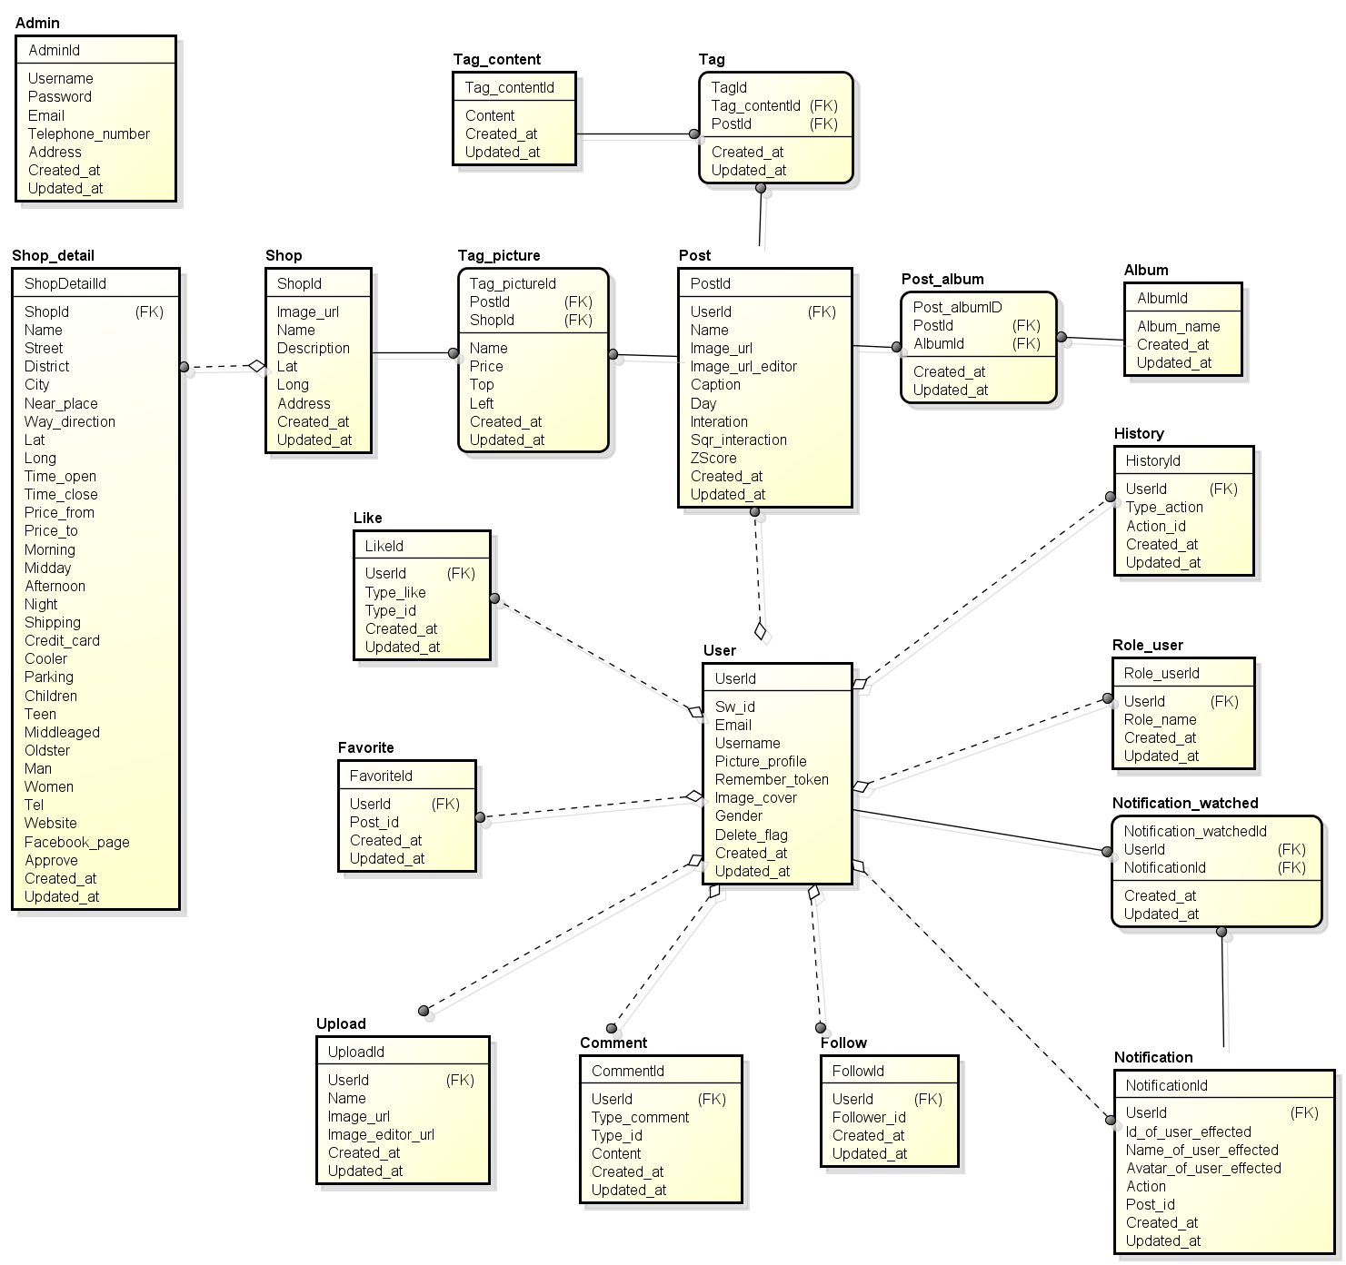

*Figure 3.5.1 Entity Relationship Diagram of Olives*

# **CHAPTER 4: SOFTWARE DESIGN**

## **4.1** **Purpose**

This chapter is to give the developer team a guidance of what the system’s architecture is, and how they should be implemented. This chapter consists of:

* Architecture overview
* Component diagram
* Detailed design
* Detailed description of components
* Database design

## **4.2 Architecture Overview**

### 4.2.1 System Architecture

<TODO: Import system data architecture>

**

*Figure 4.2.1: Olives System Architecture*

### 4.2.2. System Architecture Explanation

The Olives System is divided into 2 sub-systems hosted on Azure cloud services, use one SQL in common:

* Olives system :
  + This sub-system is for ordinary users in the system: guests, doctors and patients. It includes 2 mobile applications and 1 web application and 1 API service.
    - Mobile applications for users who are doctors and patients.
      * These 2 applications are design for 2 specific roles: doctors and owners. They're built by using Objective C and run on iOS devices. These applications help users to be more flexible in using system. Messages and Notifications are sent instantly to bring Real-Time experience.
    - One web application for users of both role.
      * An application which has been built on AngularJS. It helps users interact and consume system services. It can be connected any time, any places by using browsers. Notifications are sent instantly to bring Real-Time experience.
    - API service:
      * A service which is built on ASP.NET Web API 2 framework and hosted on Azure cloud service. It takes responsibility in taking requests come from user applications, connecting to database and processing the received data and respond processed result to user applications.
* Olives administration system:
  + This sub-system is for administrators to manage system. It includes one web application and one API service application.
    - Web application: an application which helps administrators to manage users in system, to track their statuses, to activate/deactivate ordinary users …
    - API Service: A service which is built on ASP.NET Web API 2 framework and hosted on Azure cloud service. It takes responsibility in taking requests come from user applications, connecting to database and processing the received data and respond processed result to user applications.

## **4.3 Architecture Design**

### 4.3.1 Olives Administration sub-system

API

**

|  |  |  |  |
| --- | --- | --- | --- |
| **No** | **Namespace/Directory** | **Description** | **Convention** |
| 1 | Controllers | Contains all controller source files which receive requests come from clients, processs data and return results back to requesters. | xxxController |
| 2 | Interfaces | Contains all interfaces definition files which are inherited by another classes, such as repositories, services, ... | **Ixxx** |
| 3 | Attributes | Contains all validation attributes source file which are used for data validation purposes. | xxxAttribute |
| 4 | Enumerations | Contains enumerations which are used in service. |  |
| 5 | Repositories | Contains classes which is used for access database to process data and return data to controller. Controllers don’t access database directly. | **Repositoryxxx** |
| 7 | Scripts | Contains javascript files which are used in Views. |  |
| 8 | ViewModels | Contains classes which define data structure sent from clients and vice versa. | xxxViewModel |

*Table 4-1: Namespace Explanation*

# **CHAPTER 5: SOFTWARE TESTING DOCUMENTATION**

## **5.1 Introduction**

### 5.1.1 Purpose

The primary purpose of this report is to detect software failures so that defects may be discovered and correct to ensure that our project is thoroughly tested and resulting in a successful implementation of website and iOS application we are developing. It contains the following sections:

* + Scope of Testing.
  + Testing Tool and Environment.
  + Resources and responsibilities.
  + Test strategy: Test approach, test stages.
  + Test schedule.
  + Feature to be tested.
  + Feature not to be tested.
  + Defect Log.
  + Test report.

### 5.1.2 Scope

* Stages of testing:

There are 4 stages in Testing Process: Unit Testing, Integration Testing, System Testing, Acceptance Testing.

|  |  |  |  |
| --- | --- | --- | --- |
| ID | Test stage | Description | The implementation |
| 1 | Unit Testing | - The purpose is to verify the internal logic code by testing every possible branch within the function, also known as test coverage.  - Unit testing will be done by the developer and approved by the development team leader. | Developer:  - Nguyen Duy Linh  - Pham Duc Thang  - Bui Quoc Trong  - Pham Minh Tuan |
| 2 | Integration Testing | Integration testing will be performed by testers. The separate module will be tested together to expose faults in the interfaces and in the interaction between integrated components. | All members:  - Tran Anh Duong  - Pham Duc Thang  - Nguyen Duy Linh  - Nguyen Van Hung  - Bui Quoc Trong  - Pham Minh Tuan |
| 3 | System Testing | System Testing will be performed by the tester and development team leader with assistance from the individual developers as required. No specific test tools are available for this project. Programs will enter into System/Integration test after all critical defects have been corrected. |
| 4 | Acceptance Testing | Acceptance testing consist of Alpha Test and Beta Test will be executed by all team members, stand at end user point of view. Determine whether a system satisfies the requirements specified in the requirements analysis phase. Finding defects is not the main focus in this stage.  Acceptance testing will assess the system’s readiness for deployment and using. | All members and some students at FPT University. |

* Types of testing:

The test team has to test the following type on Google Chrome and Olives application (iOS application):

* GUI test
* Function test
* Performance test
* Regression test
* Acceptance test
* Range of testing:

Team performs all functions defined in the SRS based on the approved version.

## **5.2 Test Plan**

### 5.2.1 Tool and Environment

5.2.1.1 Tool Testing

Google Chrome 

*Figure 5.2.1.1.1: Google Chrome*

HostedRedmine v1.4: Log bug. ([www.hostedredmine.com](http://www.hostedredmine.com))



*Figure 5.2.1.1.2: HostedRedmine*

5.2.1.2 Tool Environment

The contents of the Testing Environment is shown in the table below:

|  |  |
| --- | --- |
| **Software** | **Hardware** |
| Testing environment consist:  Google Chrome v42.0. | Personal computer for developing with the minimum configuration:  Windows 8 Professional 64-bit, SP 1  Inter® Core™ i5.  Install memory (RAM): 6.00GB. |
| iOS 9.3.2 | iPhone 6  CPU: [Apple A8](https://www.thegioididong.com/tin-tuc/tim-hieu-ve-chip-xu-ly-danh-cho-di-dong-cua-apple-592848#applea8) 1.4 GHz dual-core 64-bit  RAM:1 GB |

### 5.2.2 Resources and responsibilities

This table shows the staffing assumptions for our project:

|  |  |  |
| --- | --- | --- |
| **ID** | **Resources** | **Responsibilities** |
| 1 | Project Manager | Responsible for Project Schedules and overall success of the project.  Review Test-case and report. |
| 2 | Tester | Preforming the actual system testing.  Manage test resource and assign test tasks.  Create Test Plan.  Create Test Cases.  Create Test Report.  Execute Test.  Test Log report. |
| 3 | Developer | Create Unit Test.  Test API.  Fix bugs. |

*Table 5.2.2.1 : Resources and responsibilities*

### 5.2.3 Test strategy

5.2.3.1 Test model

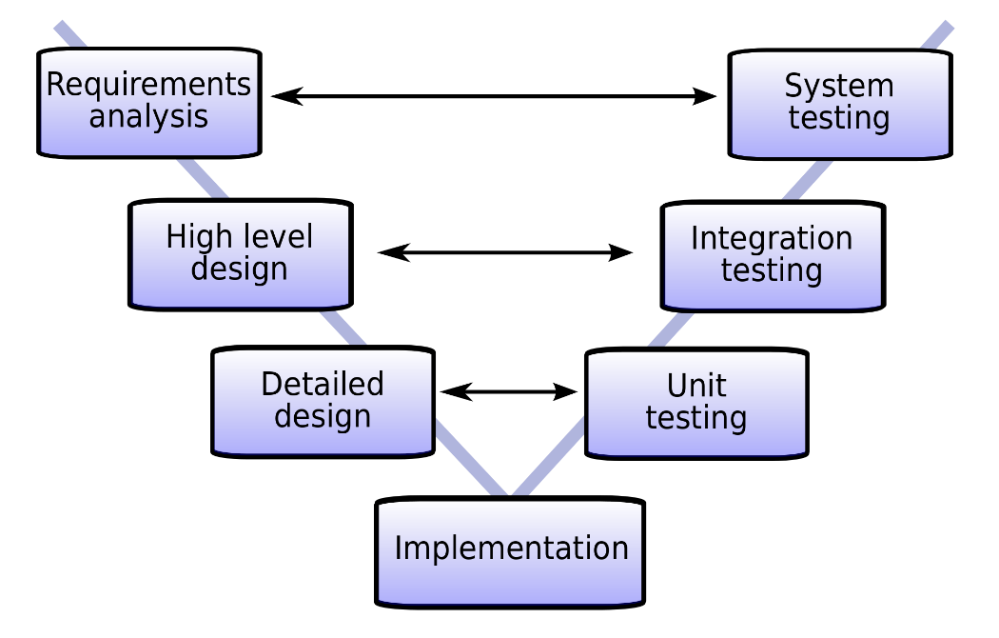

*Figure 5.2.3.1.1 V-model*

This project follows V-Model process to implement testing. The V model takes the bottom half of the waterfall model and bends it upward into the form of a V, so that the activities on the right verify or validate the work products of the activity on the left. Below figure demonstrates the relationships between each phase of the development life cycle and its associated phase of testing.

More specifically, the left side of the V represents the analysis activities that decompose the users’ needs into small, manageable pieces, while the right side of the V shows the corresponding synthesis activities that aggregate (and test) these pieces into a system that need system that meets the users’ needs.

The V-Model demonstrates the relationships between each phase of the development life cycle and its associated phase of testing. The horizontal and vertical axes represent time or project completeness (left-to-right) and level of abstraction. Advances in the production of executable requirements, architectures, and designs enable testing to begin much earlier on the left side of the V so that requirements, architecture, and design defects can be found and fixed early before they can propagate into downstream work products.

5.2.3.2 Test model

Testing Olives project will be carrying out in each release package as defined in project plan and depends on internal delivery by development side. Critical test will be defined as any new or modified test for the Olives system. Project Manager will decide which closed defects which the test team cannot determine.

The different types of testing that will be carry out this project are.

* **Function Test:**

Testing of all implemented functions on the Olives system.

The testing that will be covered for those functions in function test is verification the validation of the behavior according to requirements.

Test cases will have to be designed to cover all the above and executed.

Implemented function’s error message will be included under this test.

* **GUI Test**
  + - Graphical User Interface (GUI) Testing verifies a user’s interaction with the software. The goal of GUI testing is to ensure that the GUI provides the user with the appropriate access and navigation through the functions of the target-of-test. In addition, GUI testing ensures that the objects within the GUI function as expected and conform to requirement.
    - GUI test will be performed fully on all screens.
    - This test is targeted to cover the verification of the overall look and feel of the Olives system including initial position, font, text size, color, focus, initial button, tab order, label, screen sizes and sentences width.
    - Check all the GUI elements for size, position, width, length and acceptance of characters or numbers. For instance, it must be able to provide inputs to the input fields.
* Check Error Messages are displayed correctly.
* Check Font used in application is readable.
* Check the alignment of the text is proper.
* Check the Color of the font and warning messages is aesthetically pleasing.
* Check that the images have good clarity.
* Check that the images are properly aligned.
* Check the positioning of GUI elements for different screen resolution.
* **Performance Test:**

The testing that will be covered for response time for Olives system.

* **Regression test:**

The testing is confirmed that the bug was removed including the extent of the impact.

* **Acceptance test:**

The testing is a test conducted to determine if the requirements of a specification or contract are met.

It involves alpha testing and beta testing. Alpha testing takes place at developers' sites, and involves testing of the operational system by internal member, before it is released to external users. Beta testing takes place at user’s sites, and involves testing by a group of users who use the system at their own locations and provide feedback, before the system is released to all users.

5.2.3.3 Test stage

Table below are the stages in which common test are executed:

|  |  |  |  |
| --- | --- | --- | --- |
| **Type of Tests** | **Stage of Test** | | |
| **Unit** | **Integration** | **System** |
| Function Tests | **√** | **√** | **√** |
| API Tests | **√** | **√** | **√** |
| GUI Tests |  | **√** | **√** |
| Regression Tests |  | **√** | **√** |
| Performance Tests |  |  | **√** |
| Acceptance Tests |  |  | **√** |

5.2.3.4 Test Schedule

Table below are the Test Schedule for Olives Project. That consist of 4 phases:

|  |  |  |
| --- | --- | --- |
| **Test Schedule** | **Start Date** | **End Date** |
| Create Test Plan document | 20/5/2016 | 23/5/2016 |
| Create System Test case | 23/5/2016 | 25/6/2016 |
| Review System Test case | 25/6/2016 | 27/6/2016 |
| Update System Test case | 4/7/2016 | 29/7/2016 |
| Execute System Test | 1/8/2016 | 15/8/2016 |
| Verify bug fixed | 15/8/2016 | 24/8/2016 |

5.2.3.5 Deliverables

Table below are the Deliverables for Olives Project:

|  |  |  |
| --- | --- | --- |
| Deliverables | Responsibilities | Completion date |
| Test Plan | Tester | 22/8/2016 |
| Test Cases | Tester | 22/8/2016 |
| Test case review | Tester + PM | 22/8/2016 |
| Test Data (Data Set) | Tester | 22/8/2016 |
| Defect report | All members | 22/8/2016 |
| Final test Summary report | PM | 22/8/2016 |

*Table 5.2.3.5.1: Deliverables*

## **5.3 Test Approach**

### 5.3.1 Integration and System Test

The detailed Test case will be described in TestCase_Final.xlsx

### 5.3.2 Acceptance Test

* Build website to host with domain name is
* Invite friends use and comment.
* Fix bug arising when people use.

### 5.3.3 Defect Log

* Olives project used [www.hostedredmine.com](http://www.hostedredmine.com) to manager bug list.
* Every member of Olives project created an account in [www.hostedredmine.com](http://www.hostedredmine.com) to get bug and fix bug.
* Processes:
* Tester log bug to hostedredmine.com with status “Assigned” and assign developer.
* Developer fix bug and change status bug in hostedredmine.com to “Resolved” and assign tester who log bug.
* Tester check bug again:
* If bug fixed, check relating test case and Tester change status to “Closed”.
* If bug didn’t fix, Tester change status to “Open” and assign again developer.

**5.4 Test Report**

* **Test coverage**: ([number of test cases pass] + [number of test cases Fail] ) / ([number of test cases] - [number of test cases N/A]).
* **Test successful coverage:** [number of test cases pass] / ([number of test cases] - [number of test cases N/A]).

Version 1.0

Phase 1:

* Admin Website Application

|  |  |  |  |  |  |  |
| --- | --- | --- | --- | --- | --- | --- |
| **No** | **Module Test** | **Pass** | **Fail** | **Untested** | **N/A** | **Number of test cases** |
| 1 | Login | 15 | 0 | 0 | 0 | 15 |
| 2 | Home | 6 | 0 | 0 | 0 | 6 |
| 3 | Request | 16 | 1 | 0 | 0 | 17 |
| 4 | Doctor | 22 | 3 | 0 | 0 | 25 |
| 5 | Patient | 25 | 0 | 0 | 0 | 25 |
| 6 | Place | 18 | 9 | 0 | 0 | 27 |
| 7 | Category | 15 | 5 | 0 | 0 | 20 |
|  | **Sub total** | 117 | 18 | 0 | 0 | 135 |
|  | **Test coverage:** |  |  |  |  |  |
|  | **Test successful coverage** |  |  |  |  |  |

**DETECTION: 18 bug**

* Olives Website Application

+ Doctor website

|  |  |  |  |  |  |  |
| --- | --- | --- | --- | --- | --- | --- |
| **No** | **Module Test** | **Pass** | **Fail** | **Untested** | **N/A** | **Number of test cases** |
| 1 | Login |  |  |  |  |  |
| 2 | Home |  |  |  |  |  |
| 3 | Notification |  |  |  |  |  |
| 4 | Find Doctors |  |  |  |  |  |
| 5 | My Doctors |  |  |  |  |  |
| 6 | Message |  |  |  |  |  |
| 7 | Medical Record |  |  |  |  |  |
| 8 | Appointment |  |  |  |  |  |
| 9 | Prescription |  |  |  |  |  |
| 10 | My Stats |  |  |  |  |  |
| 11 | Profile |  |  |  |  |  |
|  | **Sub total** |  |  |  |  |  |
|  | **Test coverage:** |  |  |  |  |  |
|  | **Test successful coverage** |  |  |  |  |  |

+ Patient website

|  |  |  |  |  |  |  |
| --- | --- | --- | --- | --- | --- | --- |
| **No** | **Module Test** | **Pass** | **Fail** | **Untested** | **N/A** | **Number of test cases** |
| 1 | Login |  |  |  |  |  |
| 2 | Home |  |  |  |  |  |
| 3 | Notification |  |  |  |  |  |
| 4 | Find Doctors |  |  |  |  |  |
| 5 | My Doctors |  |  |  |  |  |
| 6 | Message |  |  |  |  |  |
| 7 | Medical Record |  |  |  |  |  |
| 8 | Appointment |  |  |  |  |  |
| 9 | Prescription |  |  |  |  |  |
| 10 | My Stats |  |  |  |  |  |
| 11 | Profile |  |  |  |  |  |
|  | **Sub total** |  |  |  |  |  |
|  | **Test coverage:** |  |  |  |  |  |
|  | **Test successful coverage** |  |  |  |  |  |

* Doctor Application

|  |  |  |  |  |  |  |
| --- | --- | --- | --- | --- | --- | --- |
| **No** | **Module Test** | **Pass** | **Fail** | **Untested** | **N/A** | **Number of test cases** |
| 1 | Login |  |  |  |  |  |
| 2 | Home |  |  |  |  |  |
| 3 | Notification |  |  |  |  |  |
| 4 | Find Doctors |  |  |  |  |  |
| 5 | My Doctors |  |  |  |  |  |
| 6 | Message |  |  |  |  |  |
| 7 | Medical Record |  |  |  |  |  |
| 8 | Appointment |  |  |  |  |  |
| 9 | Prescription |  |  |  |  |  |
| 10 | My Stats |  |  |  |  |  |
| 11 | Profile |  |  |  |  |  |
|  | **Sub total** |  |  |  |  |  |
|  | **Test coverage:** |  |  |  |  |  |
|  | **Test successful coverage** |  |  |  |  |  |

* Patient Application

|  |  |  |  |  |  |  |
| --- | --- | --- | --- | --- | --- | --- |
| **No** | **Module Test** | **Pass** | **Fail** | **Untested** | **N/A** | **Number of test cases** |
| 1 | Login | 49 | 24 | 0 | 3 | 76 |
| 2 | Home | 40 | 2 | 0 | 0 | 42 |
| 3 | Notification | 6 | 10 | 0 | 0 | 16 |
| 4 | Find Doctors | 72 | 8 | 0 | 0 | 80 |
| 5 | My Doctors | 27 | 0 | 0 | 0 | 27 |
| 6 | Message | 14 | 1 | 0 | 0 | 15 |
| 7 | Medical Record | 67 | 10 | 0 | 0 | 77 |
| 8 | Appointment | 70 | 13 | 0 | 0 | 83 |
| 9 | Prescription | 50 | 16 | 0 | 0 | 66 |
| 10 | My Stats | 200 | 63 | 0 | 0 | 263 |
| 11 | Profile | 80 | 28 | 0 | 0 | 108 |
|  | **Sub total** | 675 | 175 | 0 | 3 | 853 |
|  | **Test coverage:** |  |  |  |  |  |
|  | **Test successful coverage** |  |  |  |  |  |

Phase 2:

|  |  |  |  |  |  |  |
| --- | --- | --- | --- | --- | --- | --- |
| **No** | **Module Test** | **Pass** | **Fail** | **Untested** | **N/A** | **Number of test cases** |
|  |  |  |  |  |  |  |
|  |  |  |  |  |  |  |
|  |  |  |  |  |  |  |
|  |  |  |  |  |  |  |
|  |  |  |  |  |  |  |
|  |  |  |  |  |  |  |
|  |  |  |  |  |  |  |
|  |  |  |  |  |  |  |
|  |  |  |  |  |  |  |
|  |  |  |  |  |  |  |
|  |  |  |  |  |  |  |
|  |  |  |  |  |  |  |
|  | **Sub total** |  |  |  |  |  |
|  | **Test coverage** |  |  |  |  |  |
|  | **Test successful coverage** |  |  |  |  |  |

**FIXED:**

Version 10.0

Version is building on host domain trendyplus.org

When people detect error of system, they can comment and inform to team Olives

**Then:** Olives received 2 leakages from end user, and fixed it.

Bug list report

# **CHAPTER 6: INSTALLATION GUIDE & USER MANUAL**

## **6.1 Purpose**

The purpose of this chapter is:

* Describe the steps to deploy the website and database server to a new system.
* Guide users through the website’s features.

## **6.2**

## **6.3 User Guidelines**

### Admin website application

* + - 1. 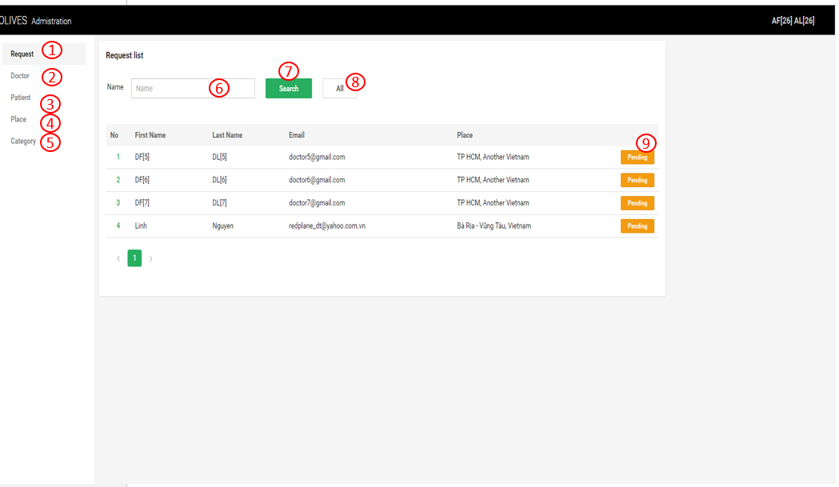**Request screen**

1. Show all request from doctor
2. Show all doctor
3. Show all patient
4. Show all place
5. Show all medical record category
6. User fill request name
7. Search request
8. List all request
9. Change status (Pending/Active/Disable)
   * + 1. **Doctor screen**

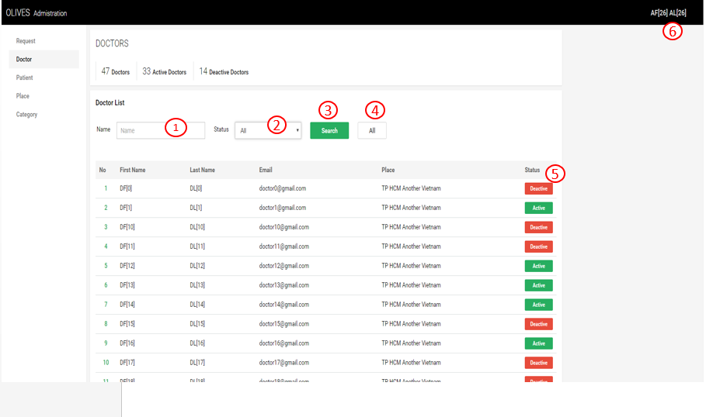

1. User fill doctor’s name
2. Search by status (Active/De-active)
3. Search button
4. List all doctor
5. Change doctor status (Active/De-active)
   * + 1. **Patient screen**

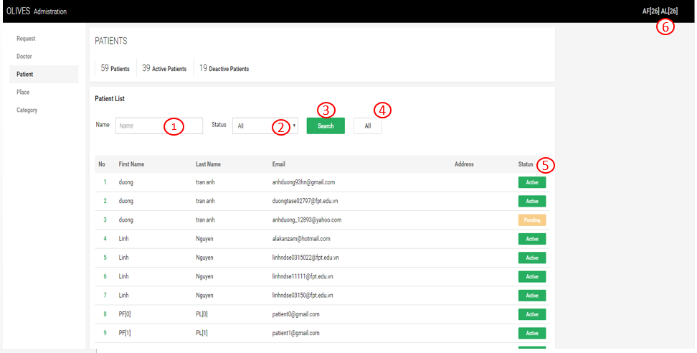

1. User fill patient’s name
2. Search by status (Active/De-active)
3. Search button
4. list all patient
5. Change patient status (Active/De-active)
6. Log out button
   * + 1. **Place screen**

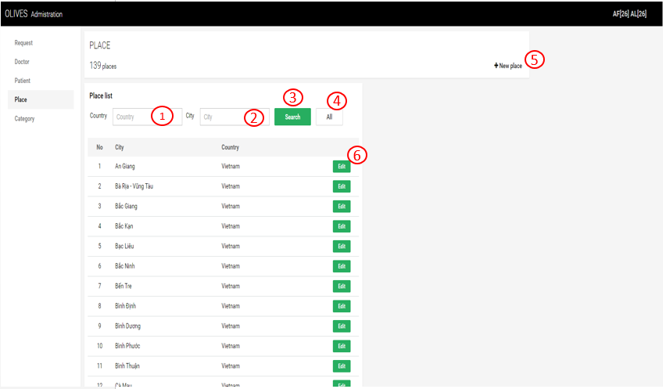

1. Search place by country
2. Search place by city
3. Search button
4. list all country
5. Add a new place
6. Edit place
   * + 1. **Category screen**

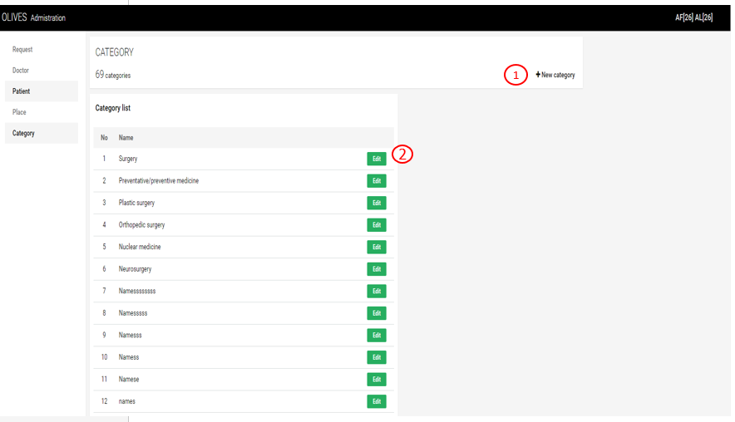

1. Add a new medical record category
2. Edit medical record category

### Olives website application

6.3.2.1 Patient website

**6.3.2.1.1 Login**

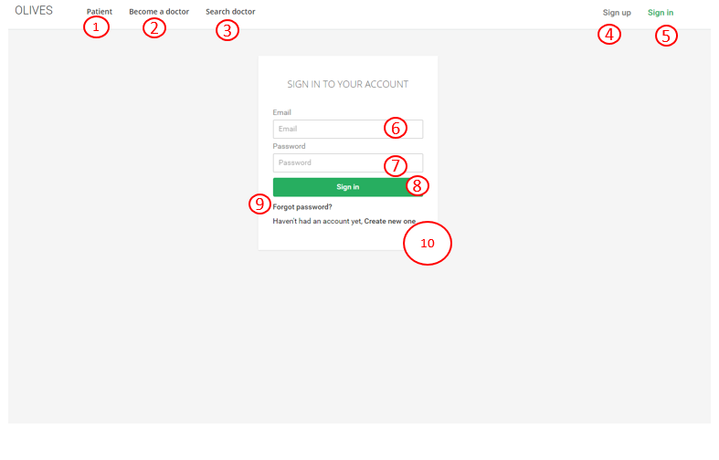

1. Introduction to patient
2. Introduction to doctor
3. Guest can search doctor
4. Create account
5. Go to log in page
6. Fill your email
7. Fill your textbox
8. Login to page
9. Password recovery
10. Create new account

**6.3.2.1.2 Register**

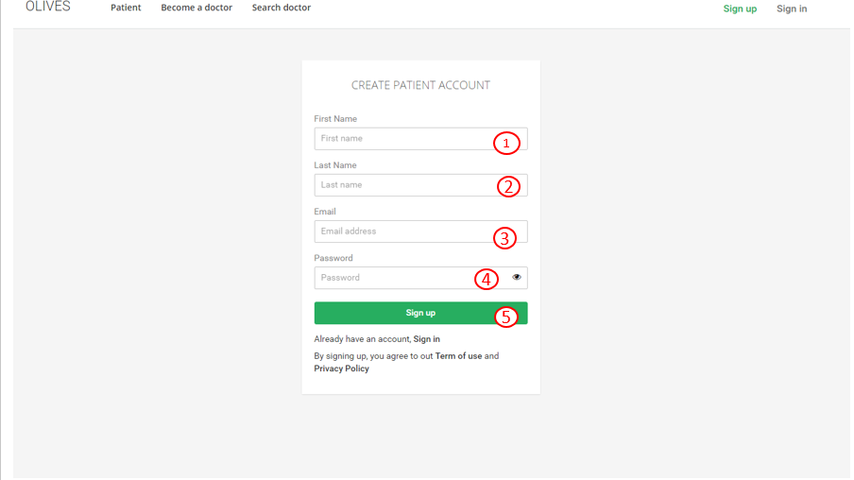

1. Fill your first name
2. Fill your last name
3. Fill your email
4. Fill your password
5. Create account

**6.3.2.1.3 Change password**

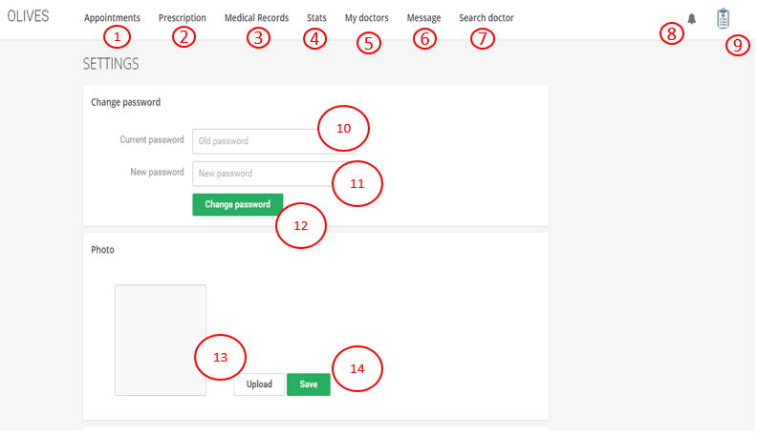

1. View appointment
2. View prescription
3. View medical record
4. View stats
5. View my doctors
6. View message and chat
7. user can search doctor
8. View notification
9. Setting and profile
10. Fill old password
11. Fill newpassword
12. Upload photo
13. Save photo

**6.3.2.1.4 Forgot password**

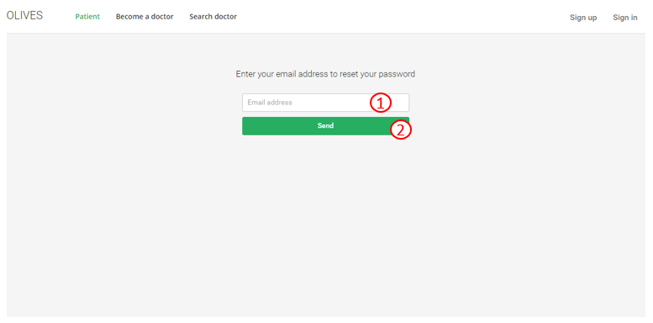

1. Fill your email
2. Send new password to your email

**6.3.2.1.5 Search doctor**

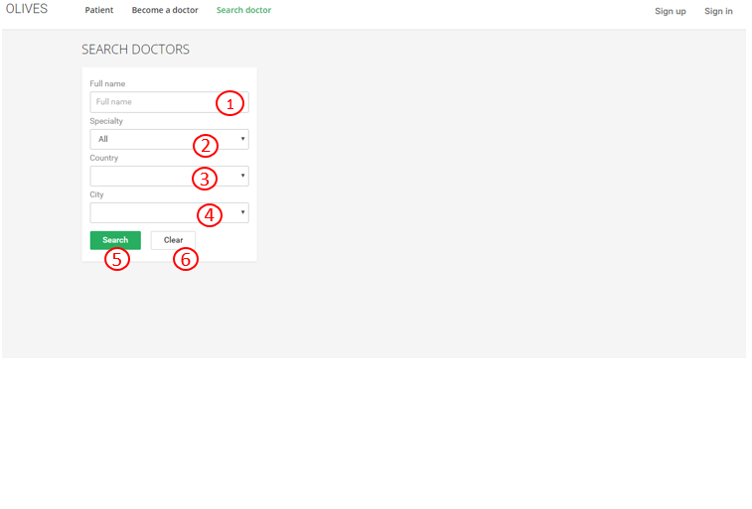

1. Fill doctor’s name
2. Select a specialty
3. Select country
4. Select city
5. Search doctor
6. Clear information

**6.3.2.1.6 View notification**

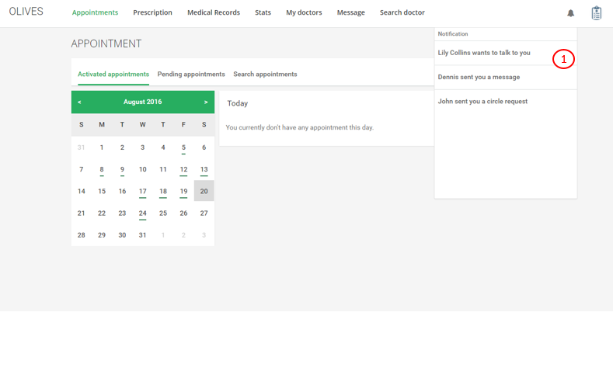

1. Click to check notification

**6.3.2.1.7 View appointment**

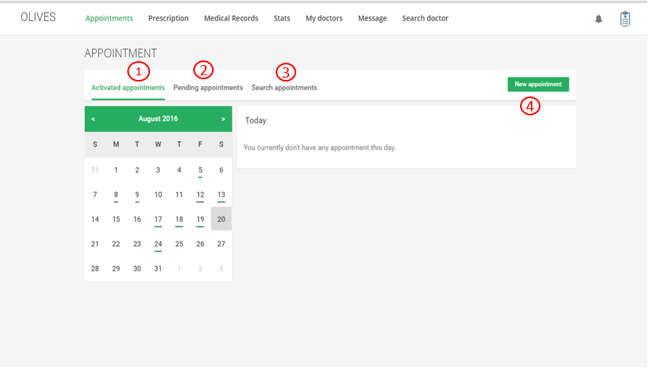

1. View active appointment
2. View pending appointment
3. Search appointment
4. Create new appointment

**6.3.2.1.8 Accept appointment**

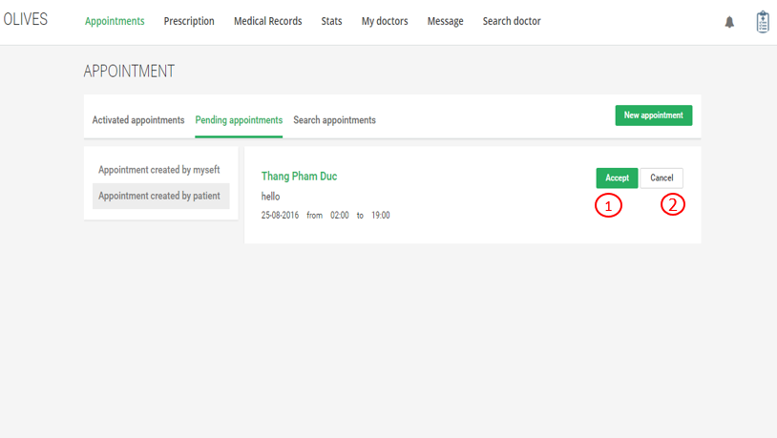

1. Accept appointment
2. Cancel appointment

**6.3.2.1.9 Cancel appointment**

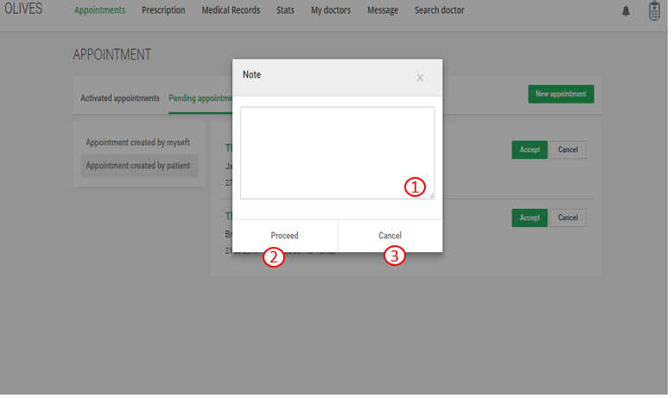

1. Enter your reason
2. Cancel appointment
3. Cancel and back to pending appointment page

**6.3.2.1.10 Add appointment**

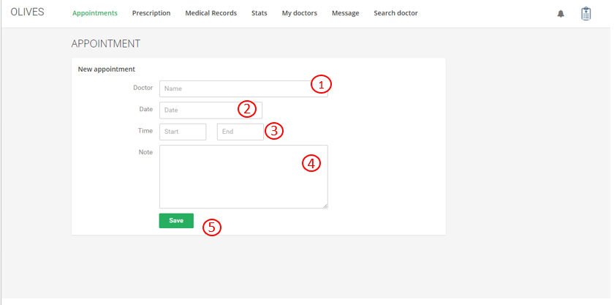

1. Enter doctor’s name
2. Select date
3. Select time
4. Fill note
5. Save information

**6.3.2.1.11 View prescription**

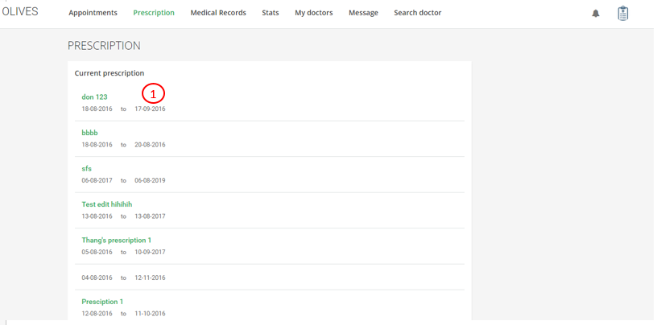

1. Click to view prescription detail

**6.3.2.1.12 Edit prescription**

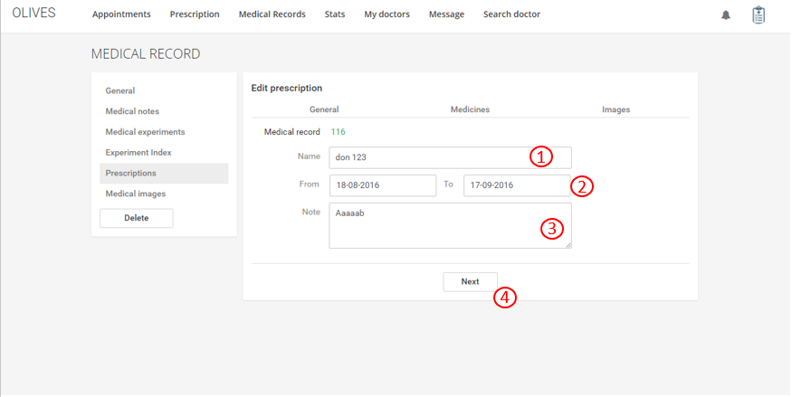

1. Edit prescription name
2. Select time
3. Fill note
4. Next to medicines and images

**6.3.2.1.13 Delete prescription**

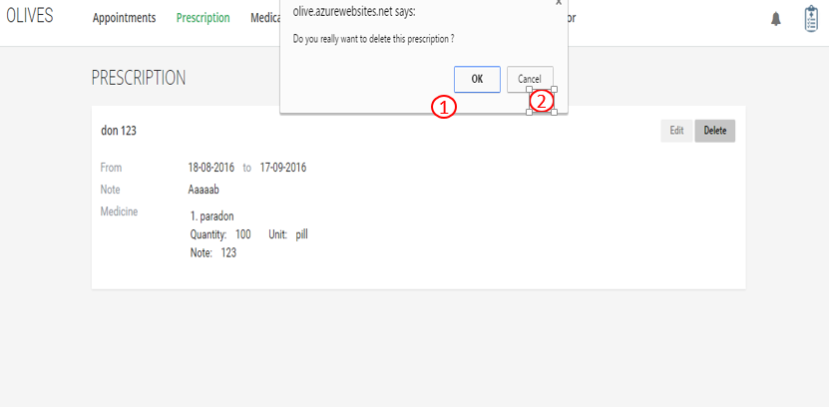

1. Click to delete this prescription
2. Cancel

**6.3.2.1.14 Create prescription**

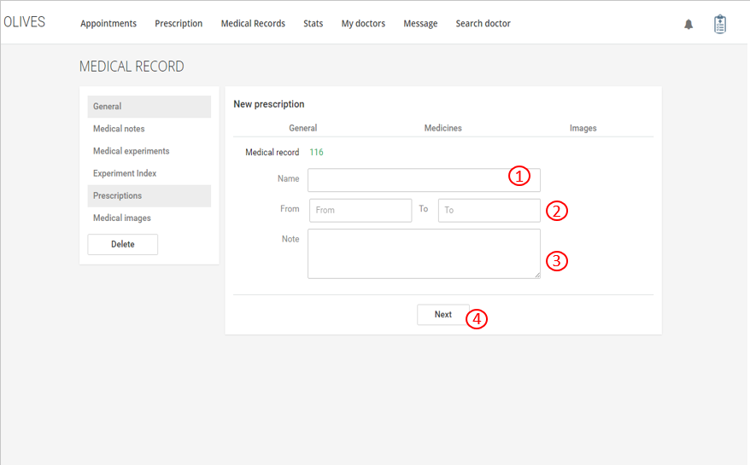

1. Fill user name
2. Select time
3. Fill note
4. Next to medicine and images

**6.3.2.1.15 View profile**

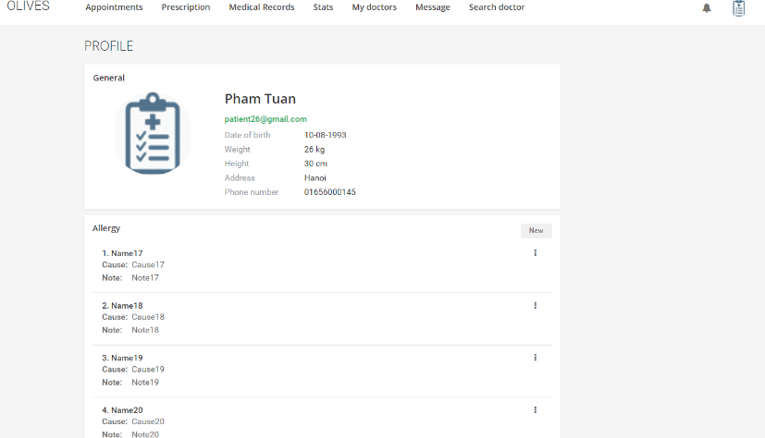

**6.3.2.1.16 Edit profile**

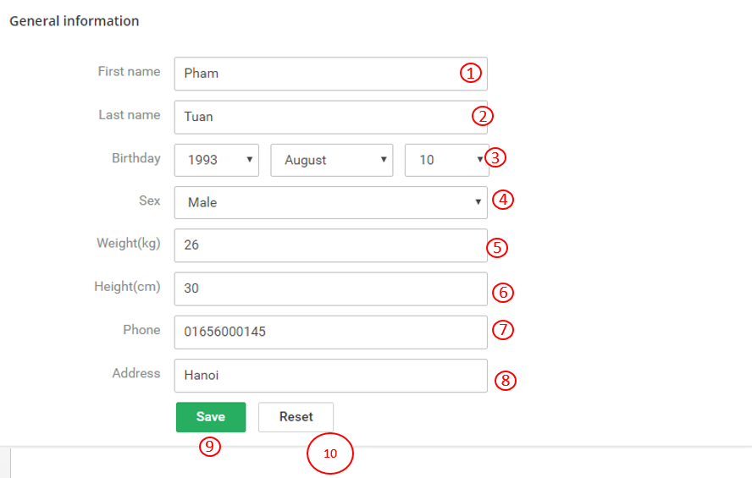

1. Edit first name
2. Edit last name
3. Edit birthday
4. Edit sex
5. Edit weight
6. Edit height
7. Edit phone
8. Edit address
9. Save button: Save information
10. Reset button: Clear information

**6.3.2.1.17 View stats**

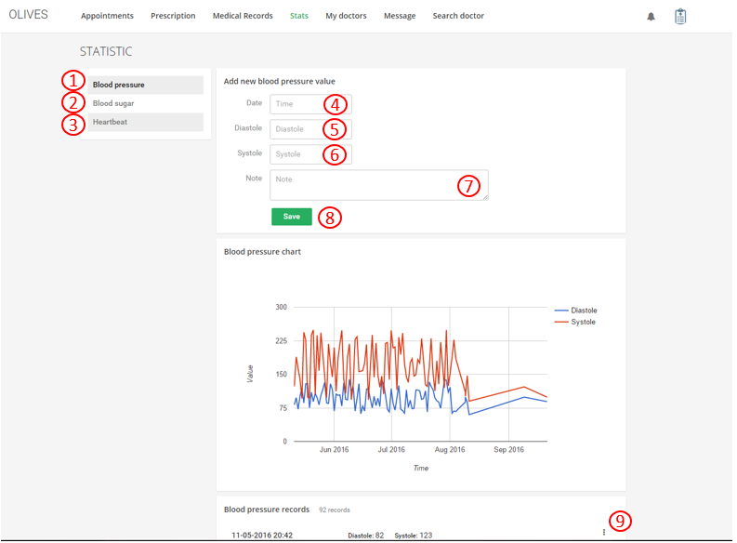

1. View Blood pressure stats
2. View Blood sugar stats
3. View Heartbeat stats
4. Select time
5. Enter Diastole
6. Enter Systole
7. Enter note
8. Save information
9. Edit, delete stats

**6.3.2.1.18 Medical record**

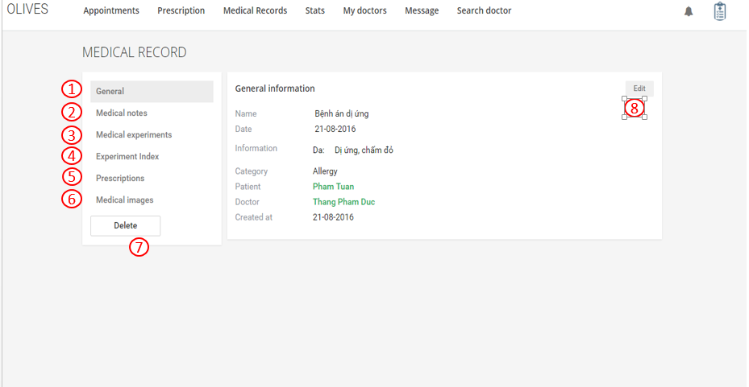

1. View General information
2. View medical note
3. View medical experiments
4. View Experiment index
5. View Prescription
6. View medical images
7. Delete this medical record
8. Edit this medical record

**6.3.2.1.19 Medical note**

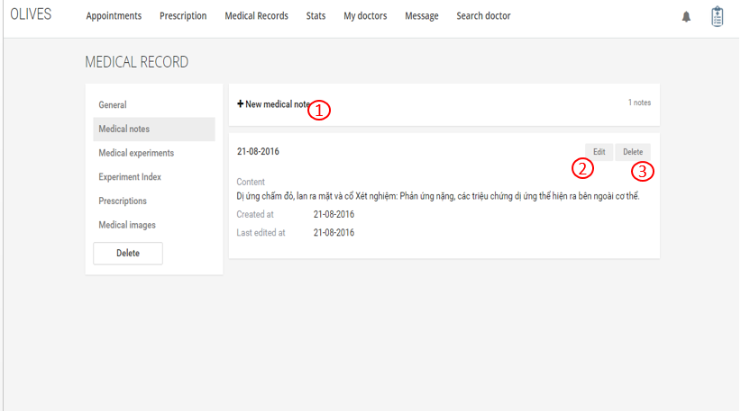

1. Create new medical note
2. Edit this medical note
3. Delete this medical note

**6.3.2.1.20 Medical experiment**

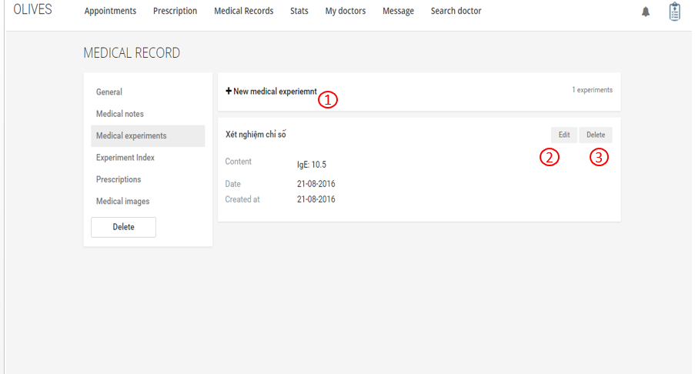

1. Create new medical experiment
2. Edit this medical experiment
3. Delete this medical experiment

**6.3.2.1.21 Experiment index**

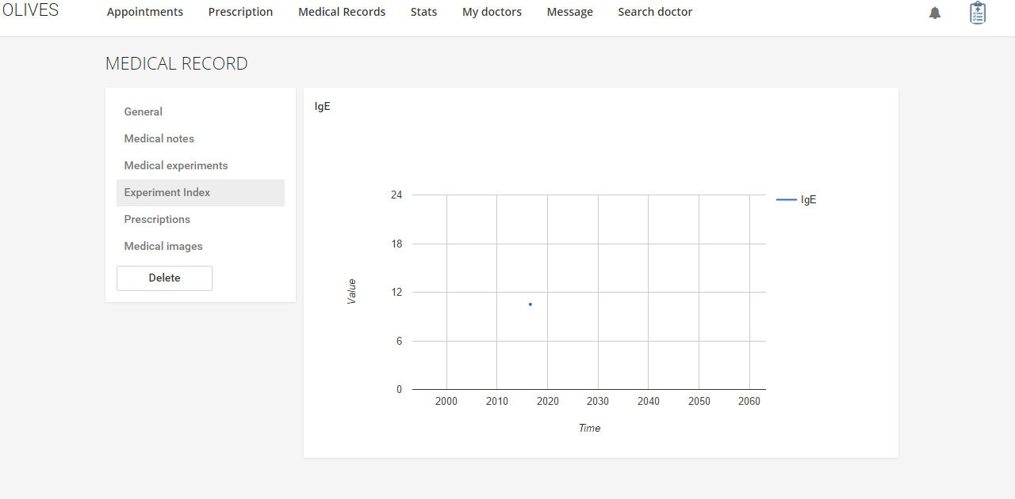

**6.3.2.1.22 Prescription in medical record**

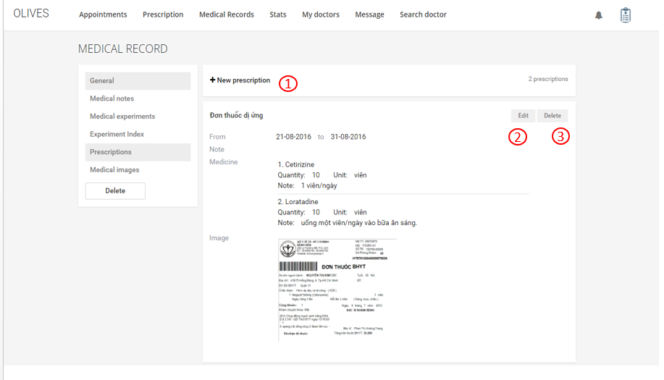

1. Create new prescription
2. Edit this prescription
3. Delete this prescription

**6.3.2.1.23 Medical Images**

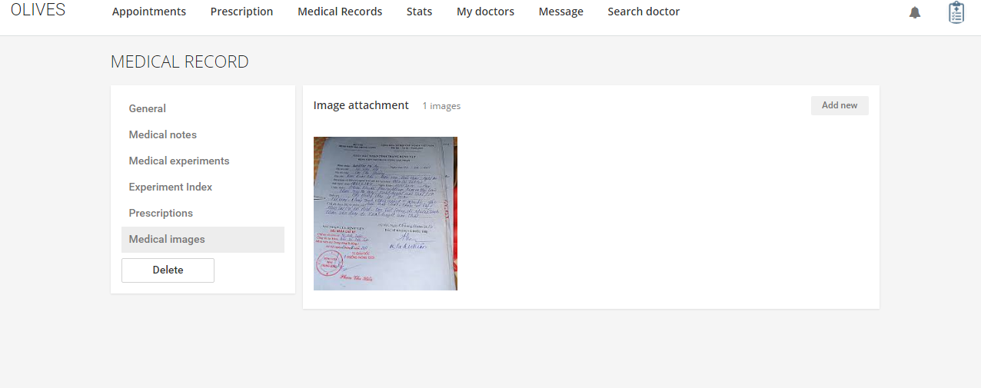

**6.3.2.1.24 My doctors**

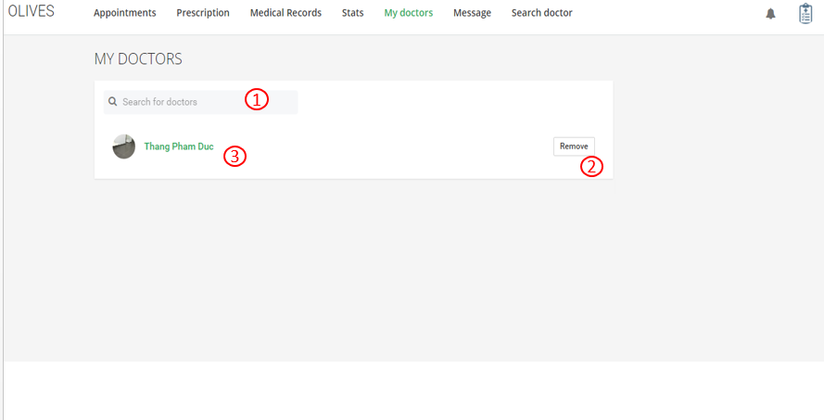

1. Search doctor by name
2. Remove this doctor
3. View doctor’s profile

6.3.2.2 Doctor website

**6.3.2.2.1 Appointment**

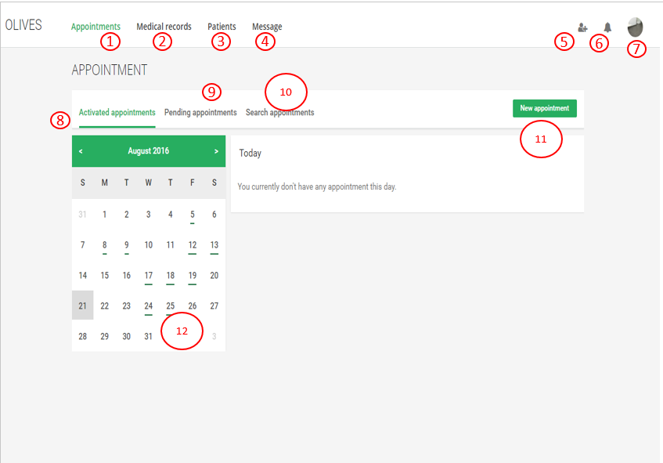

1. View appointment
2. View medical record
3. View patients
4. View message
5. View patient’s request
6. View notification
7. View profile and setting
8. View activated appointment
9. View pending appointments
10. Search appointment
11. Create new appointment
12. Click to edit appointment

**6.3.2.2.2 Accept/Cancel appointment**

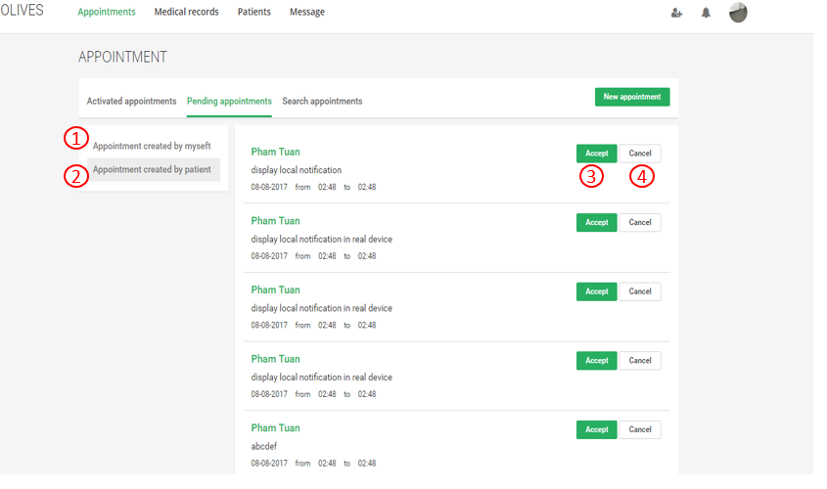

1. View appointment created by myseft
2. View appointment created by patient
3. Accept appointment
4. Cancel appointment

**6.3.2.2.3 Create appointment**

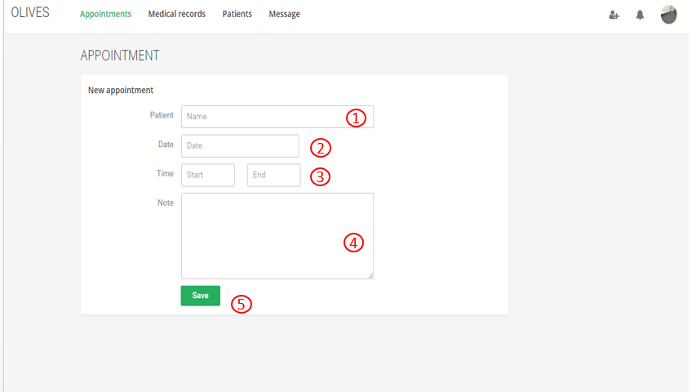

1. Fill patient’s name
2. Select date
3. Select time
4. Fill note
5. Save information

**6.3.2.2.4 View medical record**

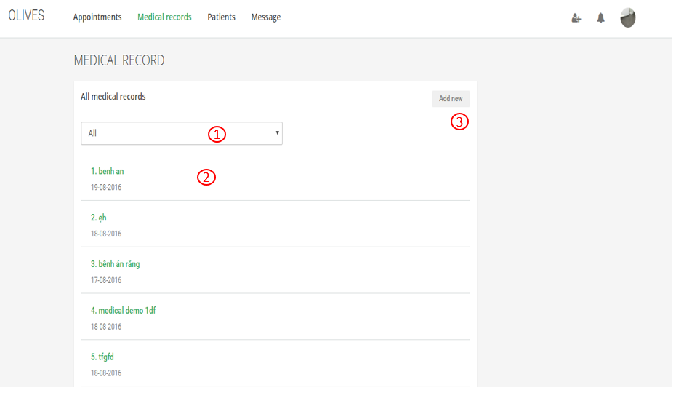

1. Select medical category
2. Add new medical record
3. View medical record detail and edit

**6.3.2.2.5 Edit medical record**

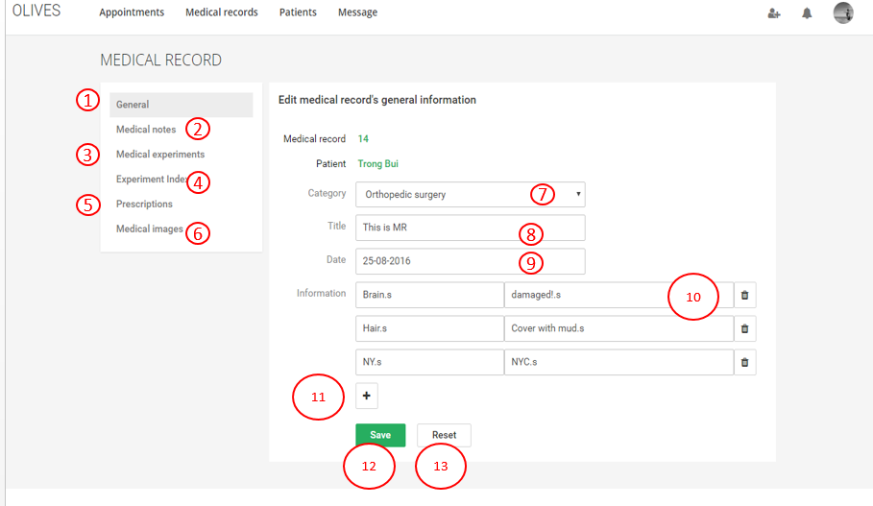

1. View general information
2. View medical notes
3. Medical experiments
4. View experiment index
5. View prescriptions
6. View medical images
7. Edit medical category
8. Edit title
9. Edit date
10. Edit information
11. Add information
12. Save information
13. Reset information

**6.3.2.2.6 Medical note**

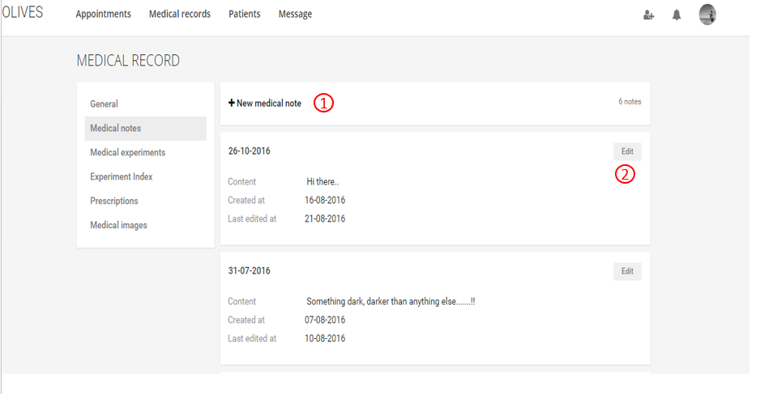

1. Create new medical note
2. Edit medical note

**6.3.2.2.7 Medical experiment**

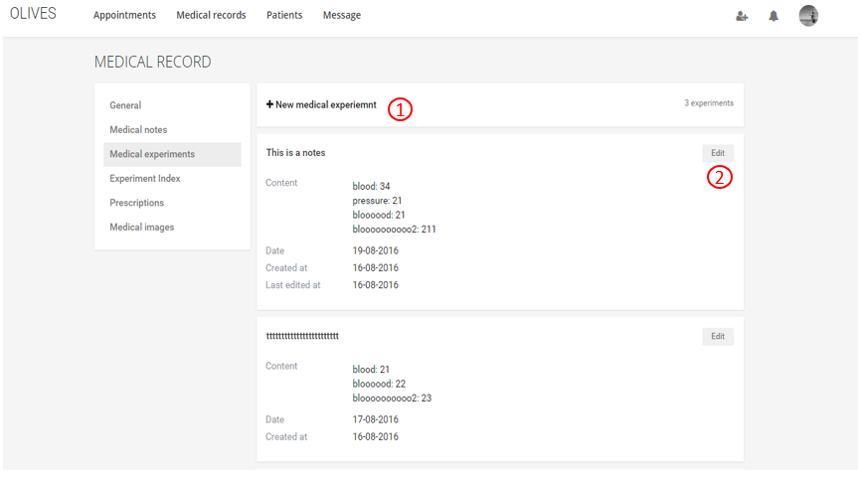

1. Create new medical experiment
2. Edit medical experiment

**6.3.2.2.8 Experiment index**

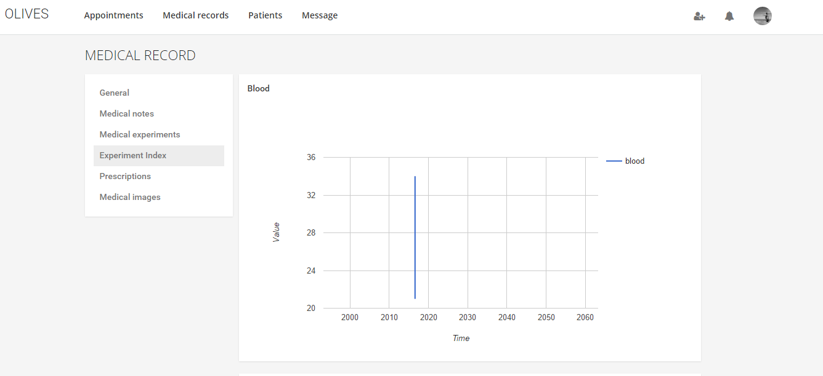

**6.3.2.2.9 Prescription in medical record**

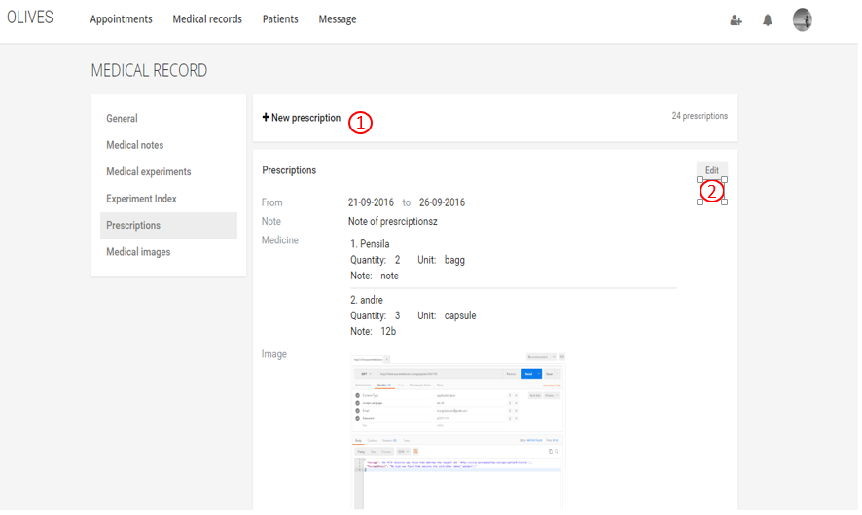

1. Create new prescription
2. Edit prescription

**6.3.2.2.10 Medical images**

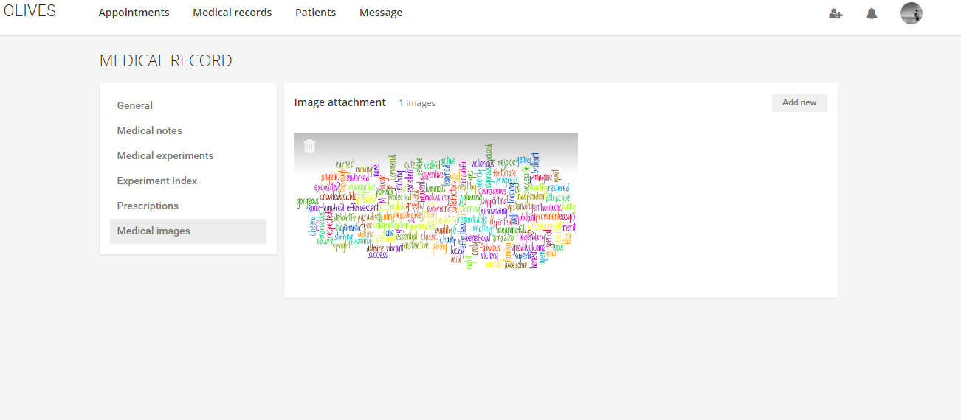

**6.3.2.2.11 Patients**

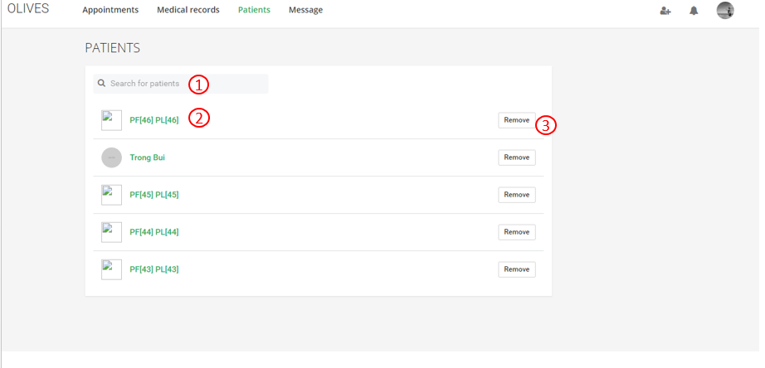

1. Search patient
2. View patient’s profile
3. Remove patient

**6.3.2.2.12 Chat**

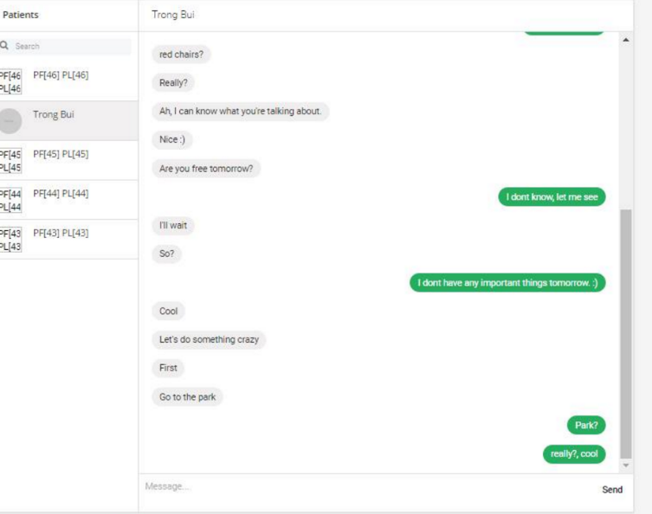

**6.3.2.2.13 View and edit profile**

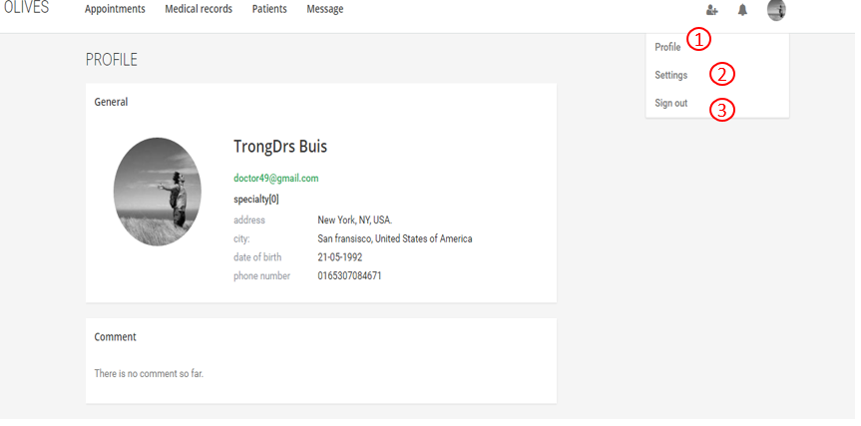

1. View and edit profile
2. Setting
3. Log out

**6.3.2.2.14 Change password**

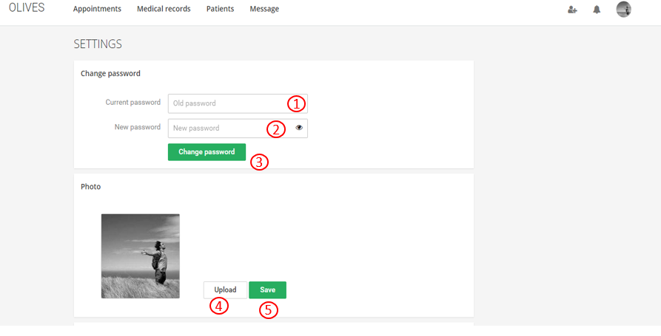

1. Fill old password
2. Fill new password
3. Change password
4. Upload avatar
5. Save avatar

**6.3.2.2.15 Login**

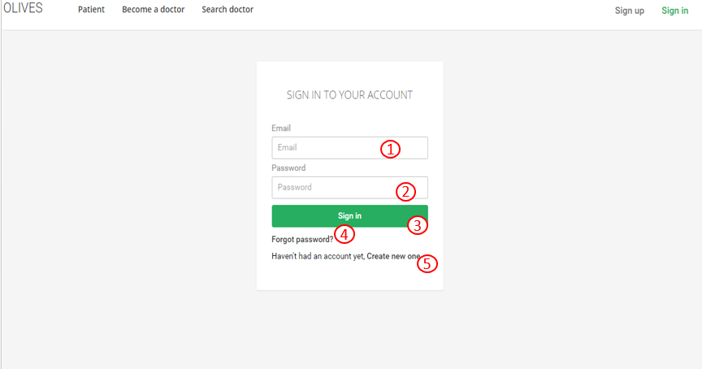

1. Fill email
2. Fill password
3. Sign in
4. Forgot password
5. Create new account

### Doctor application

* + - 1. Login screen

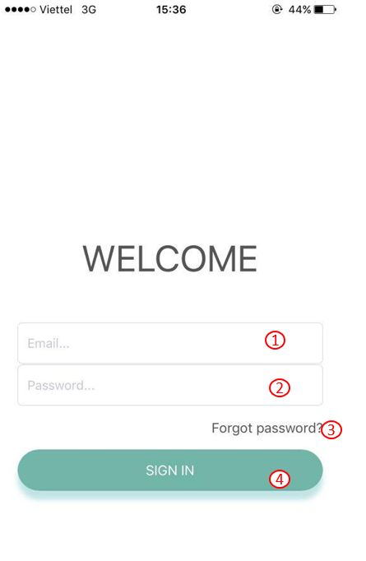

1. Fill email
2. Fill password
3. If forgot password, click here to recovery
4. Login to application
   * + 1. Home screen

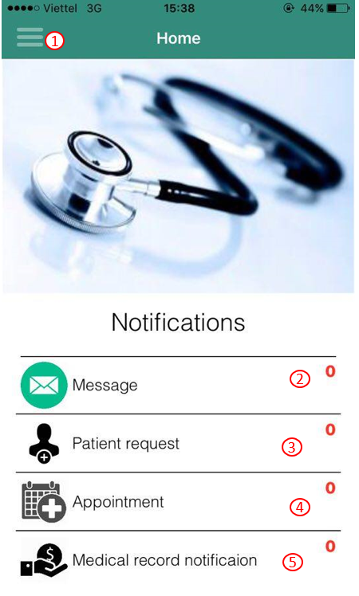

1. Show menu tab
2. Show notification of message
3. Show notification of patient request
4. Show notification of appointment
5. Show notification of medical record
   * + 1. Appointment screen

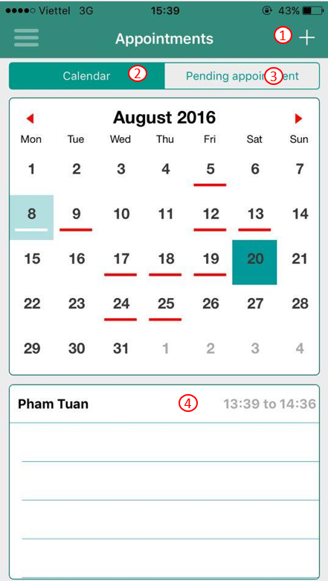

1. Add appointment
2. Calendar and actived appointment
3. Pending appointment
4. Tab to edit this appointment
   * + 1. Add appointment screen

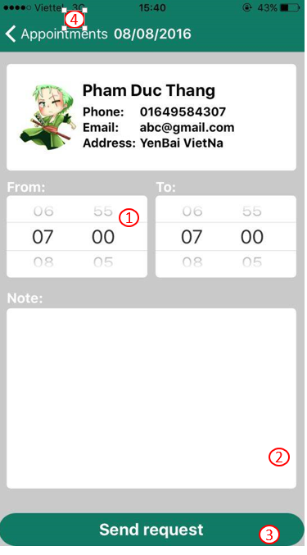

1. Back to appointment screen
2. Fill note
3. Send request to patient
4. Back to appointment screen
   * + 1. Change password

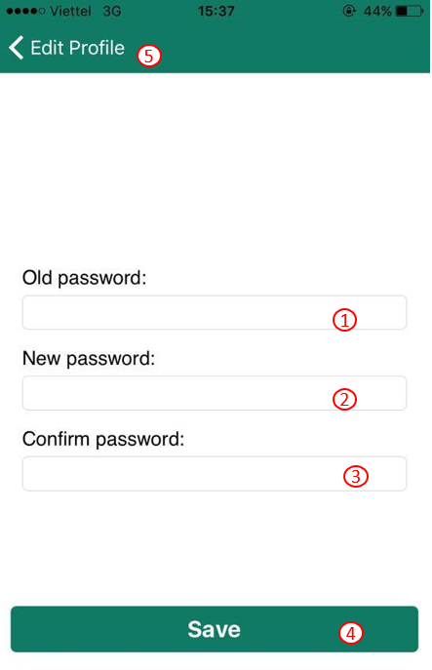

1. Fill old password
2. Fill new password
3. Confirm password
4. Save information
5. Back to edit profile screen
   * + 1. Edit profile screen

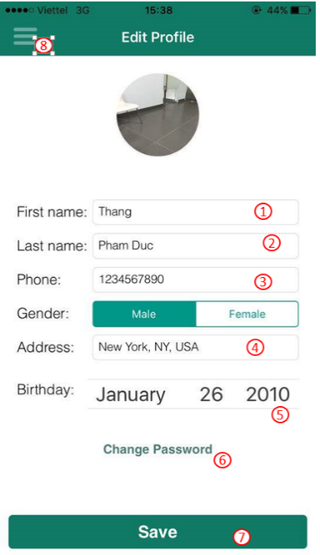

1. Edit first name
2. Edit last name
3. Edit phone
4. Edit address
5. Edit birthday
6. Change password
7. Save information
8. Show menu tab
   * + 1. Patient screen

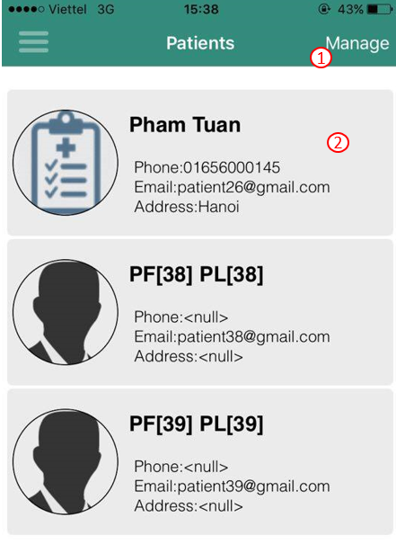

1. Manage patient
2. View patient detail
   * + 1. Manager patients screen

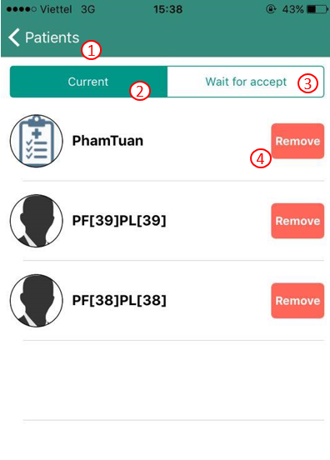

1. Back to Patients screen
2. View current patient
3. View history patient
4. Remove this patient
   * + 1. Accept/Cancel patient request

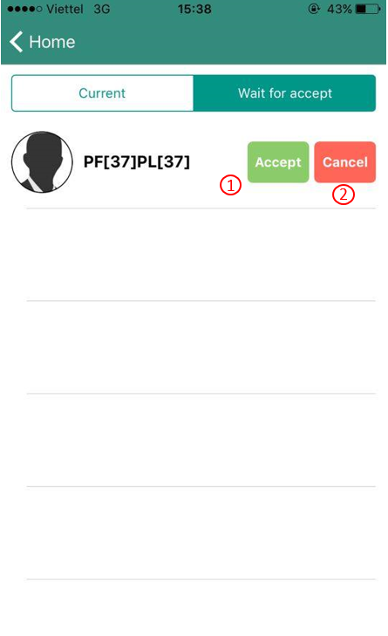

1. Accept request
2. Cancel request
   * + 1. Patient detail screen

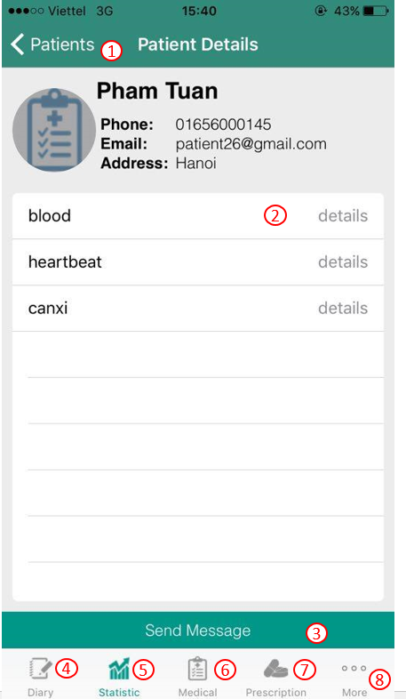

1. Back to patients screen
2. View stat detail
3. Send message
4. View diary
5. View statistic stats
6. View medical record
7. View prescription
8. More information
   * + 1. Prescription screen

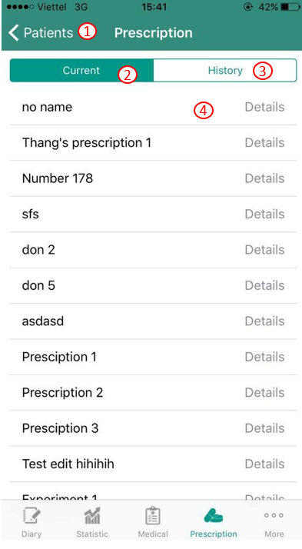

1. Back to patients screen
2. View current prescription
3. View history prescription
4. View prescription detail
   * + 1. Edit prescription

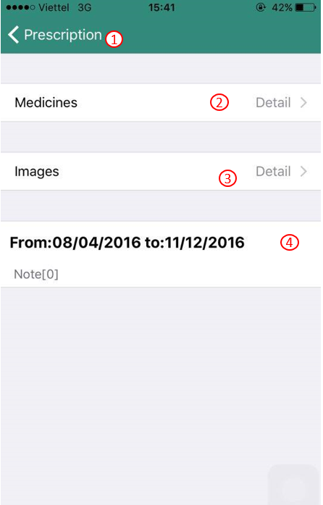

1. Back to prescription screen
2. View and edit medicines
3. View images
4. Edit time
   * + 1. Medical record screen

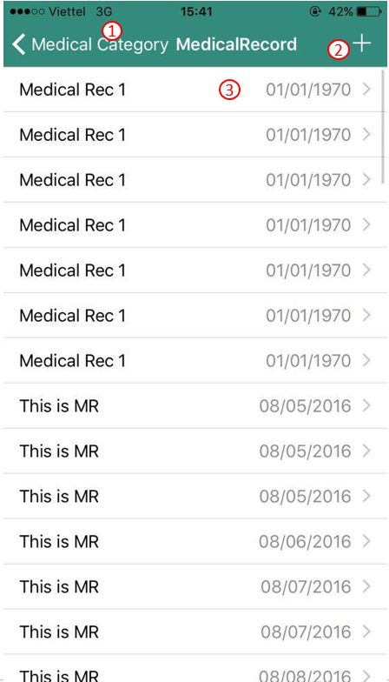

1. Back to medical category screen
2. Add new medical record
3. View and edit medical record
   * + 1. Add medical record

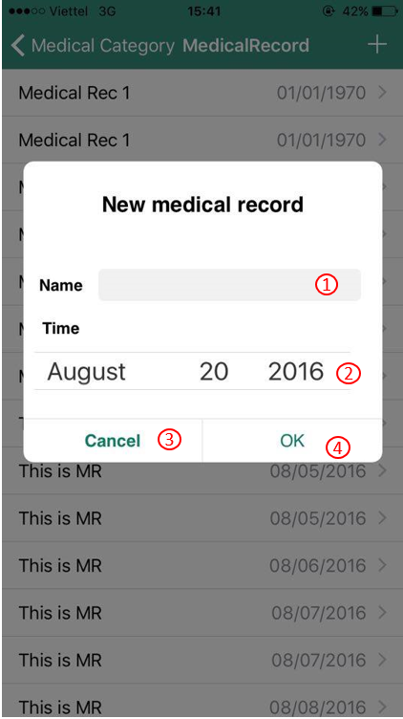

1. Fill name
2. Select time
3. Cancel
4. Create medical record
   * + 1. Medical record detail screen

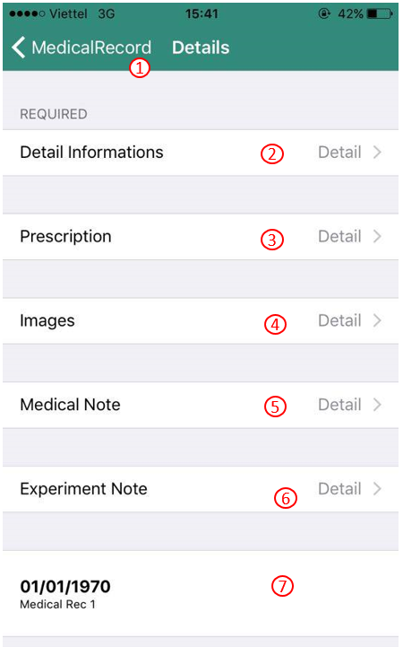

1. Back to medical record
2. View detail information
3. View prescription
4. View images
5. View medical note
6. View experiment note
7. Edit time
   * + 1. Create prescription

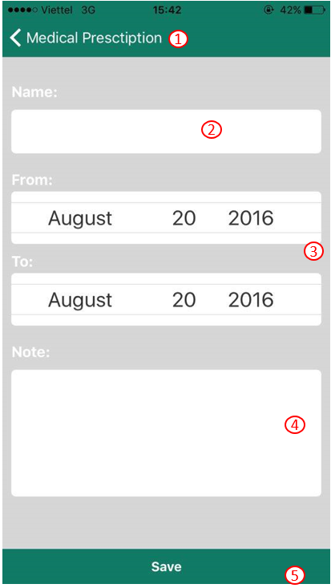

1. Back to medical prescription
2. Fill prescription name
3. Select time
4. Fill note
5. Save information
   * + 1. Diary screen

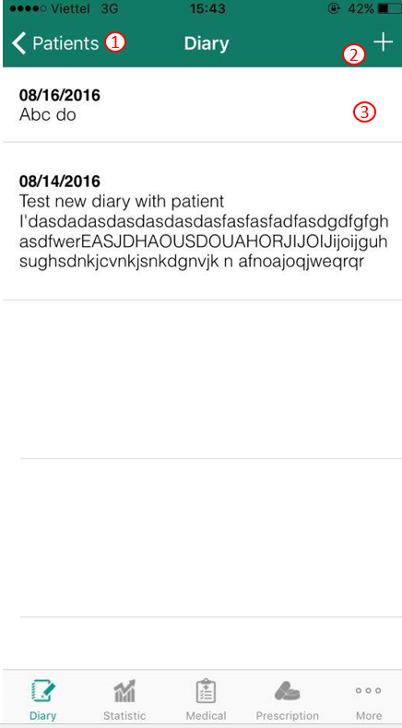

1. Back to patients screen
2. Create new diary
3. Tab to view diary detail, slide to delete this diary
   * + 1. Chat

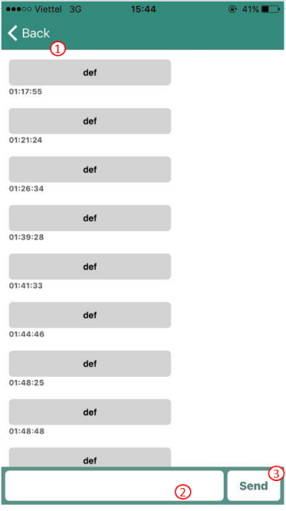

1. Back to previous screen
2. Tab to text
3. Tab to send message
   * + 1. More information screen

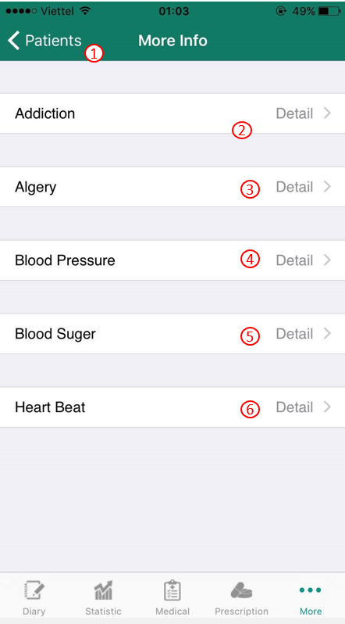

1. Back to patients screen
2. View addiction
3. View allergy
4. View blood pressure stat
5. View blood sugar stat
6. View heartbeat stat

### Patient application

* + - 1. Create account screen

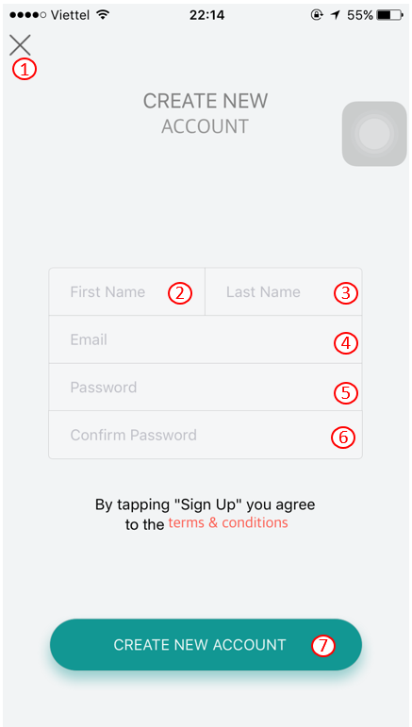

At the create account screen:

1. Close create new account screen
2. User fill their first name
3. User fill their last name
4. User fill their email
5. User fill their password
6. User fill their password again
7. Create a new account
   * + 1. Forgot password screen

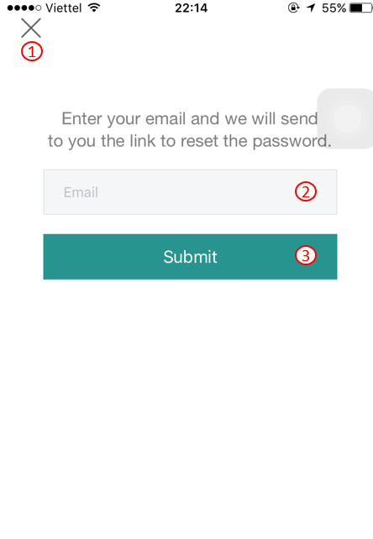

1. Close Forgot password screen
2. User fill their email
3. Send new password to their email
   * + 1. Notification screen

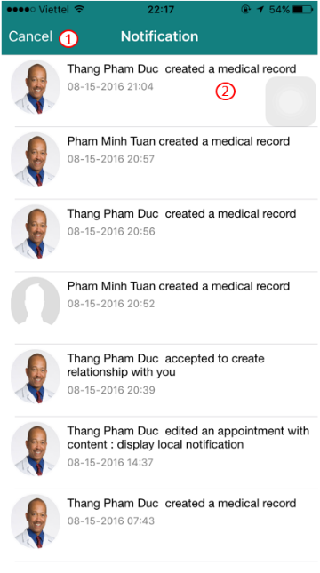

1. Close notification screen
2. View notification
   * + 1. Home screen

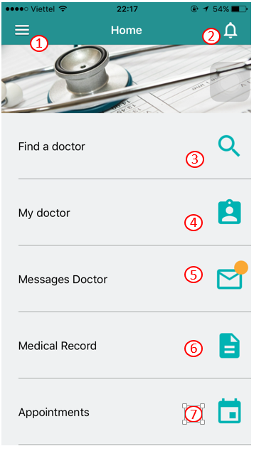

1. Show menu tab
2. Show notification
3. User can find doctor
4. User can view their doctor
5. User can view message from their doctor
6. User can view medical record
7. Check all appointments
   * + 1. Menu tab screen

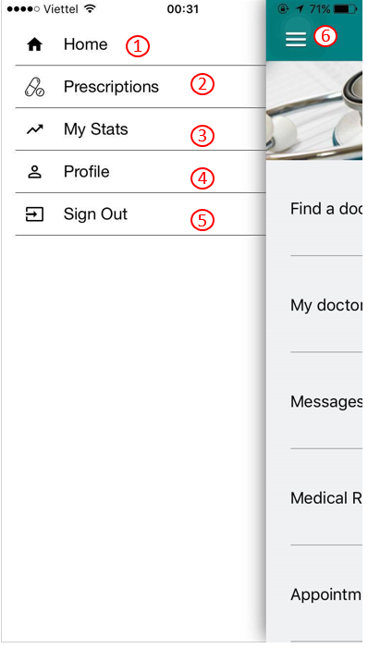

1. Back to Home screen
2. User can view their prescriptions
3. User can view their stats (Heartbeat, Blood Pressure, Blood Sugar)
4. User can edit their profile
5. Sign out application
6. Back to home screen
   * + 1. Prescription screen

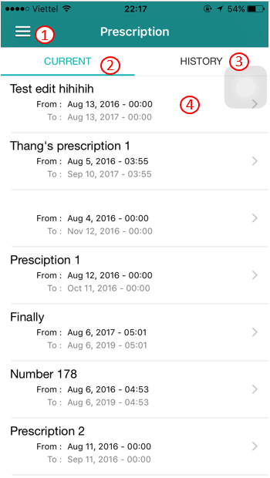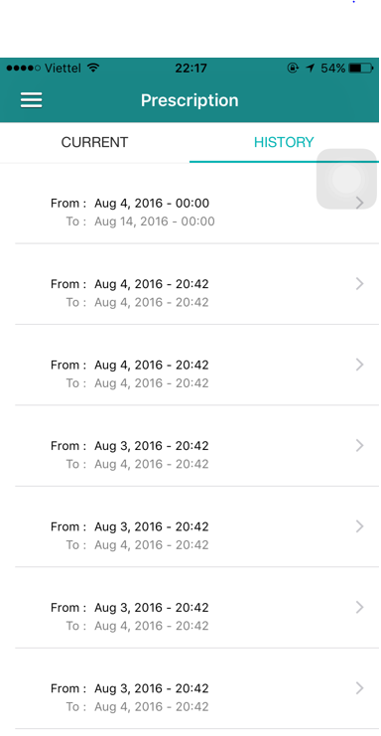

1. Open menu tab
2. User can view current prescription
3. User can view history prescription
4. Detail prescription
   * + 1. Prescription screen

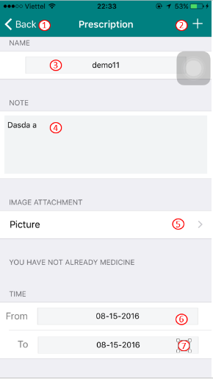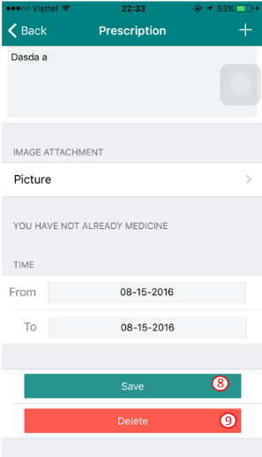

1. Back to previous screen
2. Add medicine into that prescription
3. User can edit prescription name
4. User can note in that prescription
5. Show prescription picture
6. Select time
7. Select time
8. Save information
9. Delete this prescription
   * + 1. Add medicine screen

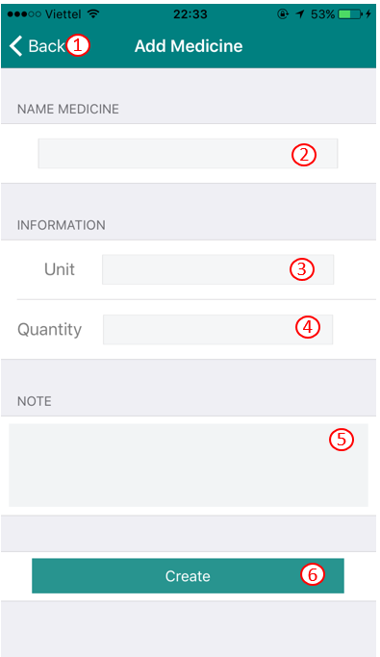

1. Back to previous screen
2. User can fill medicine name
3. User can fill unit type
4. User can fill quantity
   * + 1. Prescription picture screen

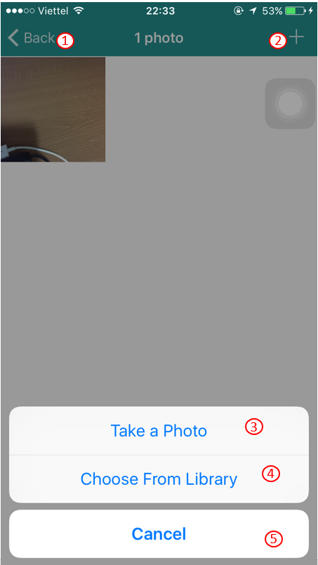

1. Back to previous screen
2. Add picture
3. Take a photo into prescription picture
4. User choose picture on their phone
5. Cancel take photo
   * + 1. My stats screen

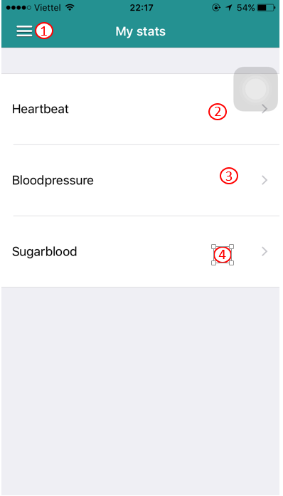

1. Show menu tab
2. User can view Heartbeat
3. User can view Blood pressure
4. User can view Blood sugar
   * + 1. Heartbeat screen

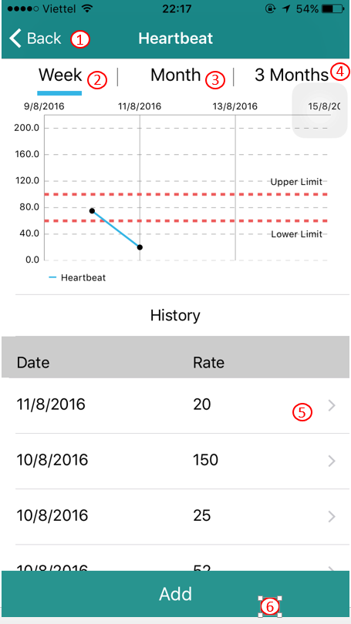

1. Back to previous screen
2. Show heartbeat in week
3. Show heartbeat in month
4. Show heartbeat in 3 months
5. User can edit heartbeat stat
6. User can a new heartbeat stat
   * + 1. Edit heart beat screen

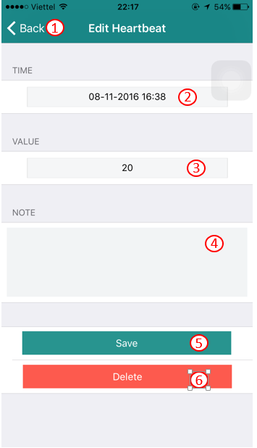

1. Back to previous screen
2. Select time
3. User can edit value
4. User can note in this stat
5. Save information
6. Delete this stats
   * + 1. Add heartbeat stat screen

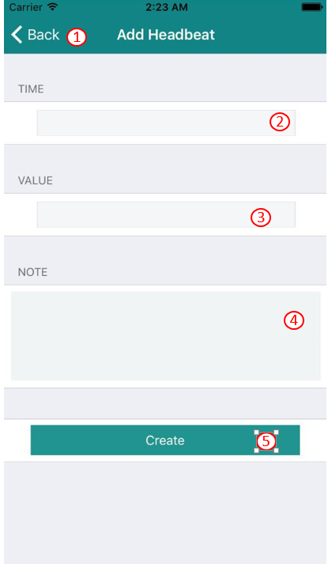

1. Back to previous screen
2. Select time
3. User can fill value
4. User can note in this stat
5. Create a new heartbeat stat
   * + 1. Blood Pressure screen

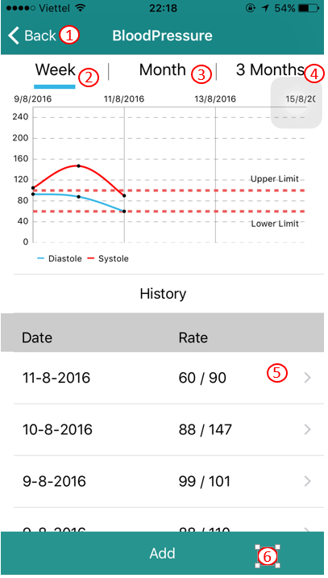

1. Back to previous screen
2. Show blood pressure in week
3. Show blood pressure in month
4. Show blood pressure in 3 months
5. User can edit blood pressure stat
6. User can a new blood pressure stat
   * + 1. Add blood pressure screen

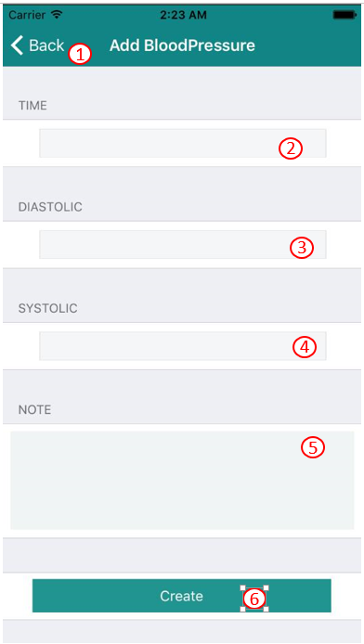

1. Back to previous screen
2. Select time
3. User can fill diastolic
4. User can fill systolic
5. User can note in blood pressure stat
6. Create a new blood pressure stat
   * + 1. Edit blood pressure screen

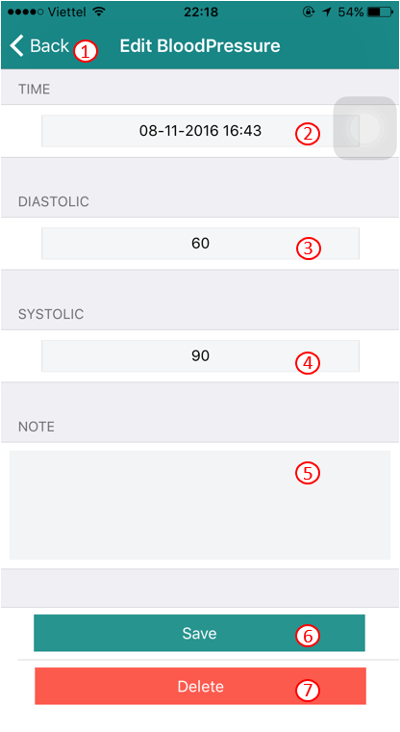

1. Back to previous screen
2. Select time
3. User can edit diastolic
4. User can edit systolic
5. User can edit note is this stat
6. Save information
7. delete this stat
   * + 1. Blood Sugar screen

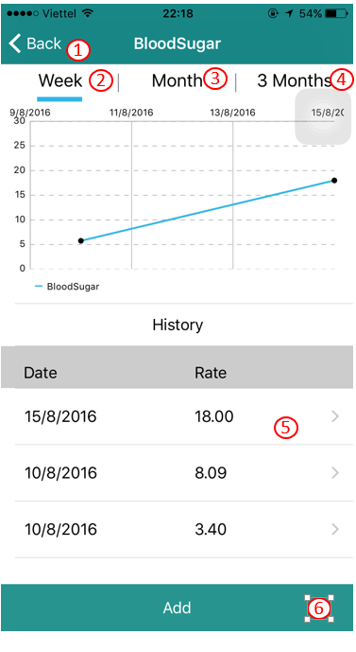

1. Back to previous screen
2. Show blood sugar in week
3. Show blood sugar in month
4. Show blood sugar in 3 months
5. User can edit blood sugar stat
6. User can a new blood sugar stat
   * + 1. Add blood sugar screen

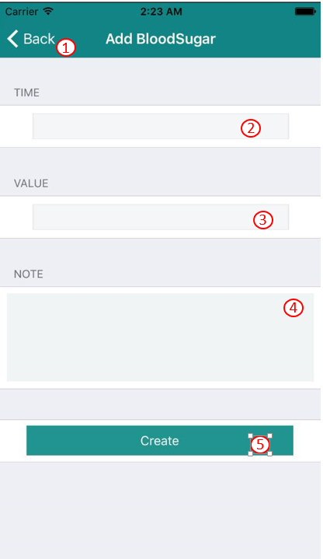

1. Back to previous screen
2. Select time
3. User can fill value
4. User can note in this stat
5. Create a new blood sugar stat
   * + 1. Edit Blood sugar screen

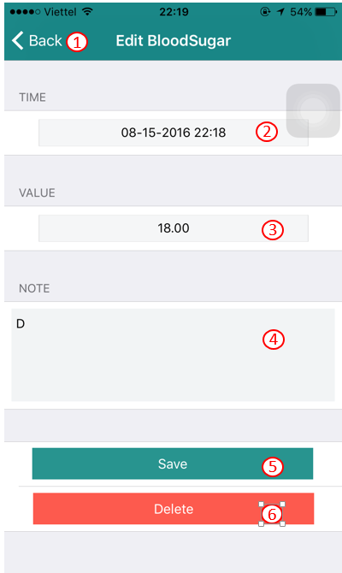

1. Back to previous screen
2. Select time
3. User can edit value
4. User can note in this stat
5. Save information
6. Delete this stat
   * + 1. Profile screen

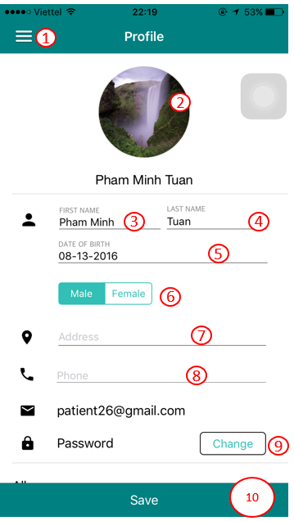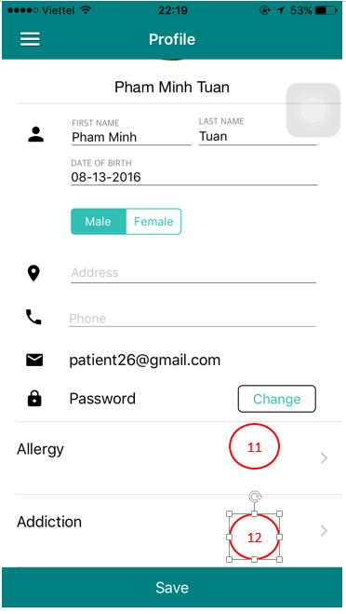

1. Back to previous screen
2. Change avatar
3. User can edit first name
4. User can edit last name
5. User can edit birth of date
6. Change sex
7. User can fill address
8. User can fill phone
9. User can change their password
10. Save information
11. the patient's allergies
12. the patient's addictions
    * + 1. Allergies screen

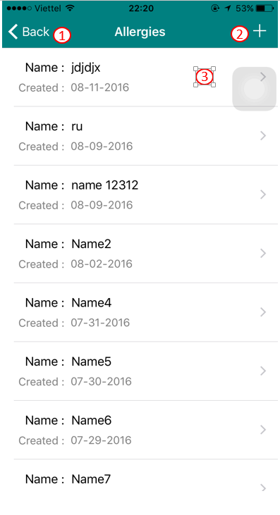

1. Back to previous screen
2. Add a new allergies
3. View detail Allergies
   * + 1. Add allergy screen

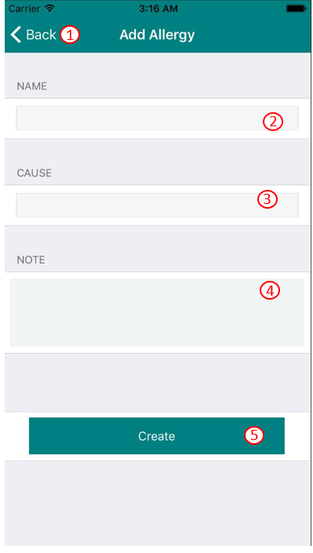

1. Back to previous screen
2. User fill their name
3. User fill their cause
4. User note in allergy
5. Create a new allergy
   * + 1. Edit allergy screen

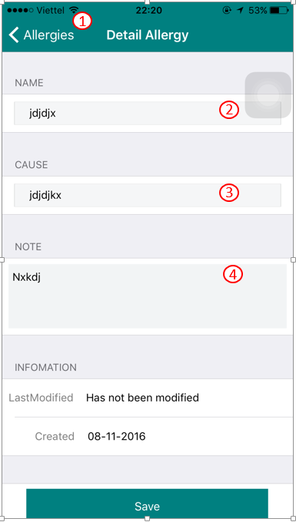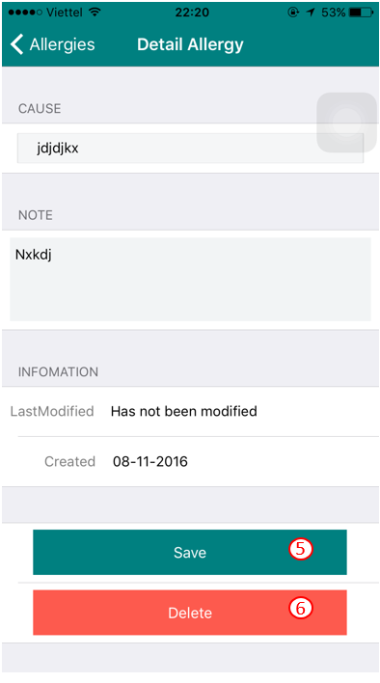

1. Back to Allergy screen
2. User can edit Allergy name
3. User can edit Cause name
4. User can edit note
5. Save information
6. delete allergy
   * + 1. Addiction screen

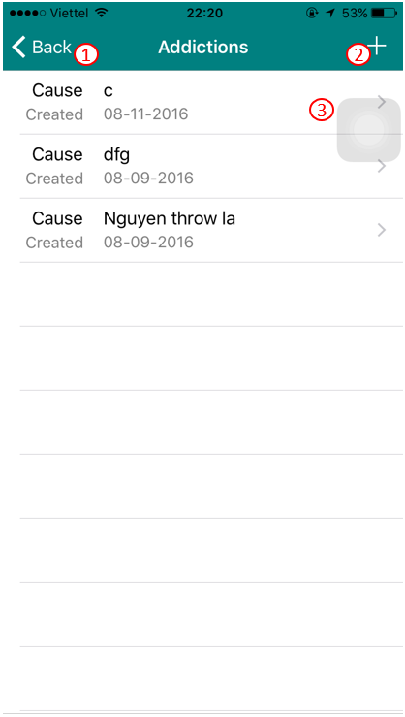

1. Back to previous screen
2. Add a new allergies
3. View detail addiction
   * + 1. Add addiction screen

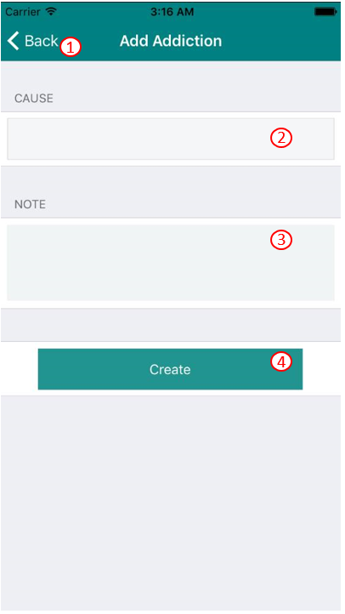

1. Back to previous screen
2. User fill their cause
3. User note in addiction
4. Create a new addiction
   * + 1. Edit addiction

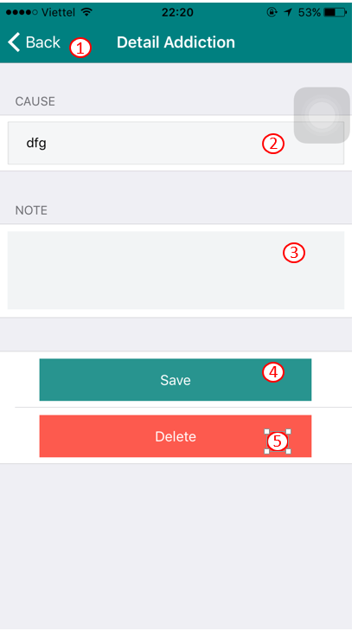

1. Back to previous screen
2. User can edit cause
3. User can edit note
4. Save information
5. Delete addiction
   * + 1. Change password

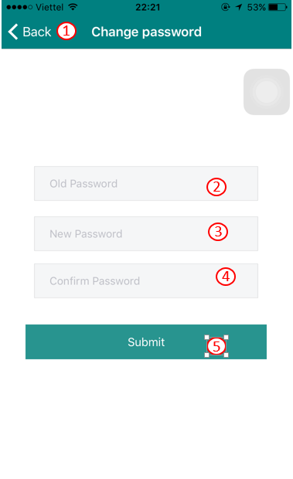

1. Back to previous screen
2. User fill old password
3. User fill new password
4. User confirm password
5. Change password
   * + 1. Change avatar
6. User take a photo from camera
7. User take a photo from library
8. Cancel change avatar
   * + 1. Find doctor screen

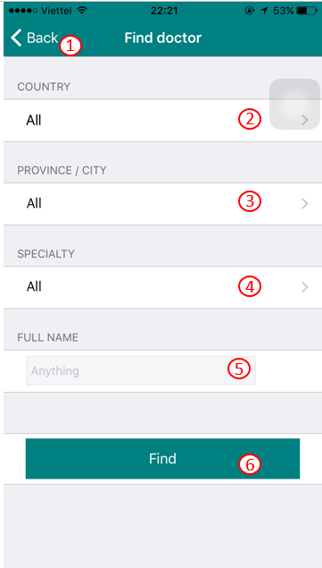

1. Back to previous screen
2. User can search doctor by country
3. User can search doctor by city
4. User can search doctor by specialty
5. User can search doctor by full name
6. Search doctor
   * + 1. My doctor screen

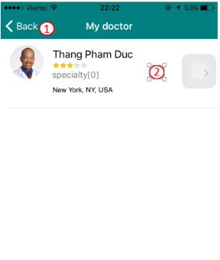

1. Back to previous screen
2. View detail doctor
   * + 1. Profile doctor screen

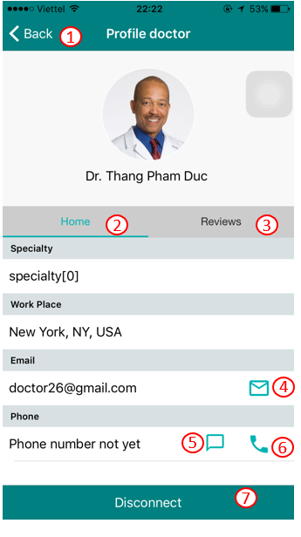

1. Back to previous screen
2. Information about doctor
3. View comment and rate about doctor
4. User can send email for their doctor
5. User can send message for their doctor
6. Call this doctor
7. Disconnect this doctor
   * + 1. Review doctor screen

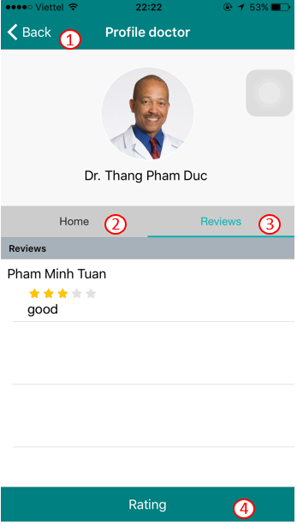

1. Back to previous screen
2. Information about doctor
3. Comment and rate about doctor
4. Rate for this doctor
   * + 1. Rating screen

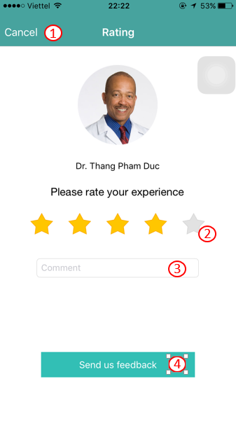

1. Cancel rate
2. User can rate for their doctor
3. Comment doctor
4. Send comment and rate
   * + 1. Message screen

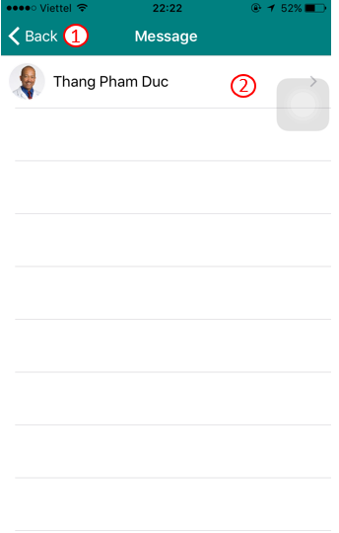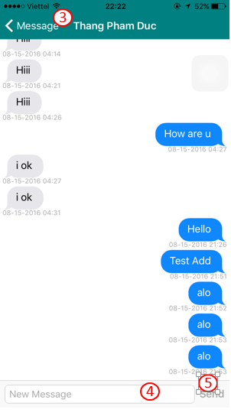

1. Back to previous screen
2. Choose doctor to chat
3. Back to message screen
4. Chat textbox
   * + 1. Medical category screen

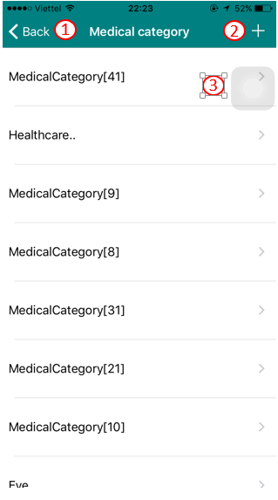

1. Back to previous screen
2. Add medical record
3. Choose medical category
   * + 1. Create medical record screen

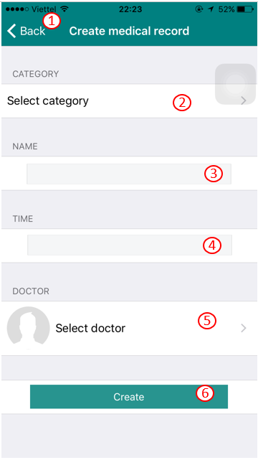

1. Back to previous screen
2. User can select medical category
3. User fill medical record name
4. User select time
5. Select a doctor
6. Create medical record
   * + 1. Name category screen

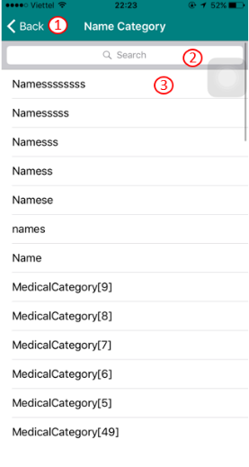

1. Back to previous screen
2. User can search a category
3. Choose category for add medical record
   * + 1. Medical record screen

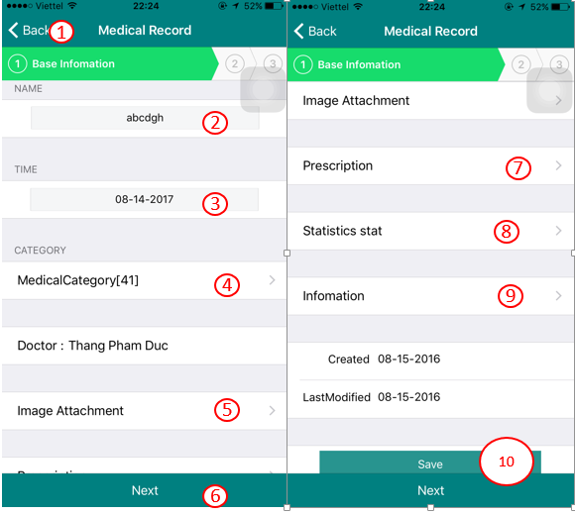 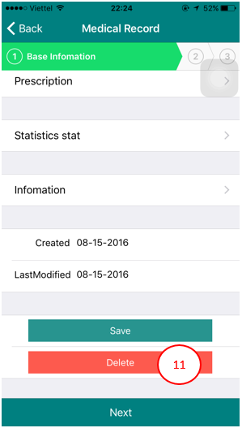

1. Back to previous screen
2. User can edit medical record name
3. User can edit time
4. User can edit medical record category
5. User can view medical record image
6. Next screen
7. View prescription in this medical record
8. View statistic stat
9. View information
10. Save edited information
11. Delete this medical record
    * + 1. Experiment Note screen

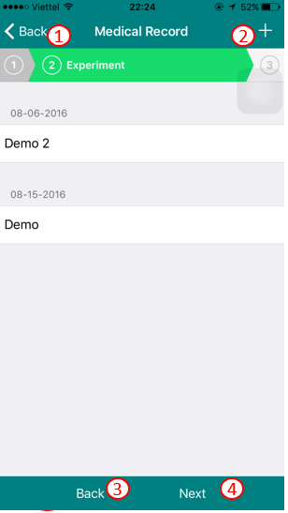

1. Back to create medical record screen
2. Create a experiment note
3. Back to previous screen
4. Next screen
   * + 1. Create experiment note screen

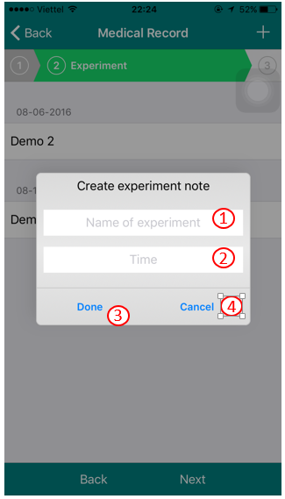

1. User fill experiment name
2. User select time
3. Create new experiment note
4. Cancel
   * + 1. Medical note screen

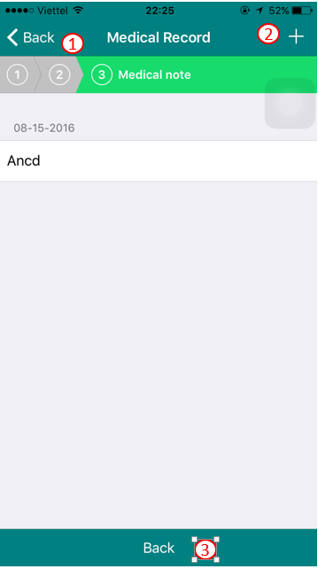

1. Back to create medical record screen
2. Add new medical note
3. Back to previous screen
   * + 1. Create medical note screen

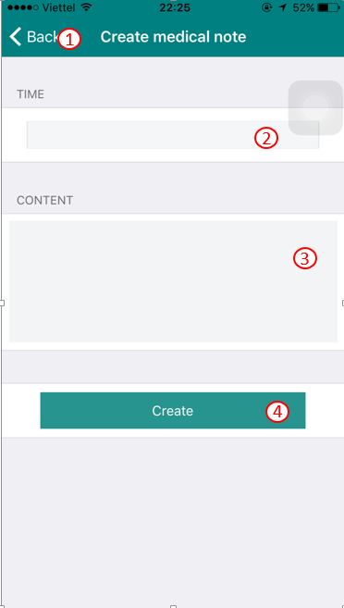

1. Back to previous screen
2. User select time
3. User fill content
4. Create new medical note
   * + 1. Appointment screen

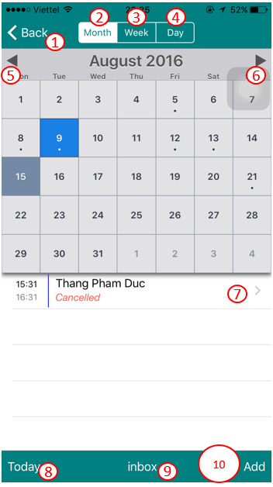

1. Back to previous screen
2. View appointment in month
3. View appointment in week
4. View appointment in day
5. Previous month
6. Next month
7. View detail appointment
8. Check appointment today
9. Check inbox
10. Add a appointment
    * + 1. Inbox screen

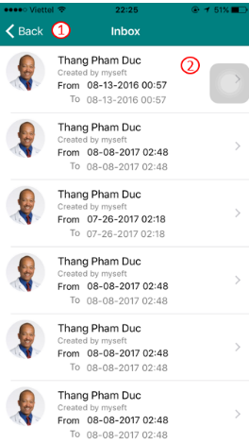

1. Back to previous screen
2. Detail appointment
   * + 1. Add appointment screen

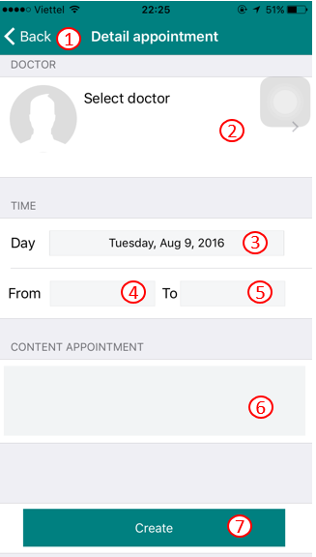

1. Back to previous screen
2. Select a doctor
3. Select day
4. Time from
5. Time to
6. User fill content
7. Create new appointment